**Incident** - INC0495871

**Fix-**

select * from lenapp_variants lv where lv.orig_loanap_acc_no=85657038

Complete ecomm product transfer on 8565703880

//Mainline/setup_data/amendment_scripts/*a9iss3415.0*

//Mainline/setup_data/amendment_scripts/a9iss3142.sql

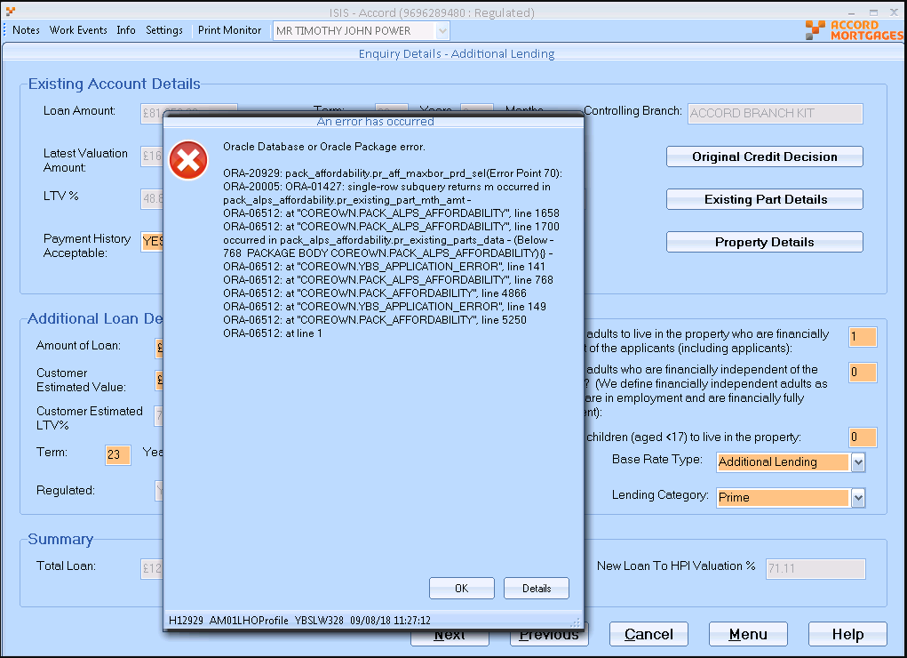

**Incident: INC0500817**

**clsPostalAddress.cs**

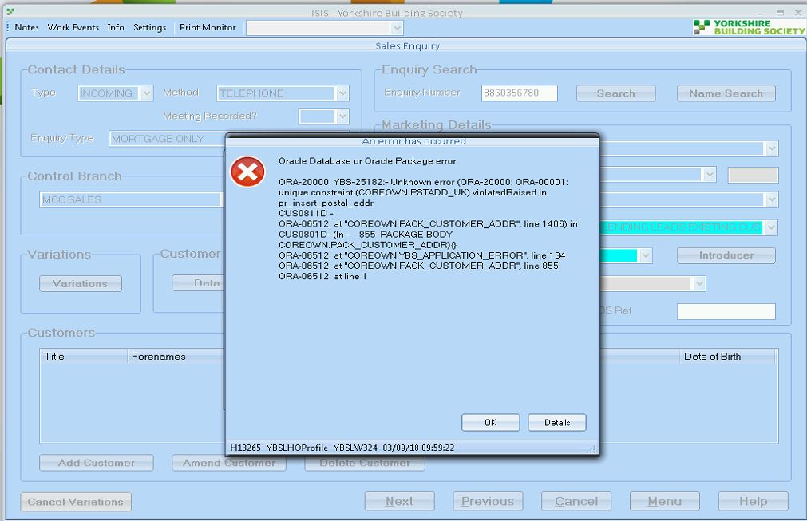

WHERE au.PARTY_SYSID=6960567613

and Nvl(au.END_DATE, sysdate) >=sysdate

and sysdate >=au.START_DATE

AND (au.ended_date IS NULL OR au.end_date > SYSDATE )

Select * FROM postal_addresses pa

where pa.sysid = 142119449;

**Patch:** //Mainline/setup_data/amendment_scripts/a9iss3271.sql

Top of Form

Incident: INC0501095

Account not exist into v_ecomm_application

SELECT vapp2.title title

,vapp2.first_name forename

,vapp2.surname surname

,vapp.aip_decision

,vapp.aip_valid_until_date aip_expires

FROM v_ecomm_application vapp, v_ecomm_applicant vapp2

WHERE vapp.application_number = 1307080680

AND vapp.application_id = vapp2.application_id

AND vapp.status in ('AIP','KFI','F')

AND vapp2.primary_app_ind ='Y'

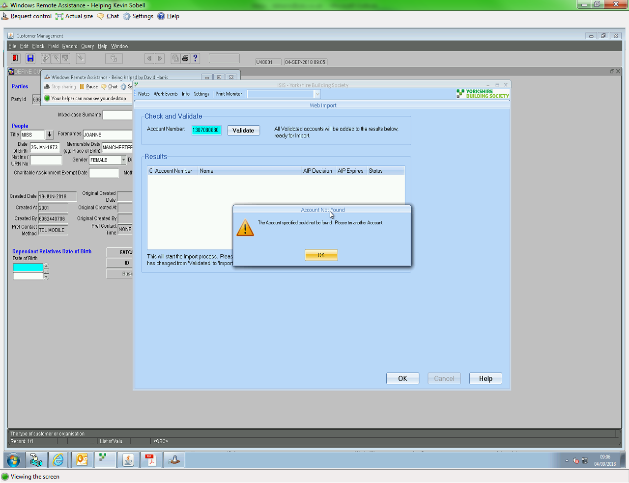

Similar - INC0591115

But vapp.status in ('AIP','KFI','F') was not belong to it

Status == ESI

INC0501907

Top of Form

In clsSalesPtParts.cs

oSelectedPart = oExistingParts.MatchPartByPartNoType

(Convert.ToInt32(oSalesPtPart.ParentLoanPartNum.Value),

clsExistingParts.DEFAULT_ACCOUNT_TYPE);

Returning null value into object oSelectedPart because of ParentLoanPartNum = 4 which Redeem in to database.

SELECT * FROM LOAN_PART_CONDITIONS LPC WHERE LPC.LOANAC_ACCGRP_NUM=72666437

AND LPC.LOANAC_LATYPE_CODE=80 AND NVL(LPC.END_DATE, SYSDATE) >=SYSDATE

SELECT * FROM LOAN_PART_STATUSES LPS WHERE LPS.LPST_CODE IN ('OPEN','LOWBAL','LOWMEM') AND LPS.LOANPT_ACCGRP_NUM = 72666437

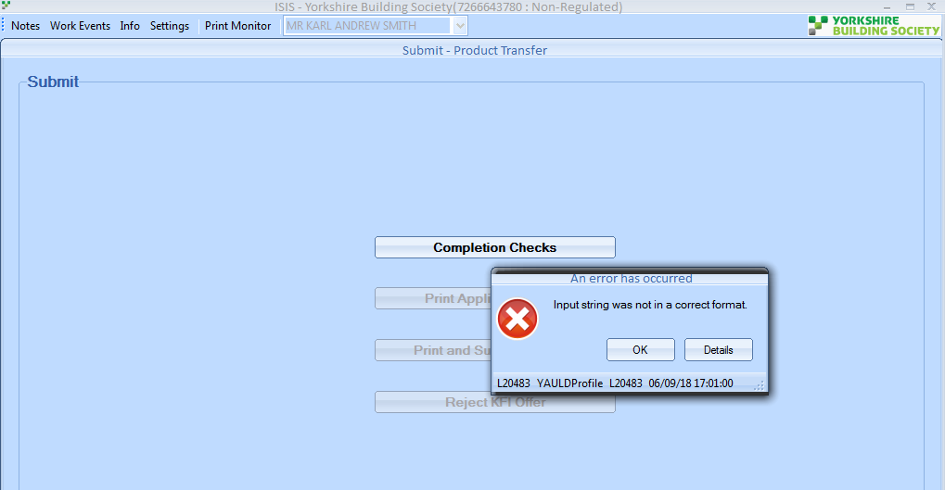

[INC0510881](https://ybs.service-now.com/incident.do?sys_id=ca629d6bdb41e3c0458516d15b9619e7&sysparm_record_target=incident&sysparm_record_row=1&sysparm_record_rows=4&sysparm_record_list=active%3Dtrue%5Eassigned_to%3Djavascript%3AgetMyAssignments%28%29%5EORDERBYDESCnumber)

ISIS - Error occurred when printing offer

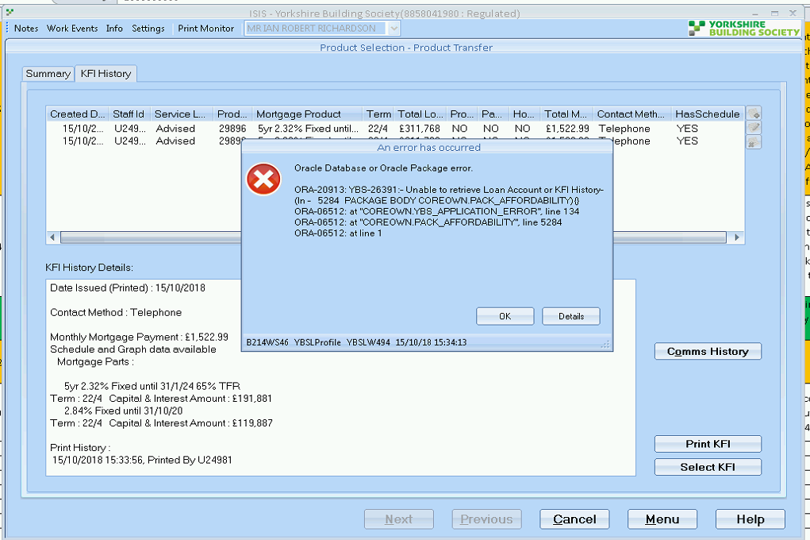

//Mainline/setup_data/amendment_scripts/a9iss3173.sql

[INC0510465](https://ybs.service-now.com/incident.do?sys_id=f1bd4926db81af80b59583305b9619d0&sysparm_record_target=incident&sysparm_record_row=2&sysparm_record_rows=4&sysparm_record_list=active%3Dtrue%5Eassigned_to%3Djavascript%3AgetMyAssignments%28%29%5EORDERBYDESCnumber)

Can’t proceed with porting case

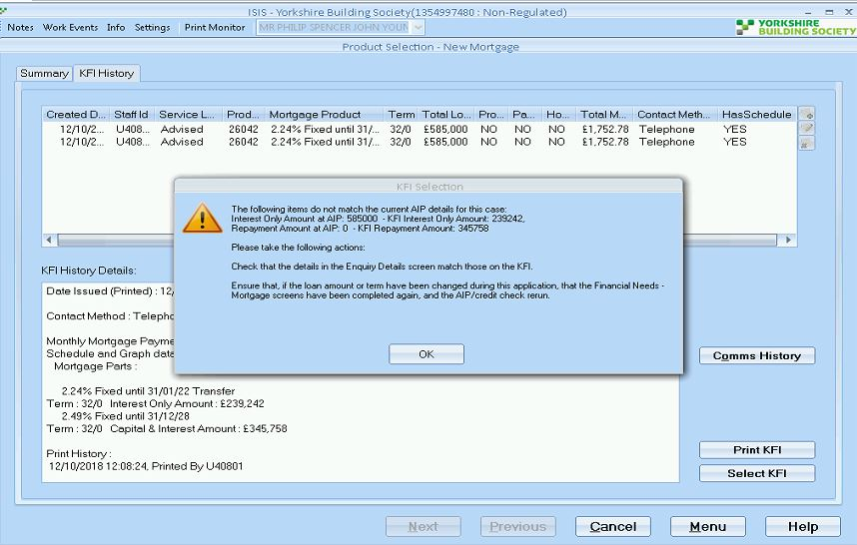

**INC0524446**

Currently the contact number shows as

Currently - 0345 669 217

But it needs to be - 01634817378

Additionally it populates the fax as something like - 123456 78912 ~

And the branch fax is - 01634 404 546

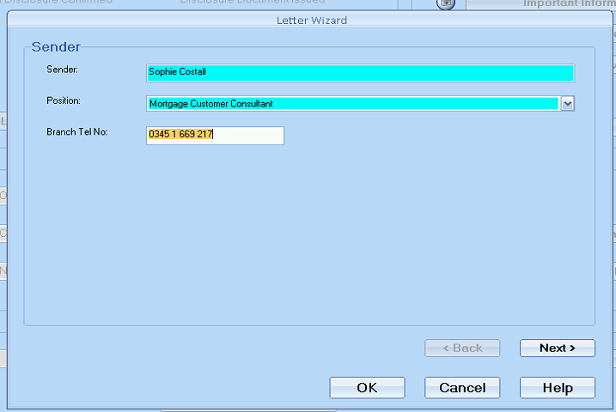

**INC0523867**

LEAP is bringing through incorrect information from LEAP

Relates to PRB0044816. An illustration has been created, can you please amend it as follows:   
  
Part 3 - term needs to remain unchanged at 7 years 8 months with a payment of £41.39 (offset savings withdrawn is reason for increase)   
Part 4 - new term of 9 years 8 months with a payment of £4.63

**Patch Run:** //Mainline/setup_data/amendment_scripts/a9iss3203.sql ?

**INC0623403 – Term and Amount change**

**INC0525807 – Term Change**

**Part Issue**

Get the sysid from below query

SELECT * from mortgage_illustrations mil

where mil.account_number=14804250

and mil.aa_selected='Y'

Replace the part in below

SELECT * FROM MORTGAGE_ILLSTR_PRODUCTS mip

where mip.morill_sysid = 5757514

**David:**

SELECT * FROM mortgage_illustrations m

WHERE m.account_number IN (82795510, 15132469)

ORDER BY sysid DESC

SELECT sysid, morill_sysid, created_date, term

,trunc(term/12) YRS

,mod(term,12) MTHS

FROM sales_pt_parts spp

WHERE spp.morill_sysid IN (6114881, 6204495)

ORDER BY sysid;

SELECT sysid, morill_sysid, term, original_term

FROM mortgage_illstr_products mip

WHERE mip.morill_sysid IN (6114881, 6204495)

ORDER BY sysid;

Patch //Mainline/setup_data/amendment_scripts/a9iss3207.sql

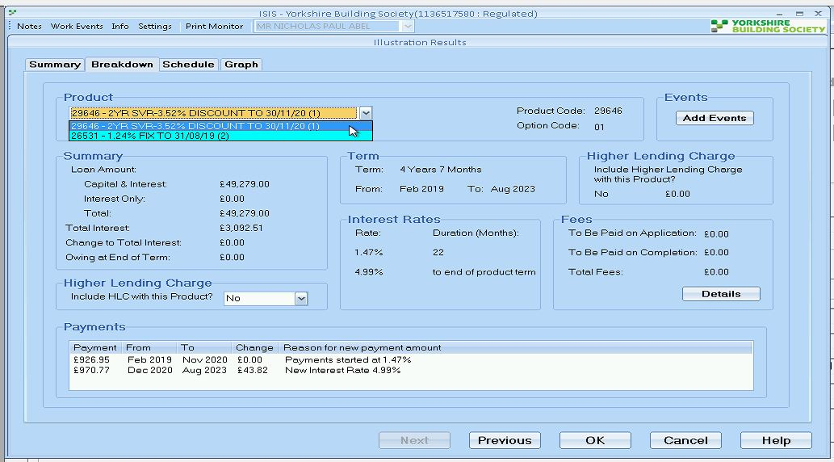

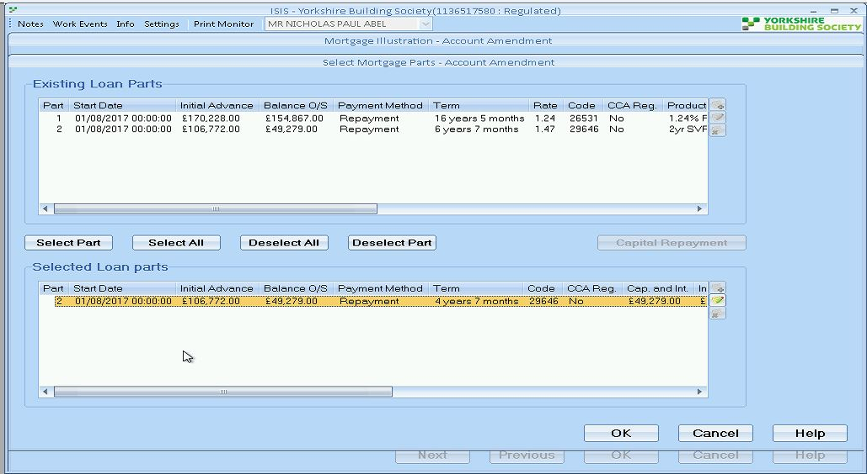

RD

Richard Durn

Additional comments•

03-04-2019 16:07:10

Hi Ami,   
  
It looks like you're attempting to do further illustrations on this case. For the avoidance of doubt, the only illustrations which are accurate on this case are the ones with an illustration date of 28/03/2019. It isn't possible to make future illustrations accurate, only to amend illustrations which have already been done.

RD

Richard Durn

Work notes•

03-04-2019 15:57:46

Further: I've checked the Product Selection screen in test and the figures shown are as per the request. So I think the user(s) are misunderstanding what we can actually do here.

RD

Richard Durn

Work notes•

03-04-2019 15:53:03

Can we check that the user(s) are not trying to illustrate from scratch again? That won't work, we can only amend illustrations which have already been done.

**INC0526246 - and INC0561913**

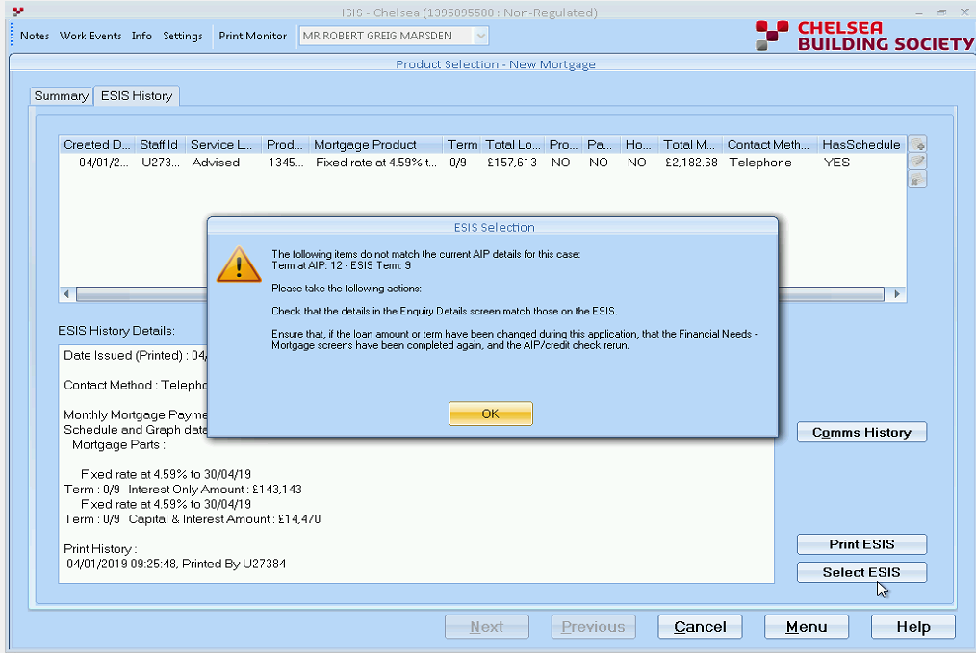

Hi,   
  
Because it's not possible to process a case below 12 months in ISIS, you will need to create a dummy illustration for 12 months, then process that through the system.

SELECT ast.sysid sysid,   
ast.loan_amount,   
ast.purchase_price,   
ast.repayment_amt,   
ast.interest_only_amt,   
ast.term,   
ast.created_date   
FROM aip_snapshot ast   
WHERE ast.account_number=13958955

**INC0528645**

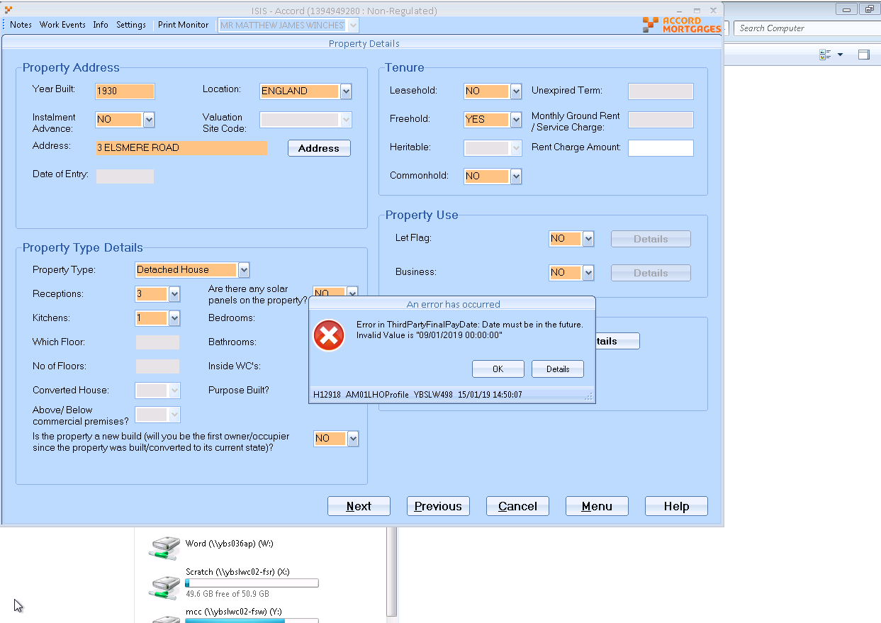

//Mainline/setup_data/amendment_scripts/a9iss3215.sql

**INC0527980**

**Details –** trying to setup a product transfer for these customers...

Error Messages (with screen shot) - "Object reference not set to an instance of an object"

**Solution:** //Mainline/setup_data/amendment_scripts/a9iss3216.sql

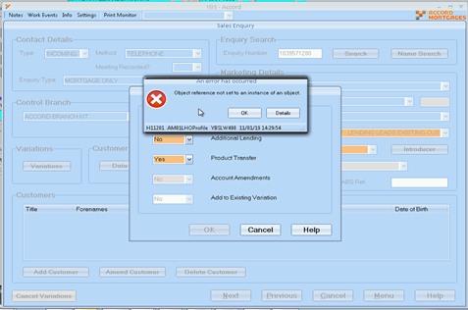

**INC0530214**

**Details –** ISIS error - set up a variation for Additional lending but says no customer found

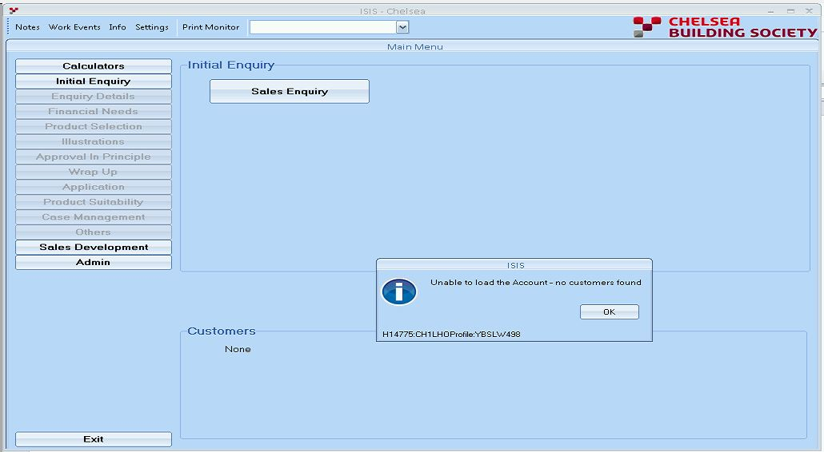

**Solution –** //Mainline/setup_data/amendment_scripts/a9iss3223.sql

//Mainline/setup_data/amendment_scripts/a9iss3263.sql

**INC0535037**

**Not able to load a mortgage account to ISIS**

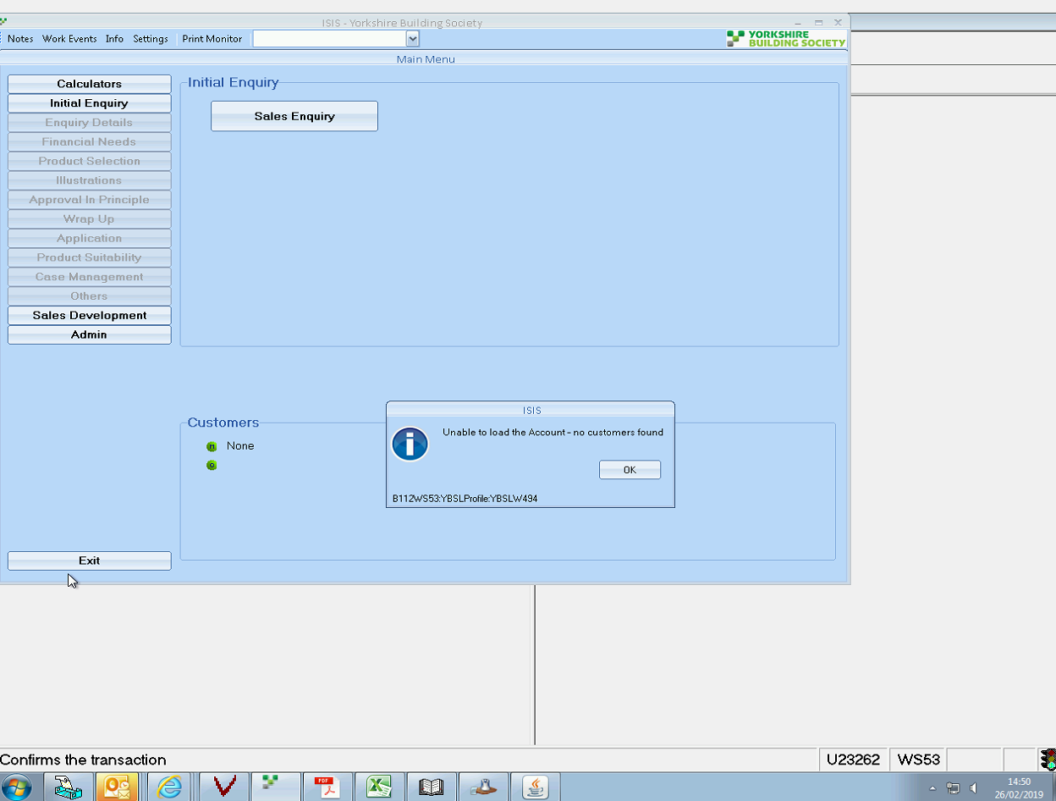

**Solution:**

select * from lenapp_variants lv where nvl(lv.orig_loanap_acc_no,lv.orig_lenapp_acc_no)=86564998;

SELECT * FROM isis_leap_variants i where i.lenvar_new_acc_no = 13094632;

Set product change as “PRDCPL”

Or Sometimes if above not work

Set further_advance to ISSCAN on isis_leap_variants for variant

**Patch:**

**Sometimes: If death date is there in People table for the case then, patch not work,**

It will work as long as we don't put the death info back in until the new applicant has been added. Aske Jill to remove the Death Info

Run patch as //Mainline/setup_data/amendment_scripts/a9iss3338.sql

INC0621629 - Sometimes when

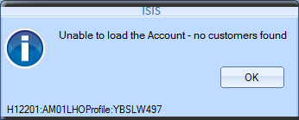

select * from isis_leap_variants i where i.lenvar_new_acc_no in

(select lv.new_lenapp_acc_no from lenapp_variants lv where nvl(lv.orig_loanap_acc_no,lv.orig_lenapp_acc_no)=96556691);

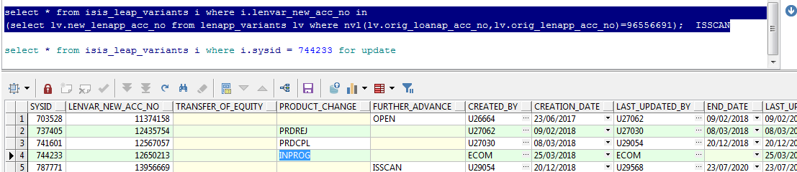

Solution:

**INC0531238 – Record Not Found**

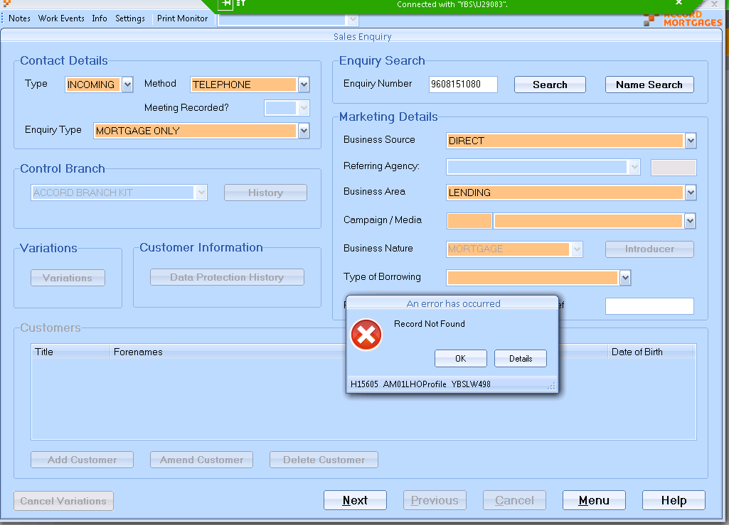

select * from lenapp_variants lv

where lv.orig_lenapp_acc_no =96081510; (Only in the case of variation, data will found in above table)

(Otherwise look into below)

select * from lending_applications l where l.account_number = 14769307

(Check Correct Mapping)

select AP.SYSID, AP.PARTY_SYSID

from ACTIVITY_PLAYERS AP,PEOPLE PP

where AP.TABLE_SYSID=14769307

and ap.ACTTYP_CODE in ('MHLDRM', 'OHLDRM', 'GRNTOR','MHLDPI','OHLDPI')

and Nvl(END_DATE, to_date(sysdate,'dd/mm/yyyy')) >=to_date(sysdate,'dd/mm/yyyy')

and to_date(sysdate,'dd/mm/yyyy') >=to_date(START_DATE,'dd/mm/yyyy')

and ap.table_id IN ('LENAPP','INSTDA')

and ap.ended_date is null

and pp.party_sysid=ap.party_sysid

and pp.date_of_death is null

order by AP.RANK

(Validate in if different than above - Update)

Select * FROM app_parties ap

where ap.lenapp_account_number = 14043187;

Select PR.PARTY_NAME,AP.Lenapp_Account_Number,PR.SYSID, AP.* from App_Parties AP

Inner Join

Parties PR on AP.PARTY_SYSID=PR.SYSID

where AP.LENAPP_ACCOUNT_NUMBER=96081510;

select ACCOUNT_NO, PARTY_SYSID, MORHLD_CODE, SMOKER, WORKING_16_HOURS, WORKING_6_MONTHS, SICK_PAY_CODE, SICK_PAY_PERIOD, REDUNDANCY_PERIOD, REDUNDANCY_PAYMENT,TOTAL_SAVINGS, substr(EXISTING_MORTGAGE_ACCOUNT,0,8) EXISTING_MORTGAGE_ACCOUNT, CREATED_BY, CREATED_AT, CREATED_DATE, ENDED_BY, ENDED_AT, ENDED_DATE, PRESENT_AT_CREDIT_CHECK, ABSENT_CREDIT_CHECK_AUTHORISED, ADDED_VIA_TOE, MPI_FORM_PRINTED, MTGE_SECURED_LOANS_FLAG

from SALES_APP_PARTIES

where ACCOUNT_NO=14195475

and Nvl(ENDED_DATE, sysdate) >=sysdate

**Solution** //Mainline/setup_data/amendment_scripts/a9iss3284.sql

**INC0531356**

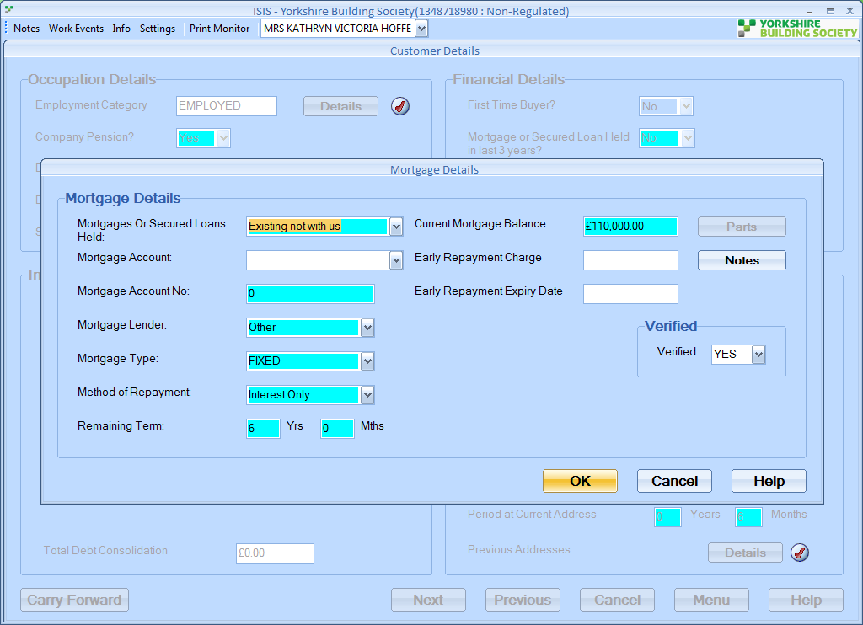

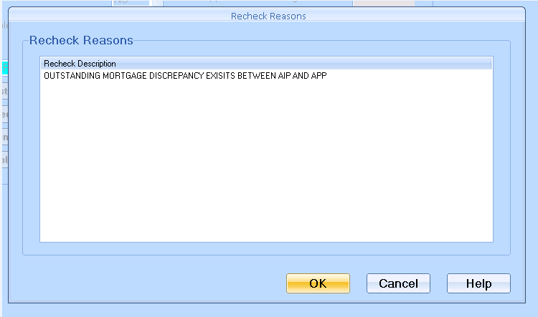

**Above message comes from:** SELECT * FROM Rechecking_Reasons

**Solution:**

**INC0532372**

**Details – Unable to amend the term in ISIS. Both Customer accounts are to match but when trying to do this, an error message pops up (see attached)**

**Gagan is able to change the term to 17 years 0 months but unable to change this to 16 years 11 months.**

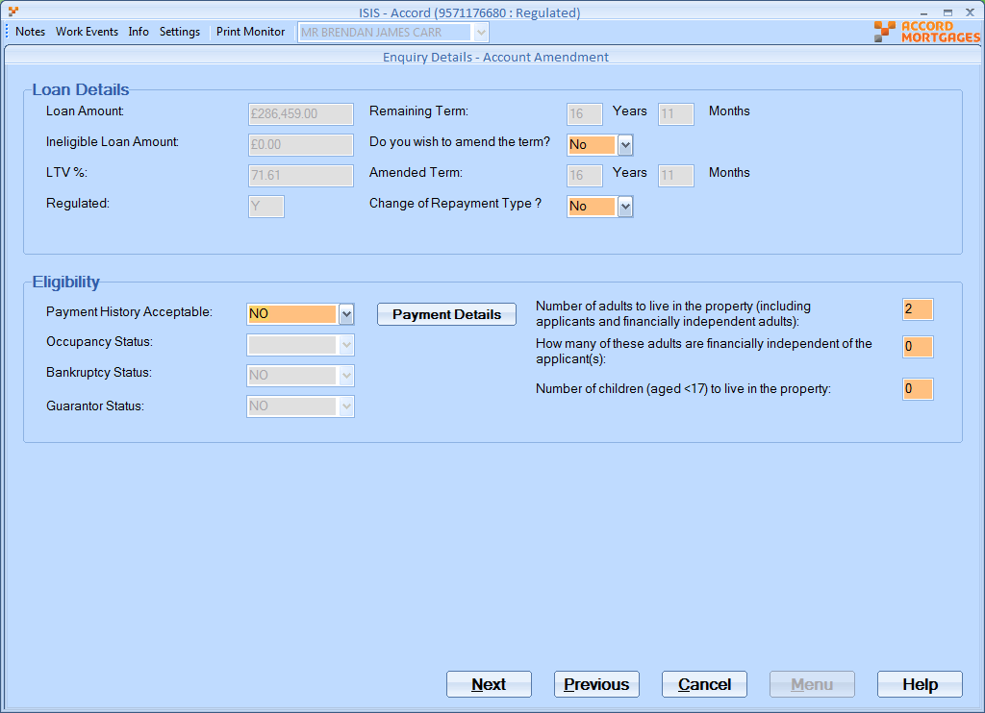

**Solution:** RD

Richard Durn

Work notes•

11-02-2019 15:36:13

Hi Sally,   
  
The workaround is to set the amended term in Enquiry Details to 17y 0m (i.e. 1 month longer) - this will allow the illustration to be done on 16y 11mo as there's a one month tolerance set when we check the illustration.

**INC0532683**

**Details – when trying to select the kfi , we are getting on screen LEP041FF an error message , last week we believed this to be connected to the mortgage balance , as was below min amount £98, so Matt got 3 months refund completed and bring the balance back up to £107.**

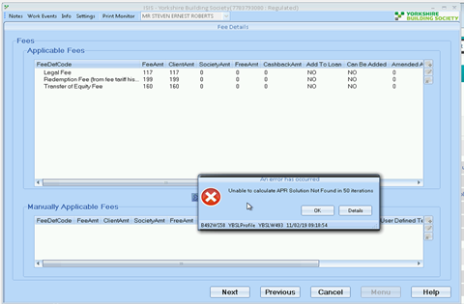

**Solution:** RD

Richard Durn

Work notes•

11-02-2019 15:17:25

Looks like the balance is too low for us to be able to illustrate.

**INC0532417**

**ISIS - CBS Unable to save existing morgage details to case, ""Oracle datasbases or orcale package error ""**

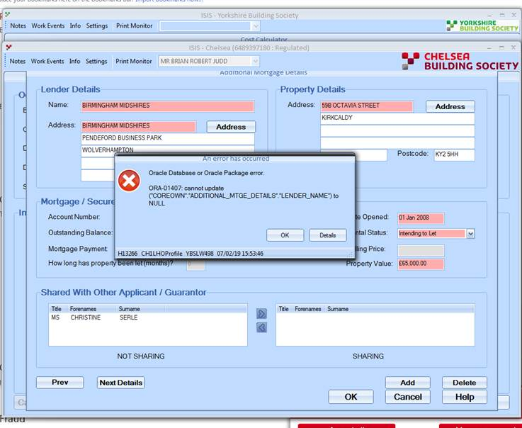

**Solution:**

SELECT * FROM party_add_mortgage_usages p

where p.apppty_sysid = 3075442;

select * from ADDITIONAL_MTGE_DETAILS t

where t.sysid in (997207, 997210, 997211,997213)

Patch : //Mainline/setup_data/amendment_scripts/a9iss3233.sql

**INC0532683**

**isis - Ybs - When selecting the KFI - Unable to calculate APR soloultion Not Found in 50 iterations**

**Details – when trying to select the kfi , we are getting on screen LEP041FF an error message , last week we believed this to be connected to the mortgage balance , as was below min amount £98, so Matt got 3 months refund completed and bring the balance back up to £107.**

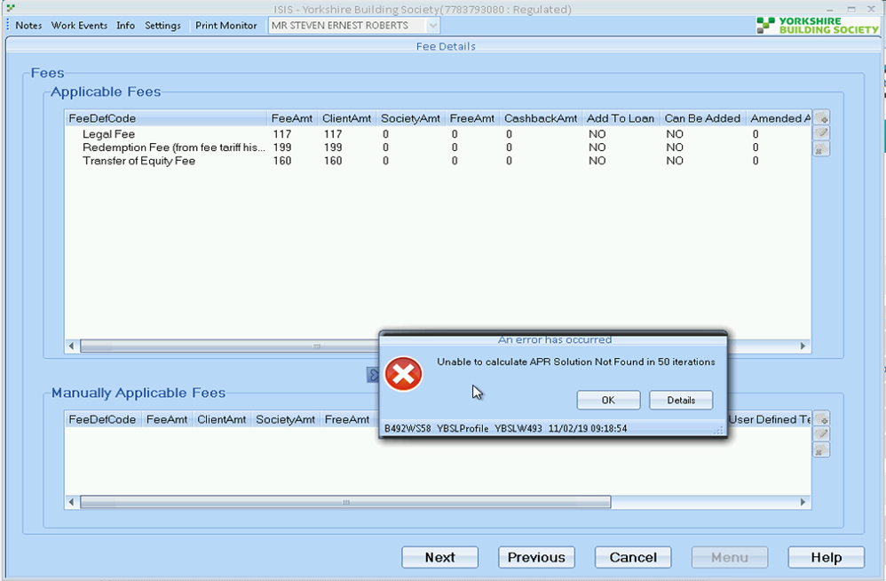

**Solution:**

RD

Richard Durn

Work notes•

11-02-2019 15:17:25

Looks like the balance is too low for us to be able to illustrate.

RD

Richard Durn

Work notes•

11-02-2019 18:21:31

Looks like £200 is the lower limit for this case, can't say for sure whether that's a general rule, although it does seem possible for ToEs as the fees are usually the same.

**INC0532365**

**Isis Variations - not closing after completed issues**

**Solution:** Says ISIS in the title but these have been submitted into ALPS/Core, so the variant statuses should be updated by those systems

**INC0534233**

ISIS - 'no communications found of this account number'

Details – ISIS - not able to print batch addition load application form. The status shows 'sent' but then gives an error message 'no communications found of this account number'

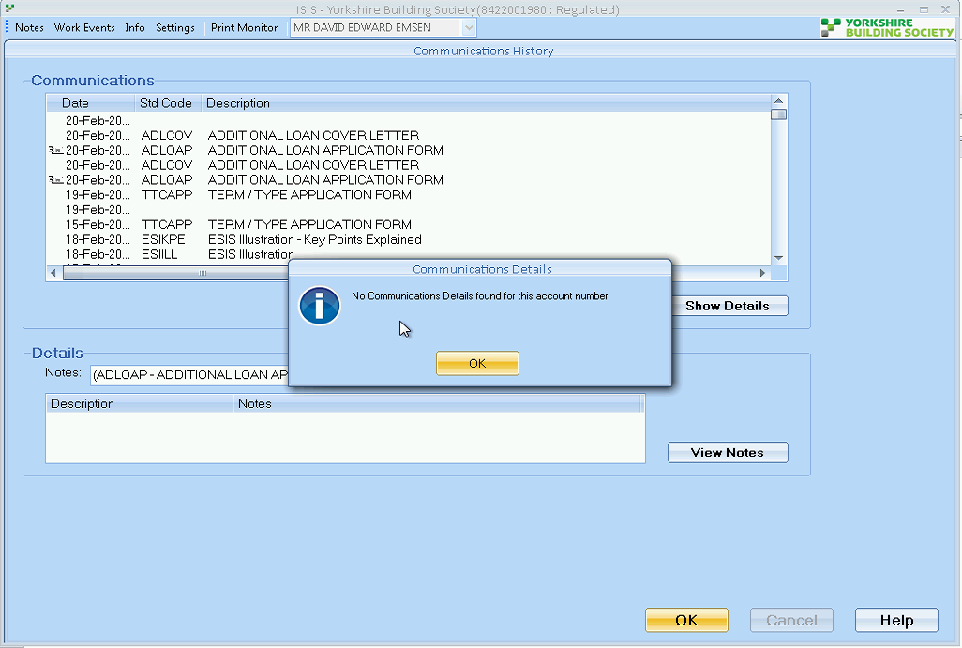

RD

Richard Durn

Work notes•

21-02-2019 10:58:03

it's probably worth noting that the additional loan app form is set to not DIP for some reason:   
  
select * from SALES_INIFILE_VALUE t   
where t.salins_sysid = 5311   
and t.sysid = 6059;

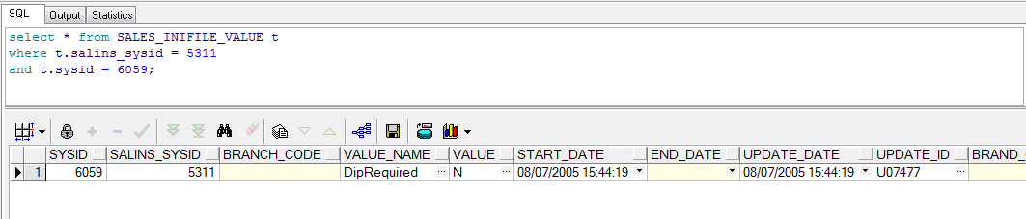

INC0534227

ISIS - Error when selecting product

Details – Issue on ISIS with an additional lending case,

underwriters have entered an override advising the amount that can be borrowed but cannot select the illustration as it is producing an error. The error is advising it is not affordable as it is not taking into account the override.

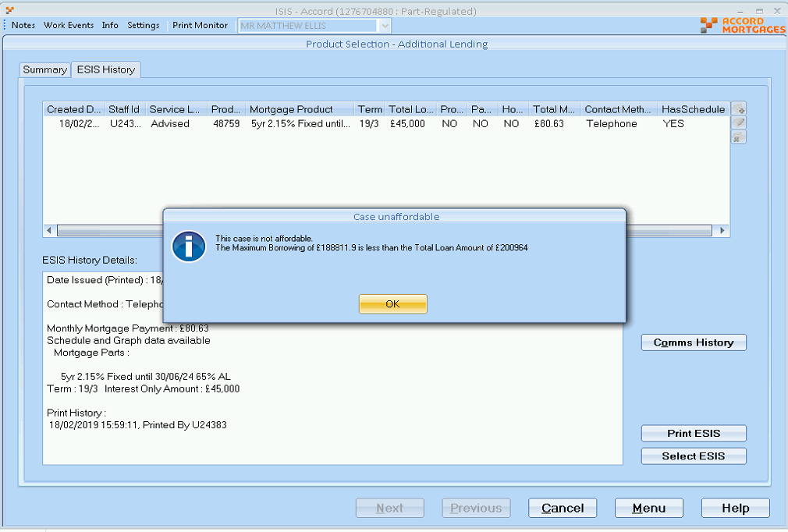

RD

Richard Durn

Additional comments•

22-02-2019 15:43:09

Hi,   
  
The override situation for Additional Lending is a bit counter-intuitive. The override amount needs to be the sum of the additional loan amount and the existing loan amount, which at the moment is £200981 (although this will change on a daily basis). If this override figure is amended, it should be possible to select the KFI.

INC0535206

ISIS YBS Status of application reverted to Advised

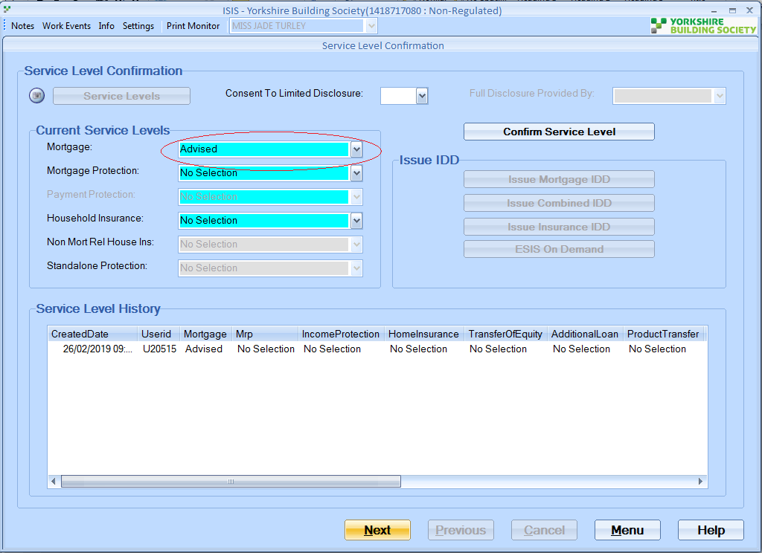

Select * FROM SL_INITIAL_DISCLOSURES SLIDIS WHERE SLIDIS.ENQ_REF_NO= 2205129;

Select * FROM SL_HISTORY SLHIST WHERE SLHIST.ENQ_REF_NO= 2205129;

Select * FROM SL_CONFIRMATIONS SLCONF WHERE SLCONF.SL_HISTORY_SYSID= 18420972

**Solution:**

**INC0536244**

**Error on ISIS when trying to issue a Type Term offer 1057945780**

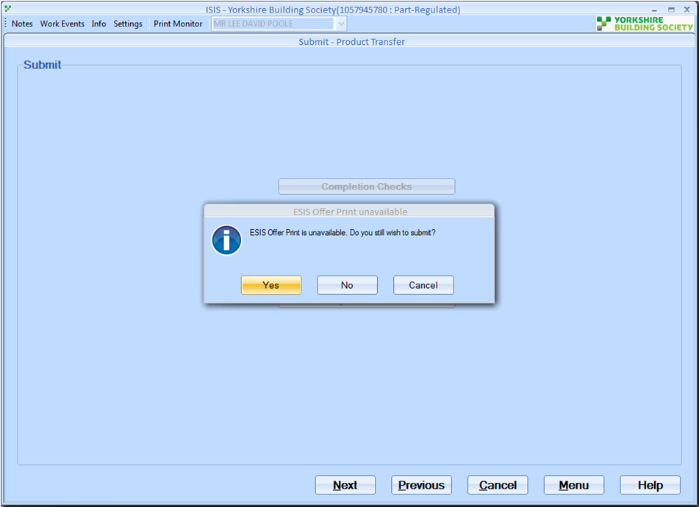

**Solution:**

RD

Richard Durn

Work notes•

11-03-2019 14:45:16

Hi,   
  
The issue with this case is that the initial product transfer illustration was done before we introduced the ESIS for variations.

As a result, the ESIS offer can't be produced. Please reillustrate the product transfer; you should then be able to submit and offer.

INC0537523

**Details – David called advising that underwriters were completing a Product Transfer with Term amendment for a customer, when trying to produce the offer one part is switching back to interest only instead of all three parts on repayment.**

**Part one has switched from repayment to interest only**

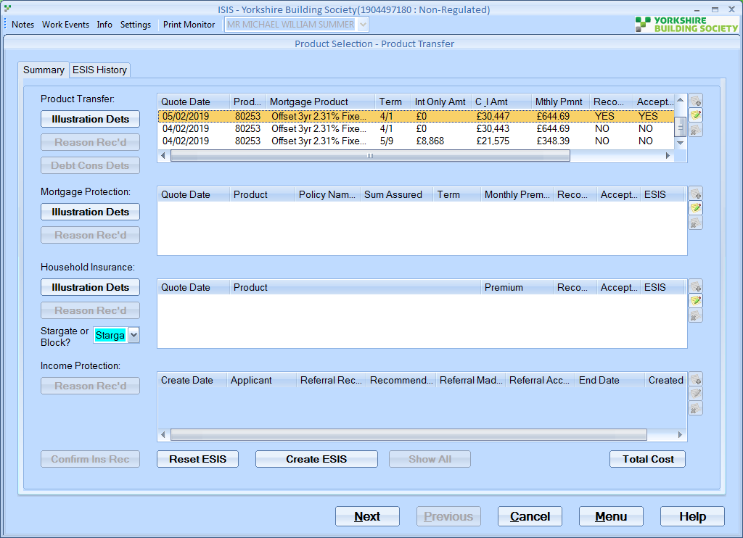

RD

Richard Durn

Work notes•

15-03-2019 14:49:20

The KFI originally selected on this case (6th Feb) was pure C&I. However, on the 7th March the part and part illustration was selected and submitted through. Seems to be pure user error - will need the offer rejecting and starting again.

**INC0538581**

**SIS - Cant run credit check on on case box isnt there**

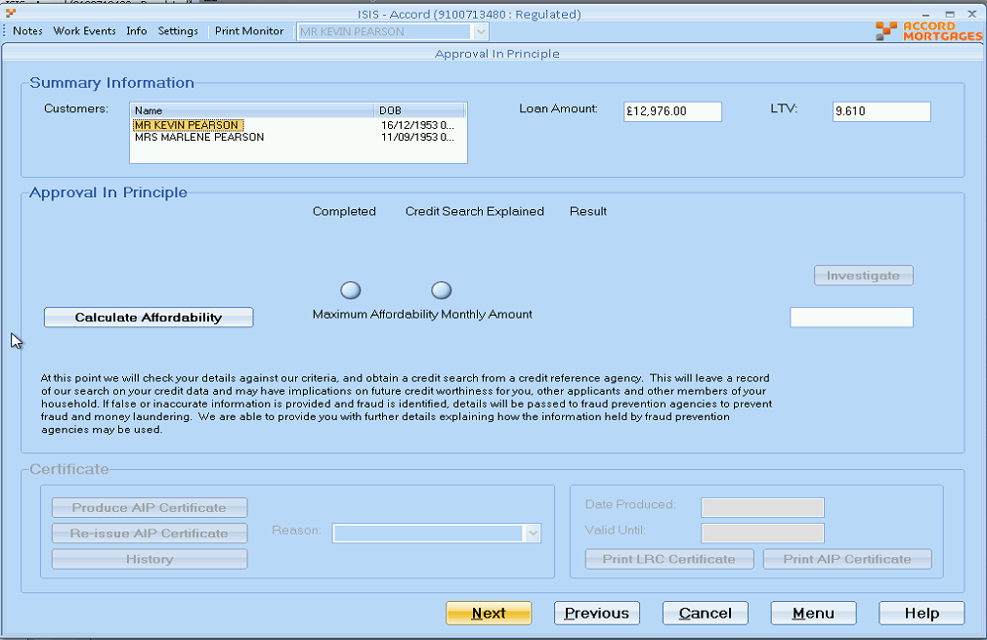

Select * FROm waivers w where w.accgrp_num = 91007134

**Solution:** Case has been waived but enddate not set.

**Another Same Incident –** **INC0589855**

Hi,

Case need an illustration, because it has IO and C&I parts and adviser changes the term on just the C&I part, it doesn't need a credit check. But if they change the term on an IO part, it does need a credit check.

Therefore the idea is, create an illustration and ESIS, try to select the ESIS and it will make the decision at that time.

Thanks,

Kamal

**INC0538336**

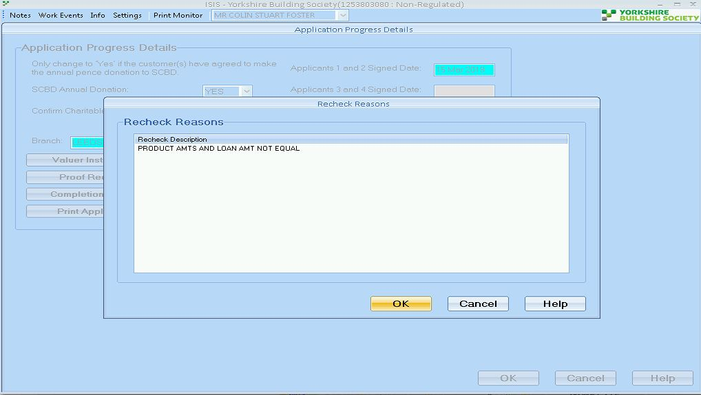

SELECT sum(mpd.capital_and_interest)

,sum(mpd.interest_only)

FROM mtge_product_details mpd

WHERE end_date IS NULL

AND mpd.morreq_sysid = 1131048;

SELECT la.borrowing_amt,

la.remtge_code,

la.remortgage_flag,

la.purchase_price,

la.ltv,

la.enq_ref_no,

la.approv_max_borrowing,

la.borrowing_amt,

la.no_of_apps,

la.term,

la.ktmatx_ktmcod_code, *-- KS Keythrough*

la.ktmatx_start_date, *-- KS Keythrough*

la.himps_inclusive, */* Added by DGW CCR4460 v1.20 */*

la.himps_required_future_value, */* Added by DGW CCR4460 v1.20 */*

nvl( la.purtpe_code,'STD'), */* CCR4561 VZM */*

la.resubmit_aip *-- change as per sc240928 jsb 01/02/2008*

FROM lending_applications la

WHERE la.account_number = 12538030;

**Update Dates to correct**

Select * FROM mtge_product_details mpd

WHERE mpd.morreq_sysid = 1131048;

**Patch:** //Mainline/setup_data/amendment_scripts/a9iss3242.sql

RD

Richard Durn

Additional comments•

26-03-2019 15:36:29

Hi,   
  
The loan amount entered in Enquiry Details for this case is £163879. The loan amount on the currently selected KFI is £163000. One of these figures will need to be changed in order for the case to progress.

**INC0539614**

**ISIS - will not print case**

**Details – ISIS - will not print case and also unable to submit the case, underwriter say they have overridden it but still unable to submit he has run AIP several times**

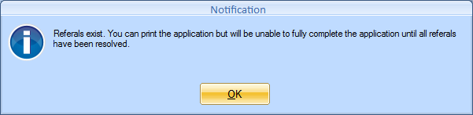

The above message is received when pressing application button

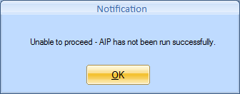

This message is received when I press completion checks and then go through to the end it says unable to proceed. I then go an rerun AIP but this doesn’t resolve the issue.

RD

Richard Durn

Work notes•

01-04-2019 12:47:34

The only issue I get in test is "Additional Mortgage Account Number Missing" - which is accurate, and amending this allows me to submit. May have changed since this was logged, can you check in live?

**INC0539987**

**ISIS Acc - Application not viewable in Underwriting screens in Live**

**Getting case to AIP. Case is unaffordable, performed credit check.**

**Underwriting have told him - it is not letting him transfer the case to the live system so they can review this.**

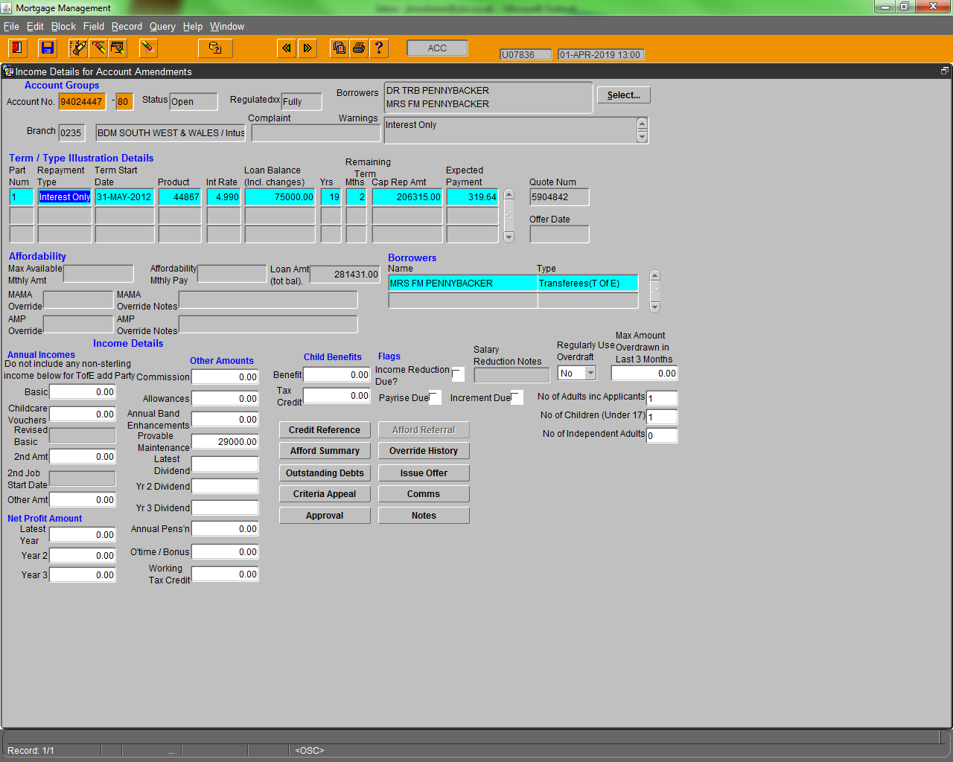

KB

Kamal Batham

Work notes•

02-04-2019 10:54:26

Info from ISIS is being populated on screen but affordability info isn't.

**INC0540323**

**Trying to change product on part 3 of the mortgage but presented with error**

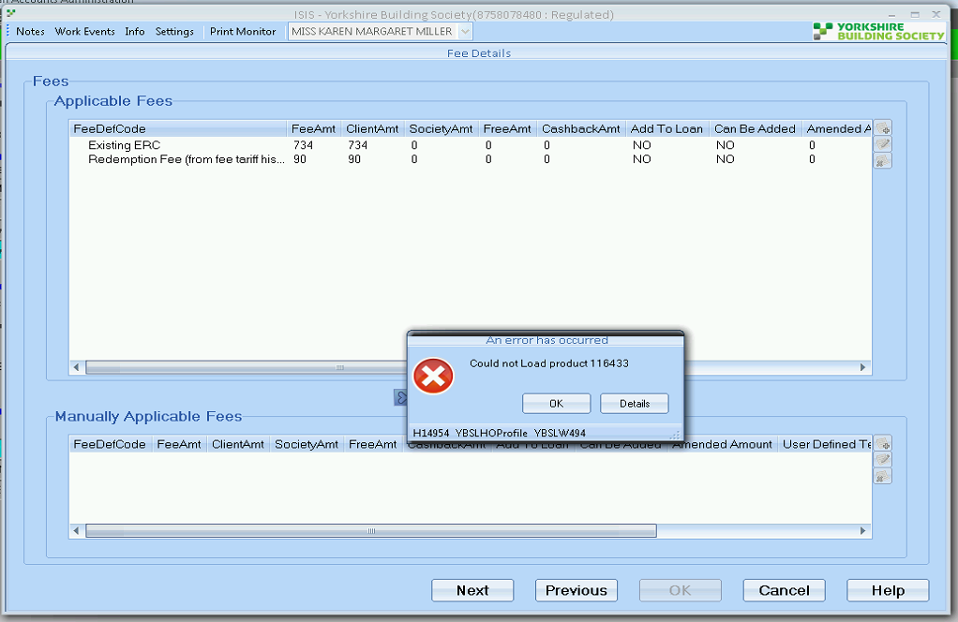

Select * FROM lending_products lp where lp.product_code = 116433

Product is Chelsea brand and account is YBS, However its best product and user are YBS.

**INC0541125**

**ISIS - variation that needs cancelling**

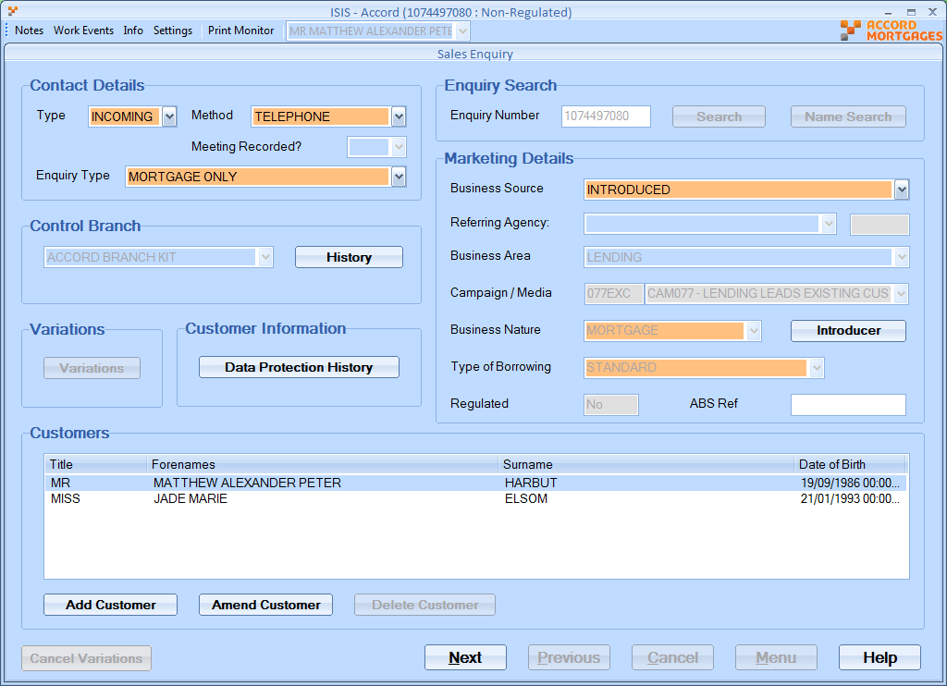

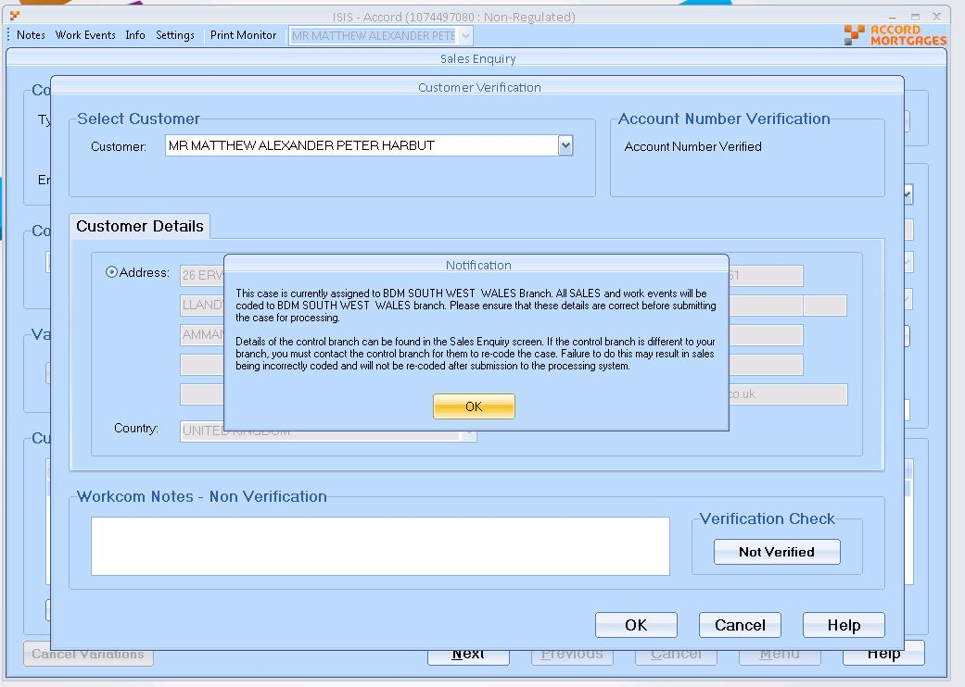

RD

Richard Durn

Additional comments•

08-04-2019 10:19:47

Hi,   
  
The account number provided is for a closed account as it was ported; the correct account number is 1400656780.

Select * FROM loan_part_statuses lps where lps.loanpt_accgrp_num = 10744970

Check LPST_CODE = Close

**INC0542146**

**Isis - YBS - Credit Score issues**

**Details – have run the credit score and noting is showing as a score decision - see attached, but you can see that it has been run through.**

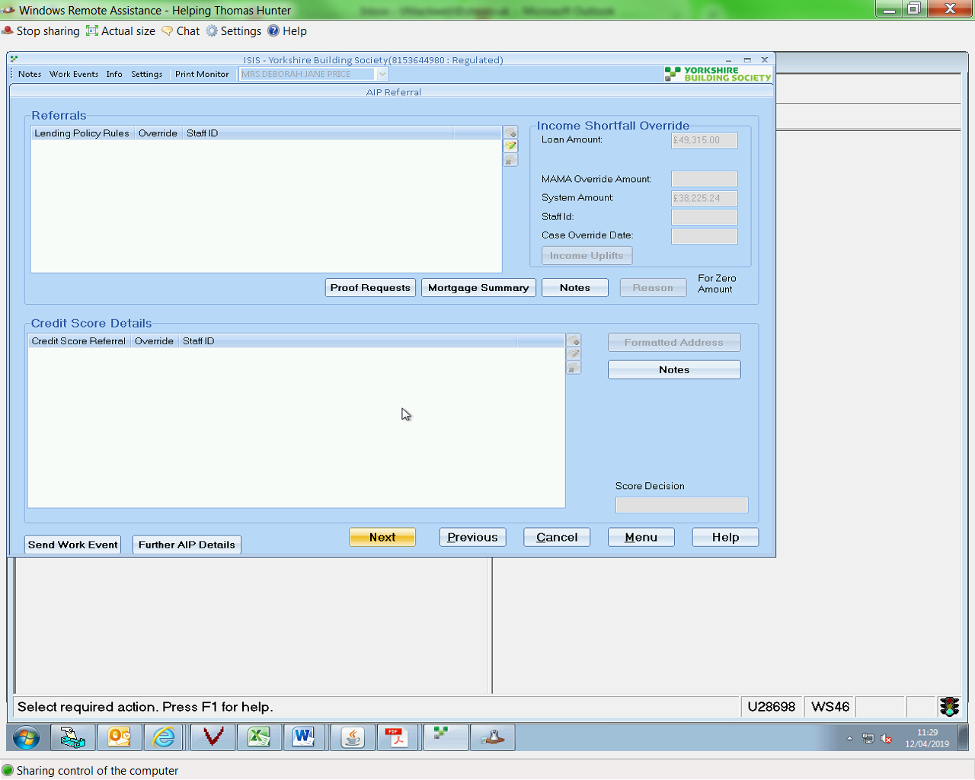

RD

Richard Durn

Work notes•

16-04-2019 09:43:35

Hi,   
  
Score decisions aren't generated for variation cases - only new mortgages.

select TH.LINK_APP_SYSID, TH.SYSID, TH.TRANSACT_NUMBER, TH.ACCOUNT_NUMBER, TH.ACCOUNT_TYPE, TH.SCORE_DECISION, TH.SCORE, TH.STATUS, TH.CALL_DATE, TH.CALL_TYPE, TH.RECORD_NUMBER, TH.PC_NUMBER, CSDT.DESCR

from TRANSACT_HISTORIES TH, CREDIT_SCORE_DECISION_TYPES CSDT

where TH.ACCOUNT_NUMBER=14208763

**INC0626423**

Details – Error message when trying to create a KFI on ISIS. When selecting top up amount, system advises you can't select this product for a non offset account however the account was previously offset

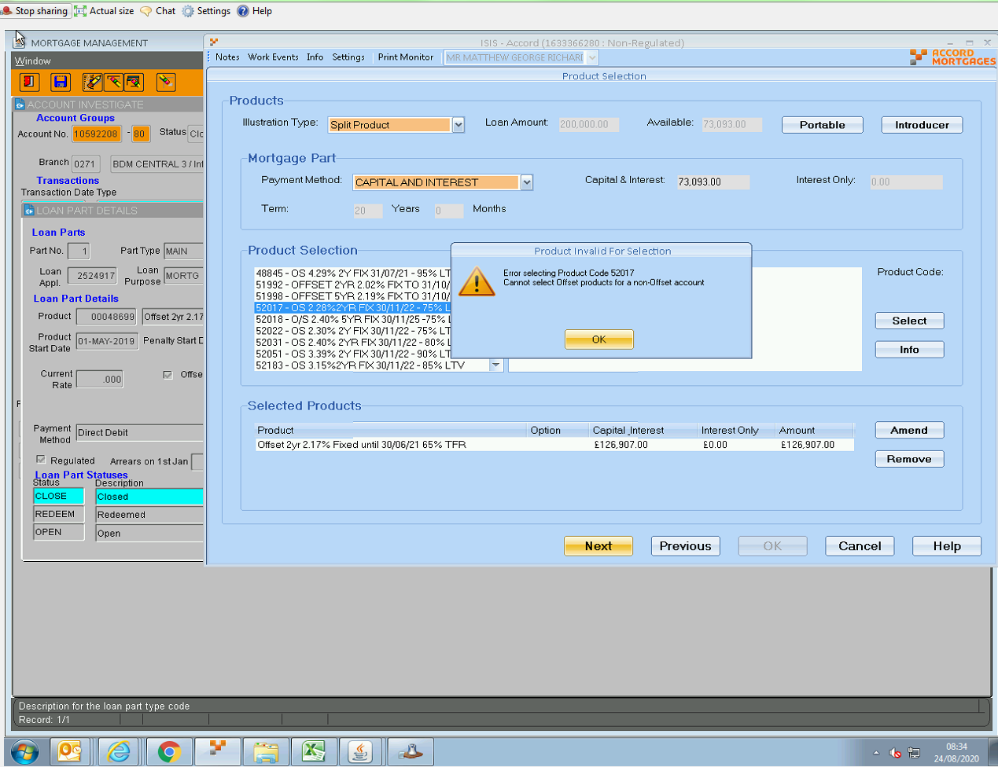

**Solution:**

I think they forgot to set the offset flag to **Yes** when illustrating

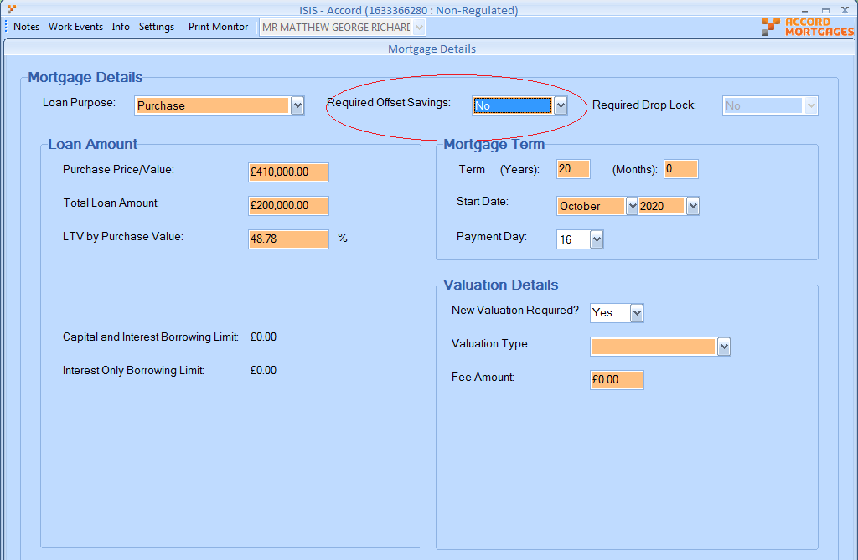

**INC0543495**

**ISIS - Portability Offset products not showing**

Details – Jane called advising that she is trying to Create a KFI on a Portability case, however when selecting Offset on the account and trying to select the product nothing is showing up when it should be qualifying for 2 products, 80648 and 80649. Jane has double checked everything is setup correctly which she confirmed it is, she advised when she has tried to select No for Offset some other products do appear so she is not sure why nothing appears when selecting Offset.

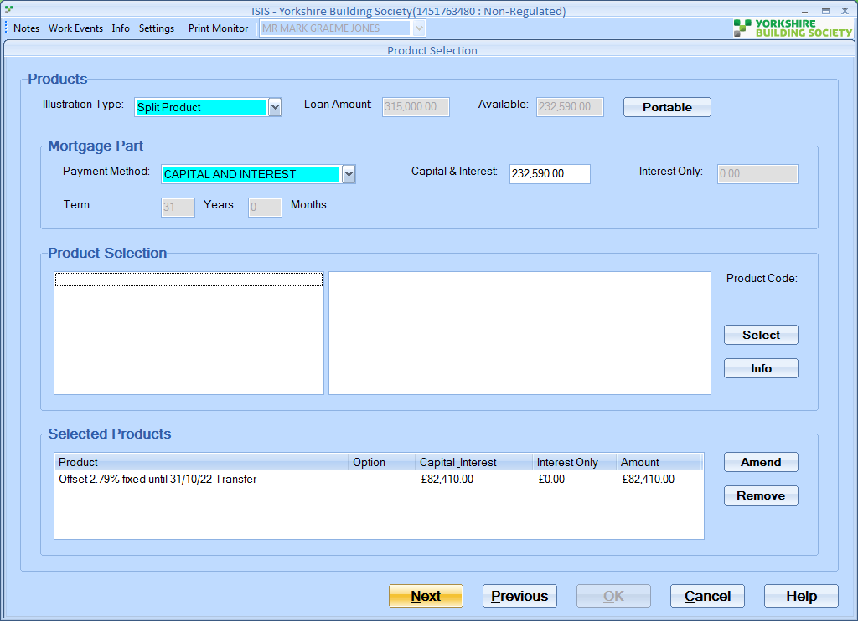

**Solution:**

On the enquiry details screen the property is set to New Build   
but the product has new_build_restriction = N   
so not eligible

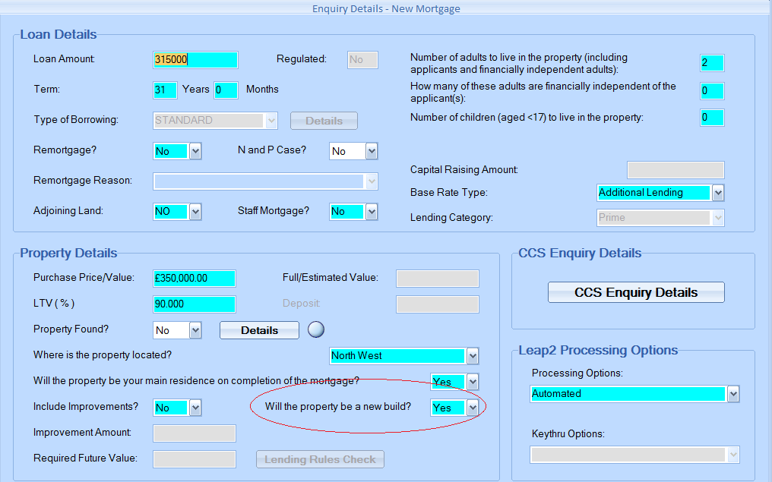

**INC0543646**

**ISIS - YBS - Illustration error - "lending Fees" - see attached**

Details – When trying to print off a illustration in ISIS, we are getting a lending Fee error appearing - see attached.

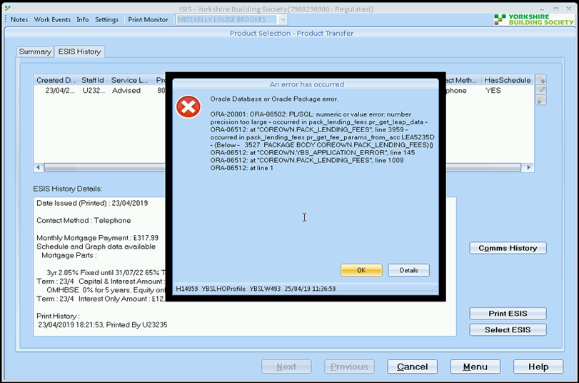

**Solution:**

//Mainline/setup_data/amendment_scripts/a9iss3252.sql

**Similar – INC0611873**

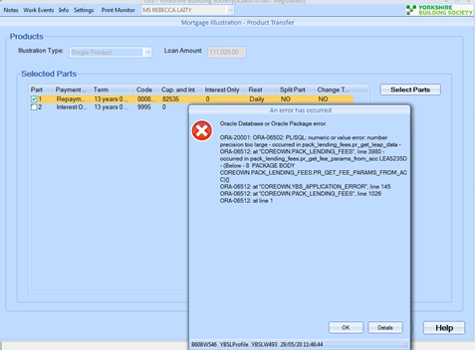

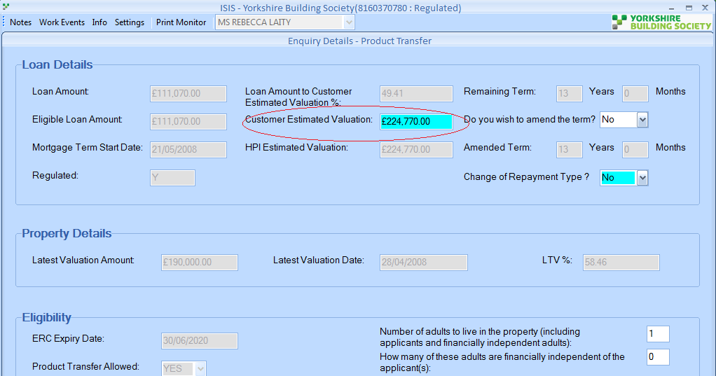

update lending_applications l

set l.purchase_price = set to valuation amount as above,

l.update_id = ls_this_name,

l.update_time = sysdate

where l.account_number = 14419365;

**Solution:**

//Mainline/setup_data/amendment_scripts/a9iss3453.sql

**INC0544334**

**Unable to Key application in ISIS - Oracle database or package error**

Details – Lydia called advising that she is trying to key into ISIS a broker additional loan, the KFI was done yesterday but when Lydia is trying to enter the information an error comes up on the screen saying Oracle Database or Oracle Package Error.

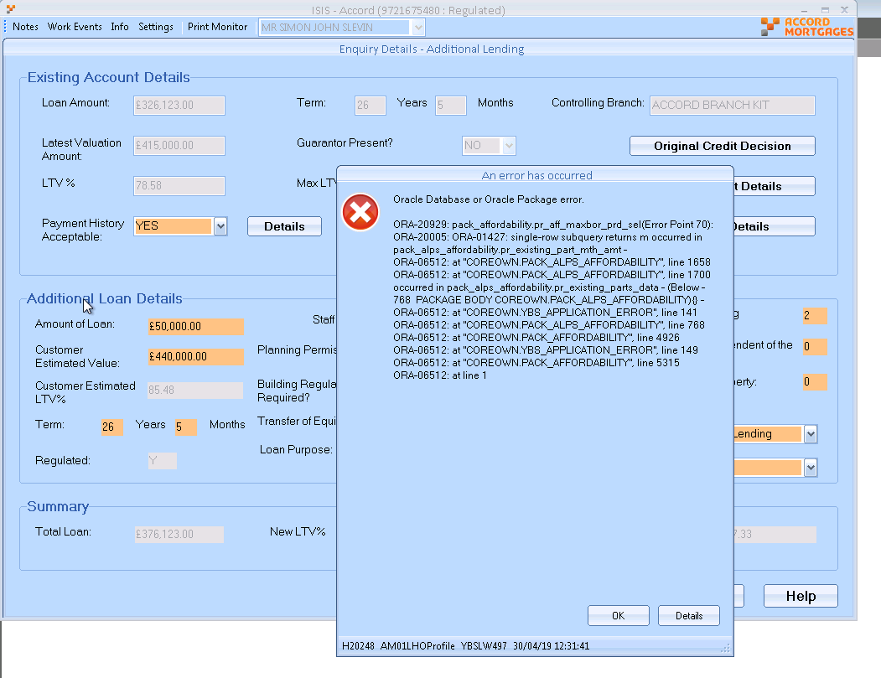

SELECT TRUNC(s.created_date)   
FROM sales_variants_details s   
WHERE s.lenvar_new_acc_no =   
(SELECT lv.new_lenapp_acc_no   
FROM lenapp_variants lv   
WHERE (lv.orig_lenapp_acc_no = cn_accgrp_num   
OR lv.orig_loanap_acc_no = cn_accgrp_num)   
AND RANK = (SELECT MAX(RANK)   
FROM lenapp_variants lv   
WHERE (lv.orig_lenapp_acc_no = cn_accgrp_num   
OR lv.orig_loanap_acc_no = cn_accgrp_num)));

Red selected query returning two values

**Solution:** //Mainline/setup_data/amendment_scripts/a9iss3255.sql

**INC0544850**

**Same as above. But for both rows has Rank = 1, so patch would not work.**

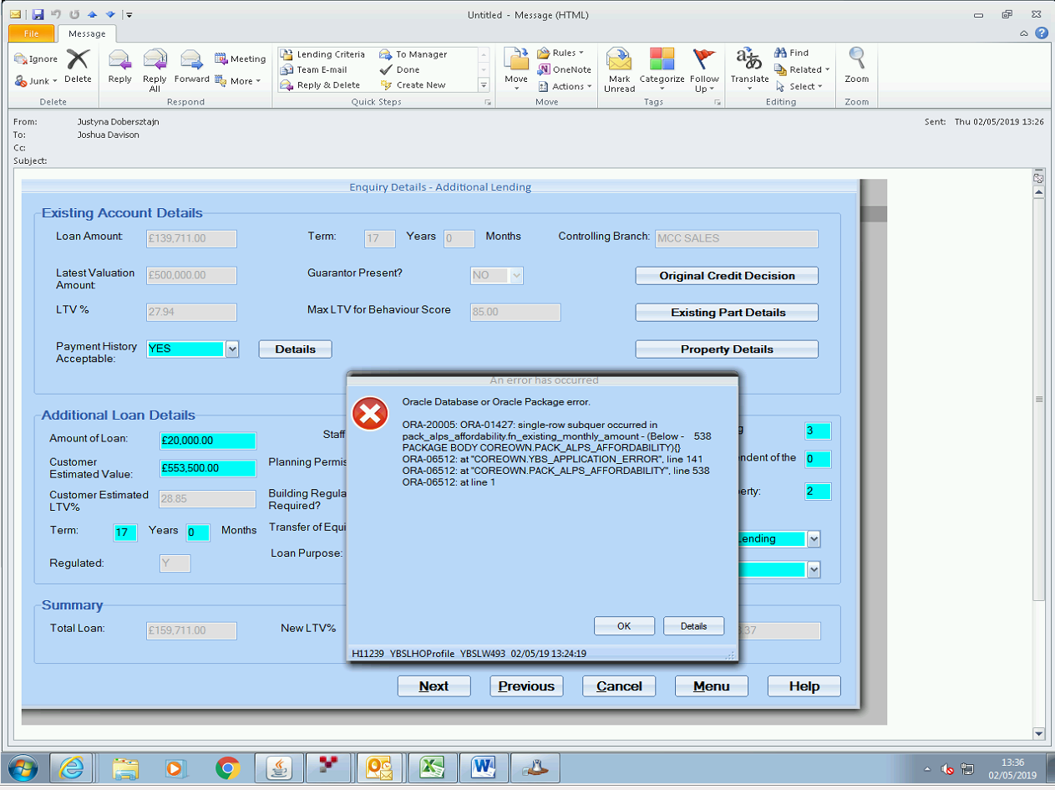

**The variation need to cancel and start again.**

**Latest Same Incident - INC0593498 – 11/02/2020**

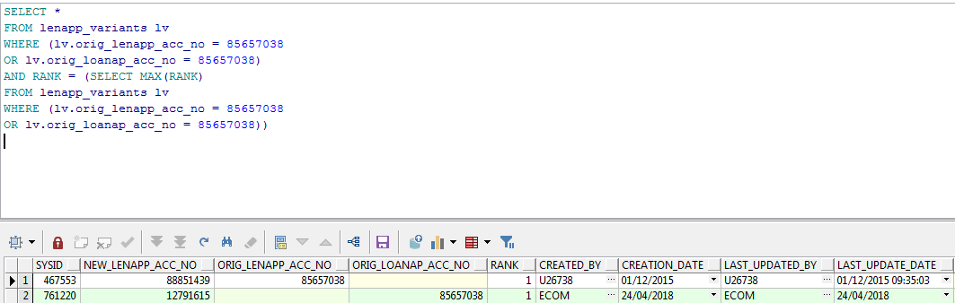

**Another Same INC0569887**

**Richard:** //Mainline/setup_data/amendment_scripts/a9iss3346.sql

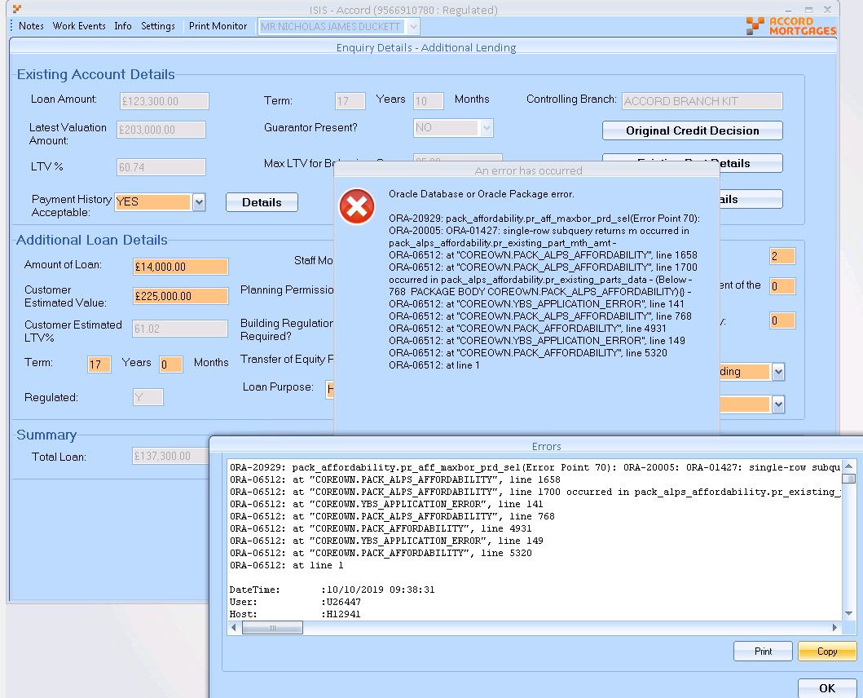

**INC0544590**

**ISIS - Can’t retrieve account information when porting**

Details – Gabby called as she is trying to do a porting case on an account that has been closed, it is with-in the 6 month window after closing so she should be able to do it but its saying the old account number doesn’t exist, can this be looked at please?

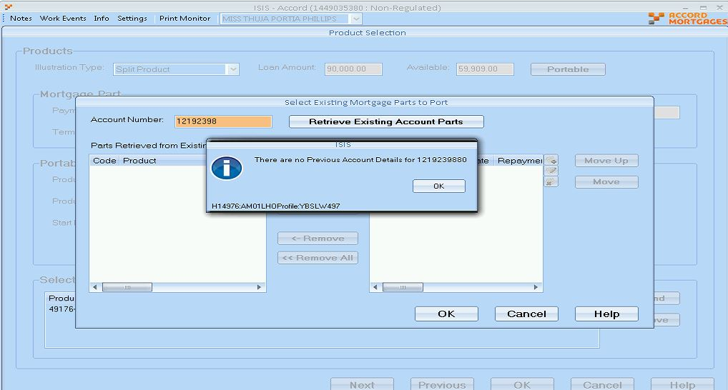

 pack_illustration.pr_get_existing_account_dtls doesn't bring any parts back

**INC0544067**

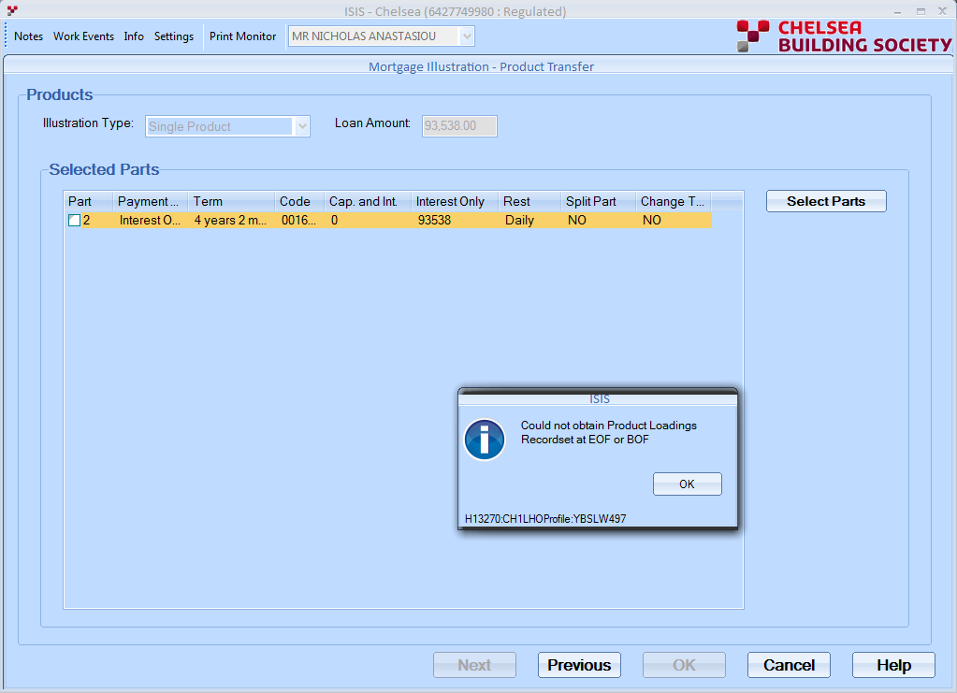

Patch //Mainline/setup_data/amendment_scripts/a9iss3256.sql

If above patch not work –

Hi,

The only workaround is to rekey the case.

Thanks,

Kamal

**INC0545030**

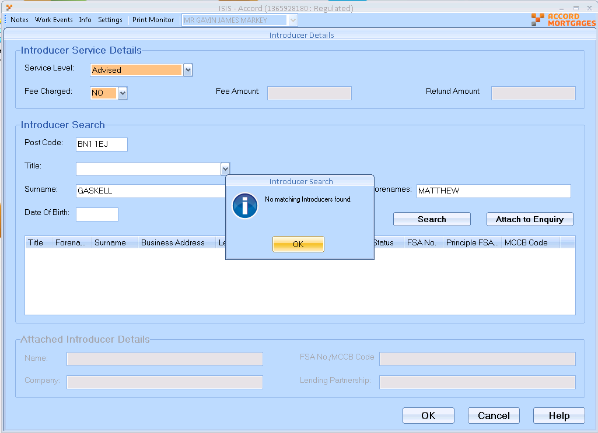

Select * FROm people person

WHERE person.surname LIKE 'GASKELL'

AND person.forenames like 'MATTHEW ALEXANDER NICHOLAS'

Select * FROm introducers introd WHERE introd.person_party_sysid = 6961938540

Select * FROM introducer_usages intusg WHERE intusg.introd_sysid = 569487

**Solution:** Introducer already ended.

SELECT *

FROM parties party,

lending_partnerships lenpnr,

postal_addresses pstadd,

address_usages adduse,

external_organisations extorg,

introducer_usages intusg,

introducers introd,

people person

WHERE person.surname LIKE 'GASKELL'

AND introd.person_party_sysid = person.party_sysid

AND intusg.introd_sysid = introd.sysid

*--AND intusg.ended_date IS NULL*

AND extorg.party_sysid = intusg.extorg_sysid

AND adduse.party_sysid = extorg.party_sysid

AND adduse.addfun_code = 'CORR'

AND adduse.pstadd_sysid IS NOT NULL

AND adduse.end_date IS NULL

AND pstadd.sysid = adduse.pstadd_sysid

AND lenpnr.sysid(+) = intusg.lenpnr_sysid

AND lenpnr.end_date(+) IS NULL

AND party.sysid(+) = lenpnr.extorg_sysid

**INC0545608**

**ISIS - Unable to enter net payment when linking offset saving account**

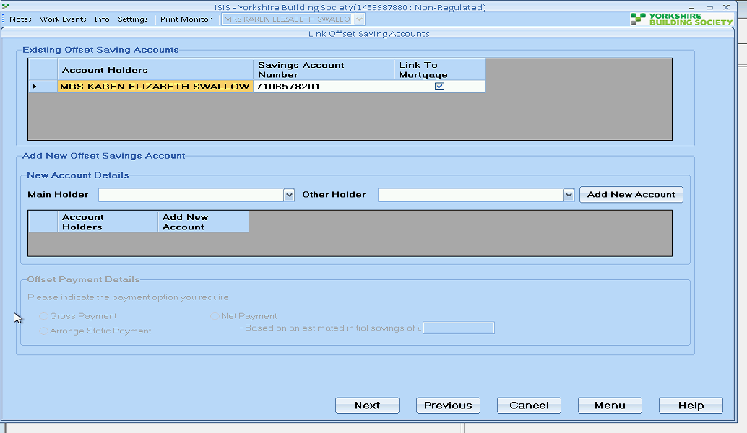

RD

Richard Durn

Work notes•

09-05-2019 15:18:13

Yes, it's only available when a new account is created.

**INC0545932**

**ISIS - Accord - when loading up for a existing customer product transfer 1088704680**

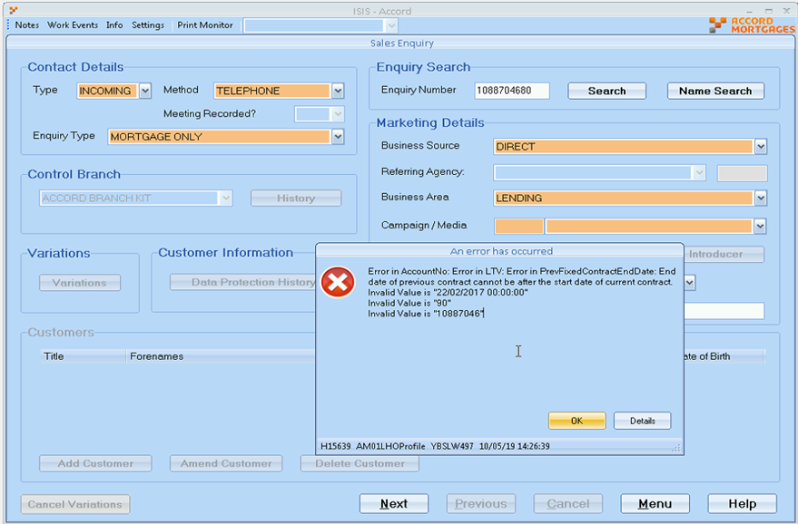

**//Mainline/setup_data/amendment_scripts/a9iss3260.sql**

**INC0547336**

**Details – Matthew called as she is trying to do a Product Transfer for a customer on ISIS but when he tries to get passed the screen attached he gets the error message shown, can this be looked at please?**

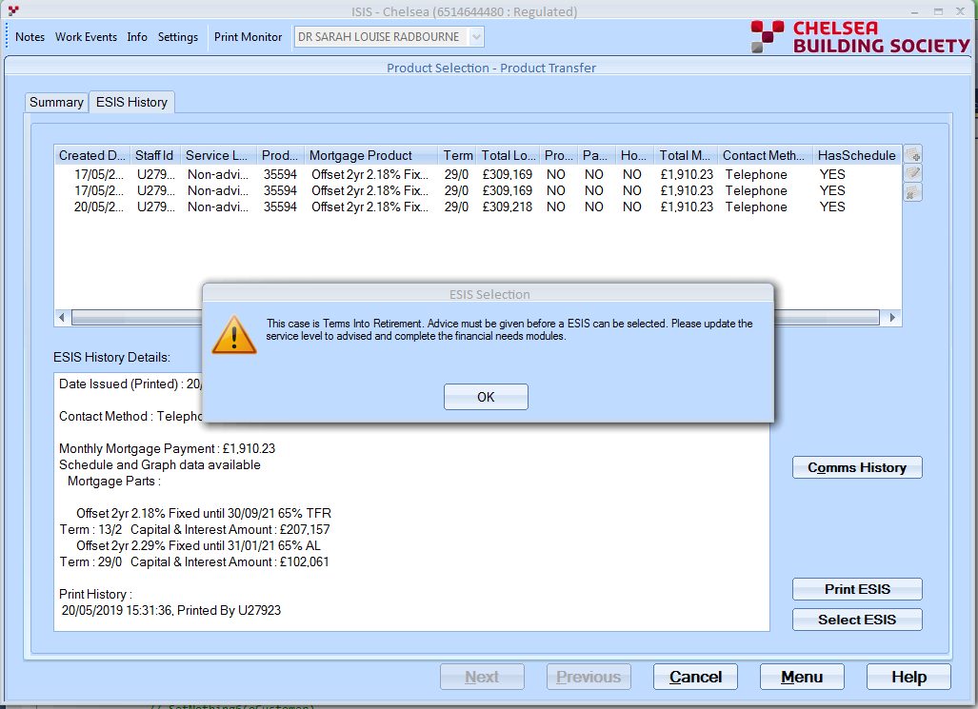

SC

Sally Carney

Additional comments•

21-05-2019 13:57:05

6514644480   
The warning message re TIR is correct.   
The system uses the whole mortgage term not just the part being transferred. In the Enquiry Details - Product Transfer screen the system is using the term on part 2 of 29 years. The borrower has declared she will retire at the age of 67 which is 21 years 6 months therefore will be into retirement.   
You will need to complete the advice screens.   
Regards   
Sally

RD

Richard Durn

Work notes•

22-05-2019 10:58:19

Yes, the case is TIR due to part 2 of the mortgage, so as per the ISIS logic the case needs to be advised. If this logic is no longer required, it can be changed via the Demand Portal.

**INC0548940**

**ISIS YBS Application showing Closed - By Systemn**

Select * FROM SALES_ENQUIRY_ACTIONS

Where ENQ_REF_NO=2237334 and

Nvl(ENDED_DATE, sysdate) >=sysdate

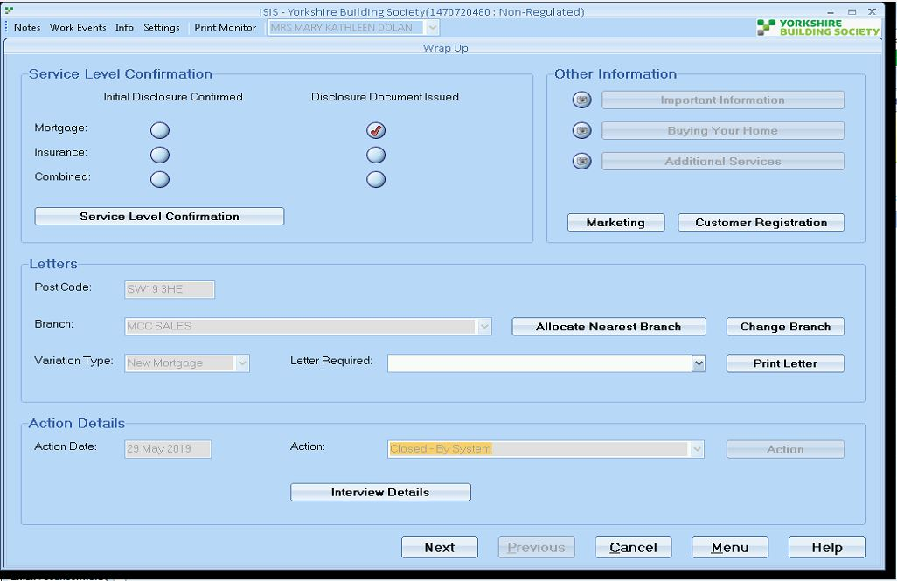

**Solution:**

**//Mainline/setup_data/amendment_scripts/a9iss3274.sql**

**------------------------------------------------------------------------------------------------------------------------------------------------------**

**INC0549127**

**ISIS ACC 1% loading not applied**

RD

Richard Durn

Additional comments•

31-05-2019 14:56:10

Hi,   
  
There's an ongoing issue where loadings don't apply at the end of the month. This should resolve itself from tomorrow.

**INC0551123**

**ISIS not deleting details**

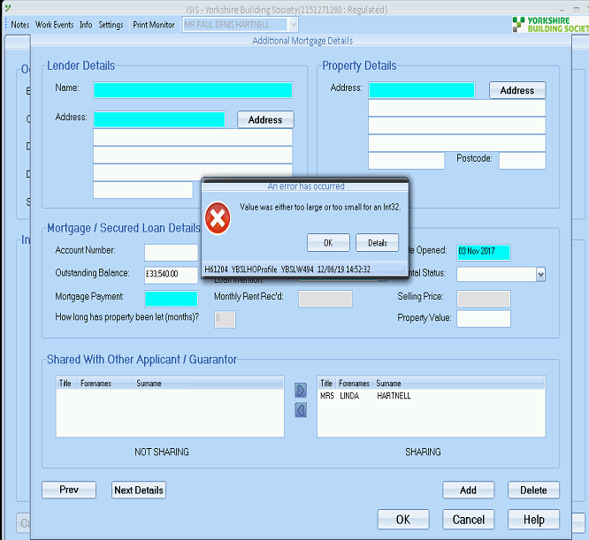

**Fix:**

 //Mainline/setup_data/amendment_scripts/a9iss3280.sql

**INC0550907**

**Additional loan & T of E on the AL it has brought through the existing deal but not the brought through the AL on the AL app form**

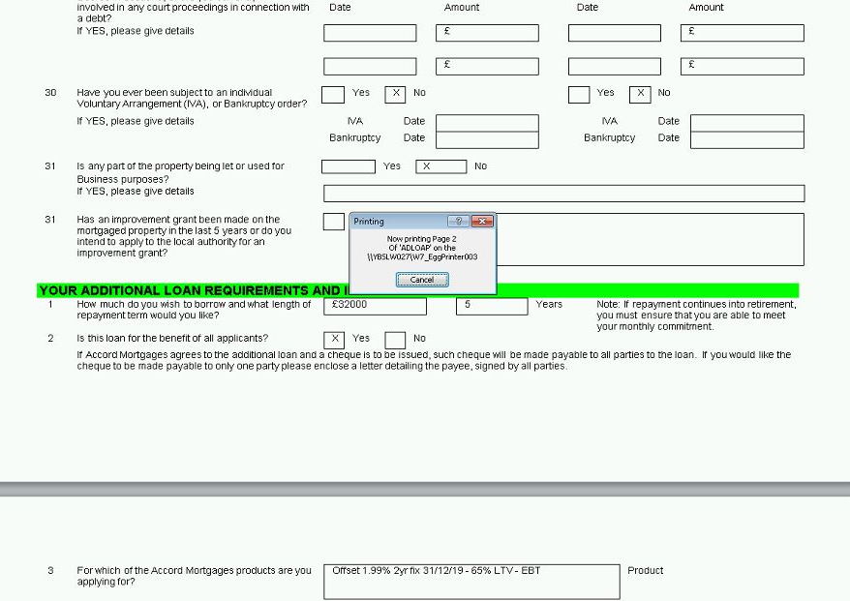

**Solution:** //Mainline/setup_data/amendment_scripts/a9iss3282.sql

**INC0551482**

ISIS -Issue running credit score on application

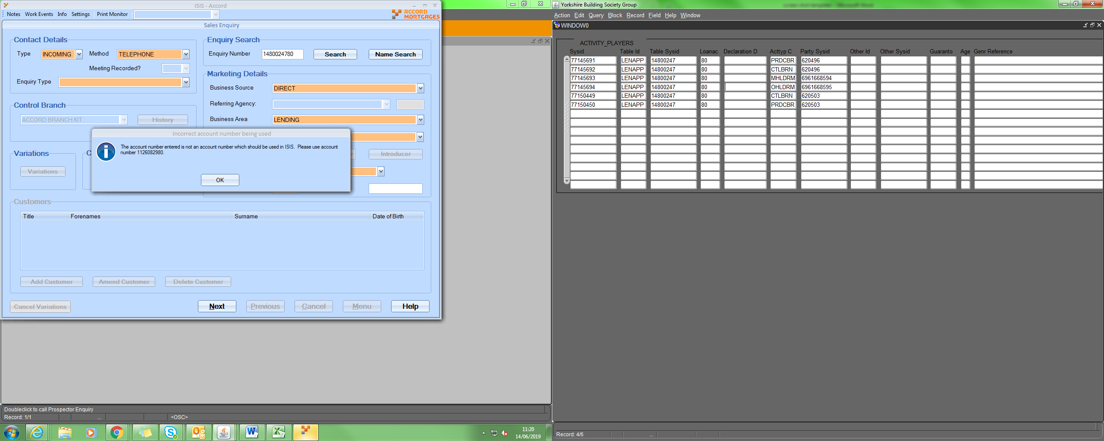

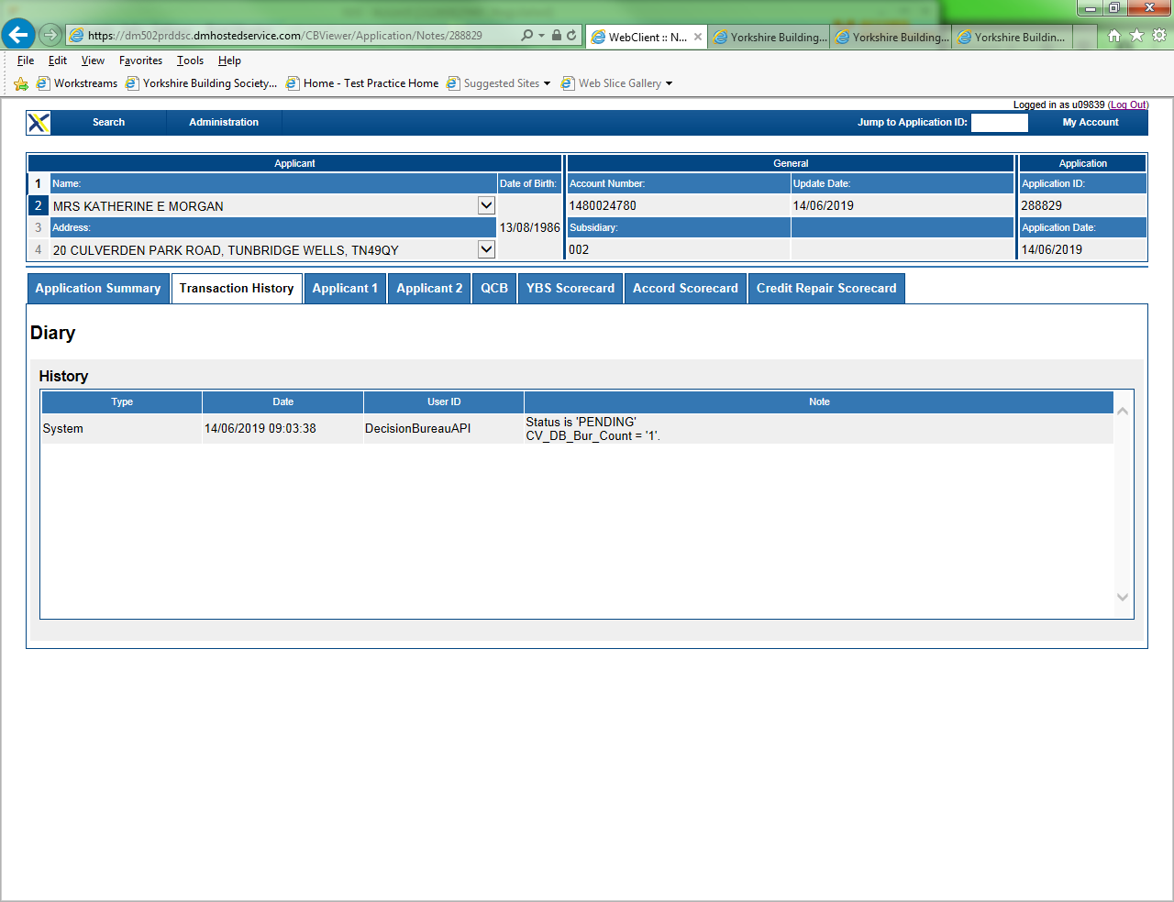

Hi,

It looks like there was a DM outage, then the credit check was rerun on Friday, but bureau doesn't return credit data.

Need to amend some of the AIP data and then rerun.

Hi Maria,

They need to rebureau the case.  Sally said this to the user on 17/6 but the user didn’t understand.

What I would do on this case is:

* Amend applicant 1’s date of birth by one year in ISIS
* Run the credit check
* Amend the date of birth back
* Run the credit check again

Thanks,

Kamal

**INC0552258**

**candled new deal on ISIS in error**

If they cancelled the additional loan app in ISIS I believe they would need to start a new variation - is that correct?

Answer: Yes they have to do re-variation again.

**INC0552570**

ISIS - correct products are not showing

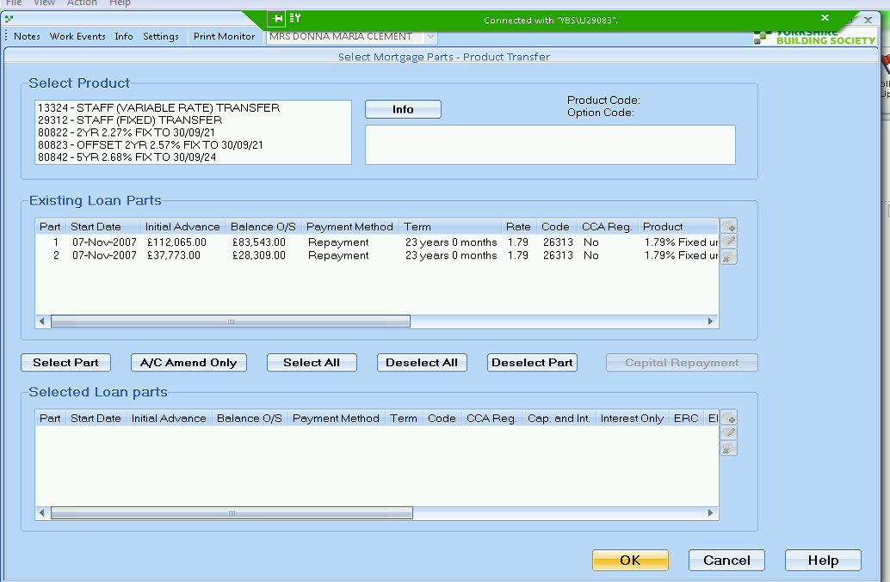

**Details – ISIS - correct products are not showing**

**the case meets the parameters of product but isnt showing**

**product code: 80807**

**a additional loan was on which had it at 84% but that has now been remoted and its taken 64% so she should be able to add the product but isn't coming up**

select *

from SALES_VARIANTS_DETAILS

where LENVAR_NEW_ACC_NO=14805303

and Nvl(END_DATE, sysdate) >=sysdate

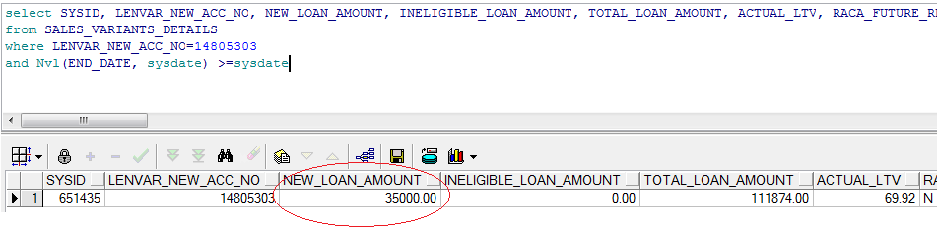

**Patch: //Mainline/setup_data/amendment_scripts/a9iss3286.sql**

**INC0553785**

**Product Transfer - asking for a valuation**

**Details – Unable to complete PT as asking for a val. This is due to customers initially wanting a AL but have since changed their minds and only want a PT.**

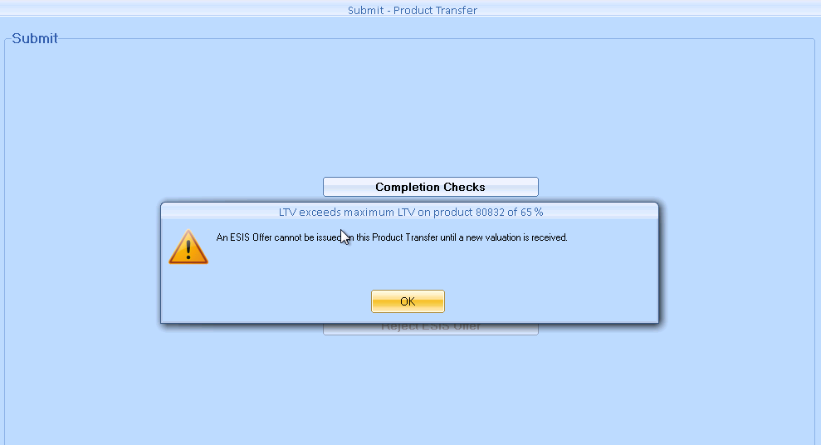

select *

where LENVAR_NEW_ACC_NO=14867155

and Nvl(END_DATE, sysdate) >=sysdate

Solution: Set NEW_LOAN_AMOUNT = 0

**Patch: //Mainline/setup_data/amendment_scripts/a9iss3292.sql**

**INC0554702**

**ISIS - Enquiry record not found**

**Details – Was able to search fine for case half an hour ago, comes up fine in all other apps, has now just decided it cant be found in ISIS gets error attached**

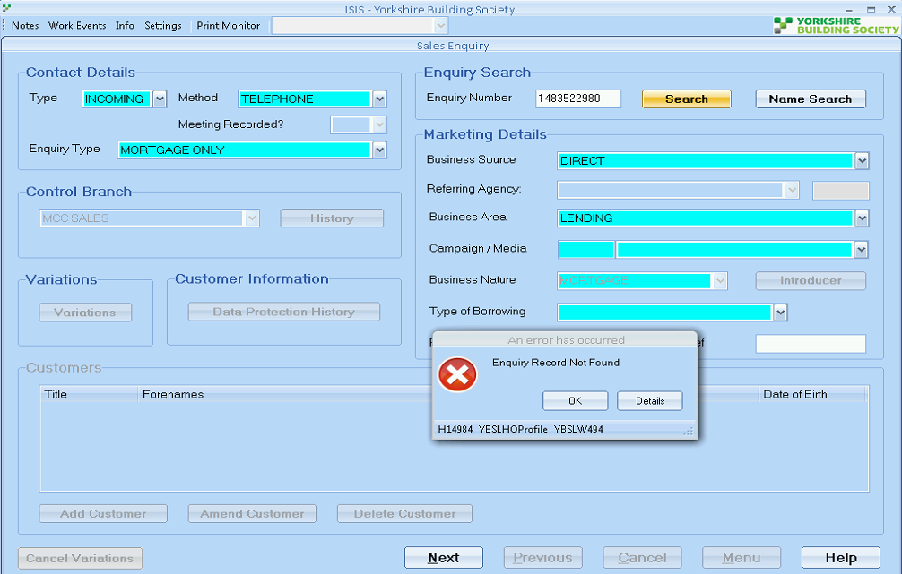

1. select * from sales_branch_history s where s.account_no = 14835229

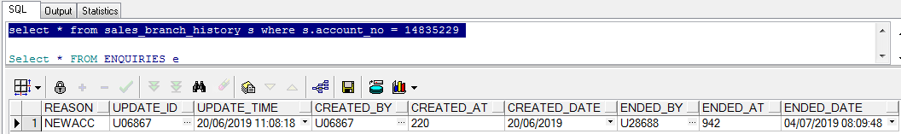

Remove Enddate

Patch: //Mainline/setup_data/amendment_scripts/a9iss3295.sql

1. Sometimes This Error Appears because of *ENQUIRIES* table contains the parent account instead of variation account.

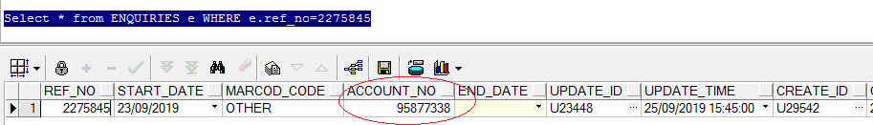

Solution : //Mainline/setup_data/amendment_scripts/a9iss3330.sql

1. Sometimes Case not imported into ISIS, you can get the record in activity_players but not in *ENQUIRIES and other*

Like - INC0596195

select * from v_ecomm_application v where v.APPLICATION_NUMBER = '1564358780'

**INC0555143**

**ISIS - number precision too large**

**Details – Unable to apply product transfer - receiving "number precision too large" error**

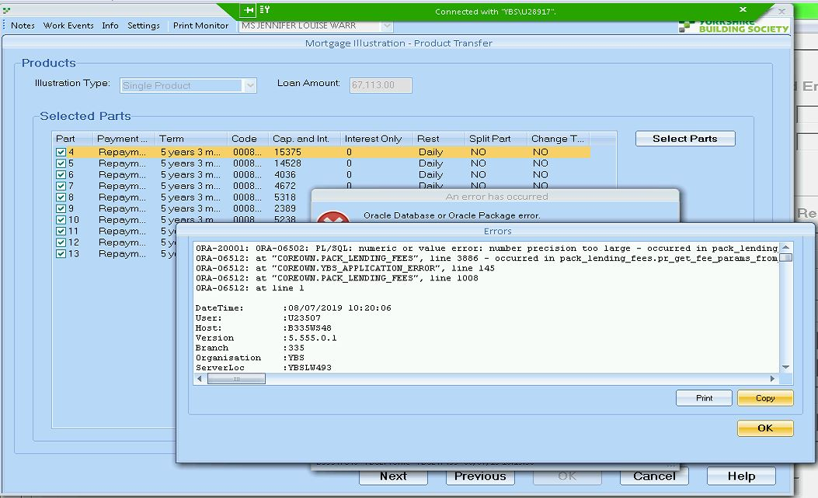

**In this case table contains unnecessary records of history with end date, so need to remove.**

**Patch :** //Mainline/setup_data/amendment_scripts/a9iss3298.sql

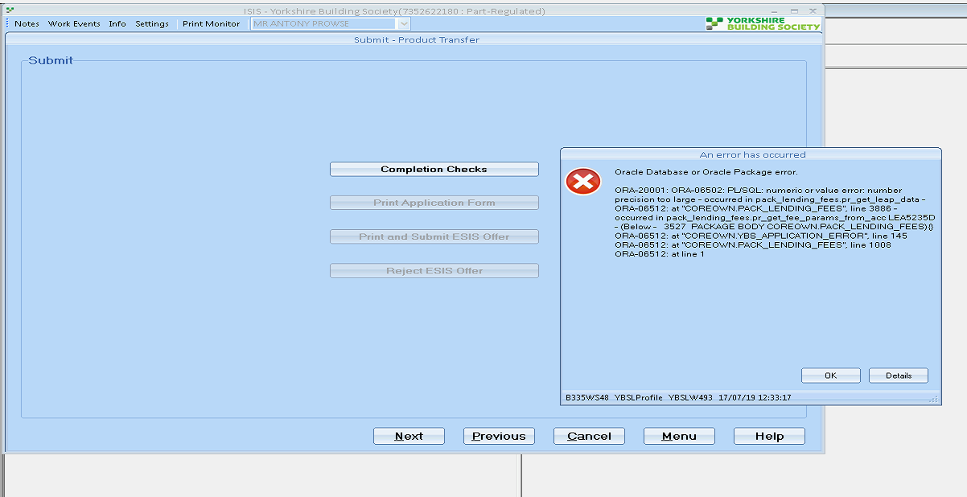

//Mainline/setup_data/amendment_scripts/a9iss3298b.sql

**INC0556231**

**ISIS - error when opening account details**

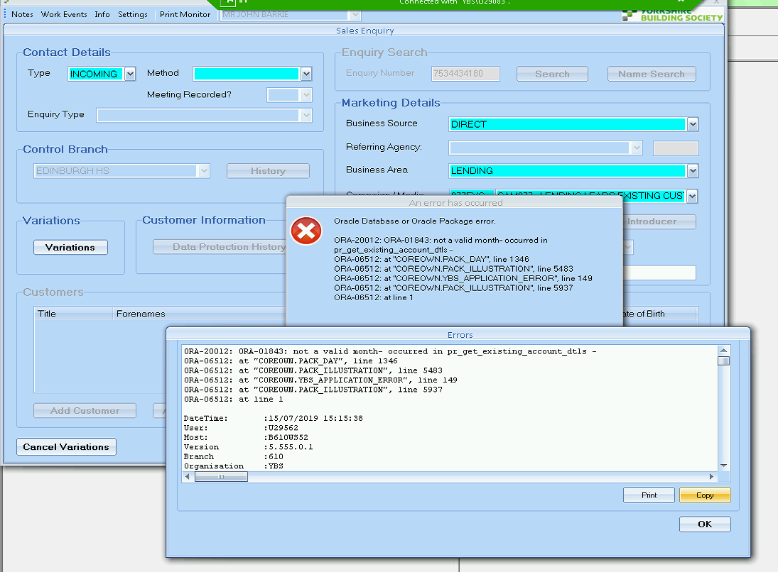

RD

Richard Durn

Work notes•

17-07-2019 09:24:02

Part 8 was recently created for this account but there's no payment set up! Would you be able to get one created? It might not fix the issue 100% (we might have to fiddle around with dates afterwards) but it's definitely required.

**Check Payment setup in**

select *

from coreown.expected_payments

where loanac_accgrp_num = 75344341

and nvl(end_date, sysdate) >= sysdate

**INC0556702**

**New application can not complete credit check**

**Details – When trying to complete a New mortgage application it will not run the credit check - when try and do this it errors.**

**On LIVE have 2 address on the system yet on ISIS only has one.**

**Antony has the current address of sunny side (moved 7 months ago into daughters and changed passport and driving licence)**

**Andrea has the current address of hawthorn**

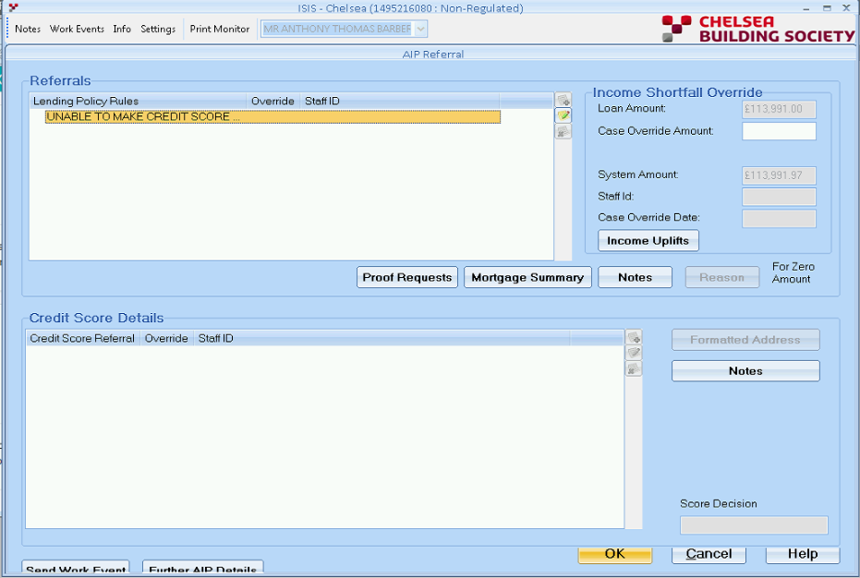

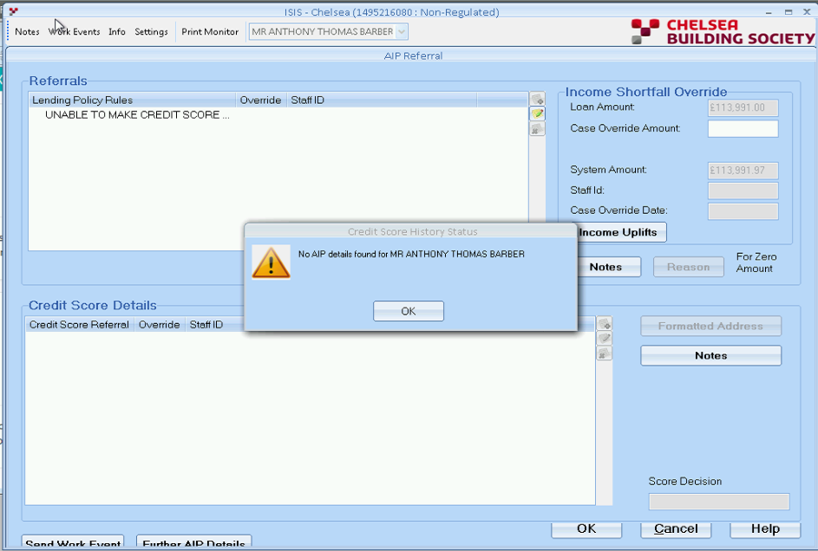

**Hi,**

**Invalid Message Returned From Transact. Reason = TRANSACTION CP70 MODULE RCCDL002 SAME CURR AND PREV1 ADDRESS (Err No: 63).**

**Due to same address exist twice in the system, therefore, equifax can't cope with it.**

**Please assign it to service desk to remove the duplicate address.**

**Thanks,**

**Kamal**

**INC0557654**

**Urgent please - Isis - Need to amend system to allow extra funds after 4mths with ybs.**

Mortgage account has been opened for less than 6 month

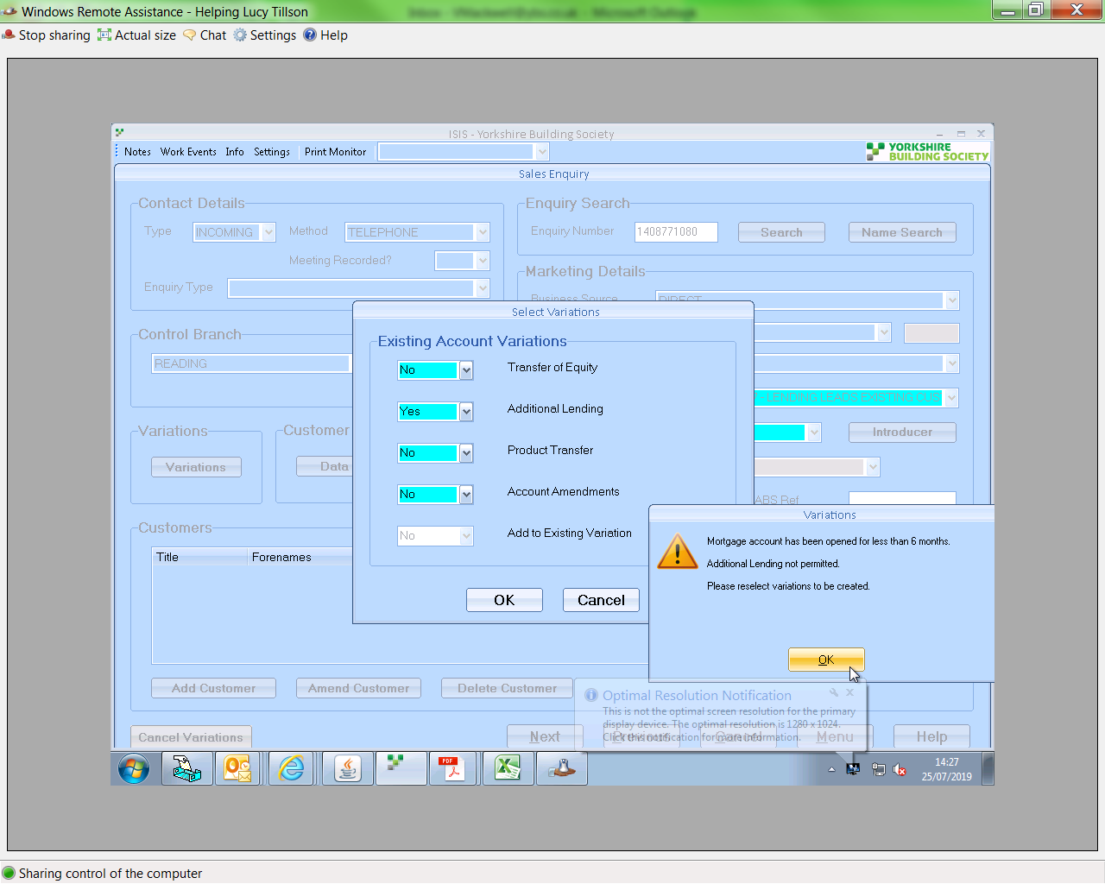

//Mainline/setup_data/amendment_scripts/a9len3521.sql

**INC0558642**

**ISIS trying to submit a case and note says referrals exist**

**Recent similar Incident - INC0593045 – 11/02/2020**

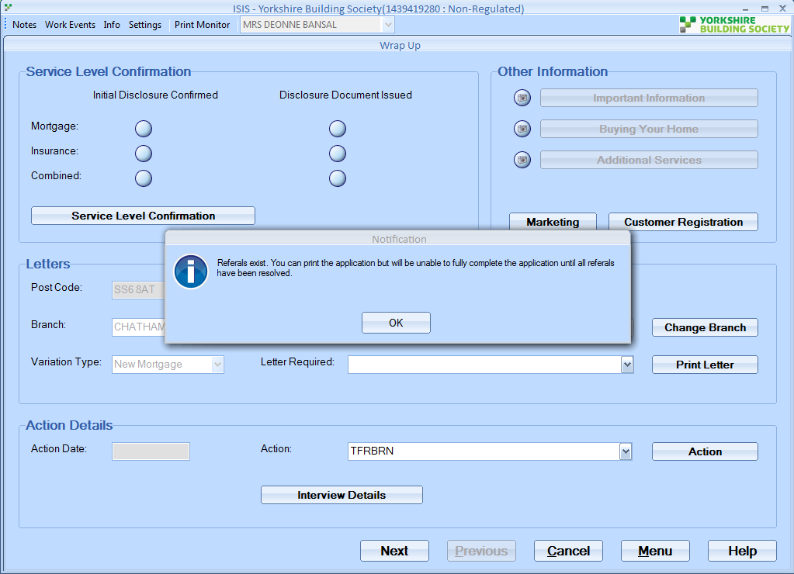

select t.aip_check_successful from SALES_ENQUIRY t

where t.enq_ref_no = 2214725

Solution: //Mainline/setup_data/amendment_scripts/a9iss3307.sql

**INC0559859**

**Missing product in ISIS**

**Details – Trying to add a top up product in ISIS and it is missing product: 35728**

Select * FROM lenprd_suitability_options lso WHERE lso.lenprd_product_code = 35728

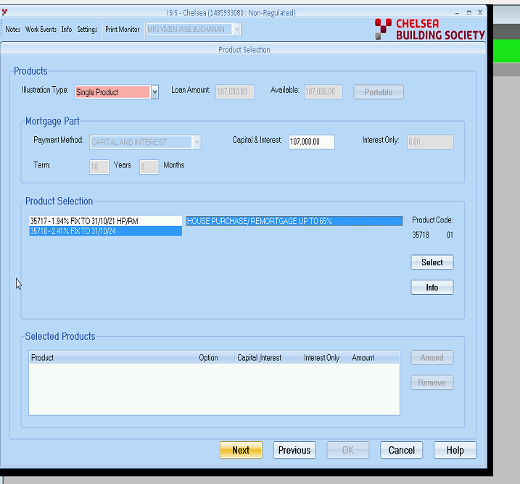

RD

Richard Durn

Additional comments•

08-08-2019 14:49:20

Hi,   
  
The issue with this case is that the maximum loan amount for the product is £100,000, and the loan amount for this case is £107,000. I know the amount which needs to go on this product is less than £100,000, but unfortunately the system doesn't work that way. You will need to contact Product Development and get them to temporarily increase the maximum loan amount for the product. This will allow you to do the illustration.

**--------------------------------------------------------------**

**INC0559815**

**Cant find broker on ISIS so cant offer case**

**Details – Phil called as had a broker that did a product transfer online but then wanted a different product so Phil said they agreed that if the broker cancelled this they would give him a different product so now they are trying to offer the second one but the broker wont show up on ISIS system even though he did before on the first offer and hes still showing in YBS Live. Can this be investigated.**

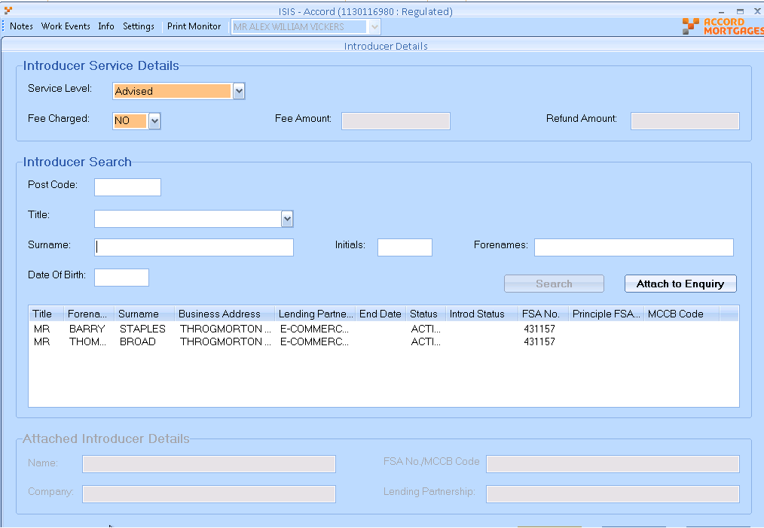

**Solution:**

[‏15/‏08/‏2019 11:13]  Richard Durn:    
phil is confused ^_^   
a broker ended in core shouldn't be visible in isis   
    
[‏15/‏08/‏2019 11:14]  Kamal Batham:    
ok, then what to do with this incident?   
    
[‏15/‏08/‏2019 11:15]  Richard Durn:    
assign it back to Jill saying the broker shouldn't appear

**INC0560223**

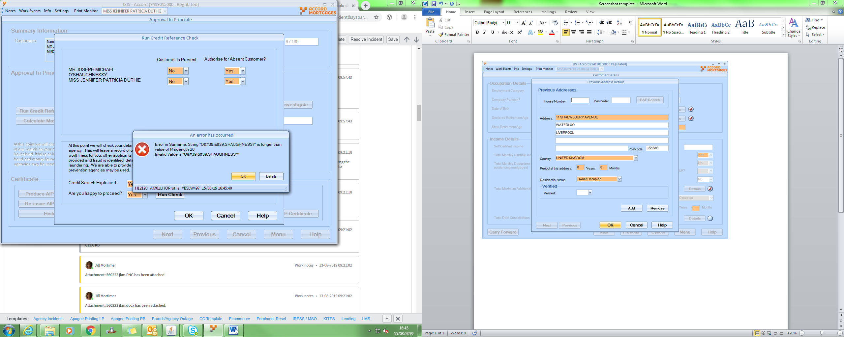

Similar INC0626589

Richard Durn

Work notes •

16-08-2019 13:19:51

Hi Jill,   
  
This is an issue with how DM picks up the data from the bureau. I think they had something in to fix at some point...but they're not a very good company. If we can get evidence of a manual credit check, we can patch the case to fudge it through.

**INC0599792**

**ISIS - Error message when running an AIP**

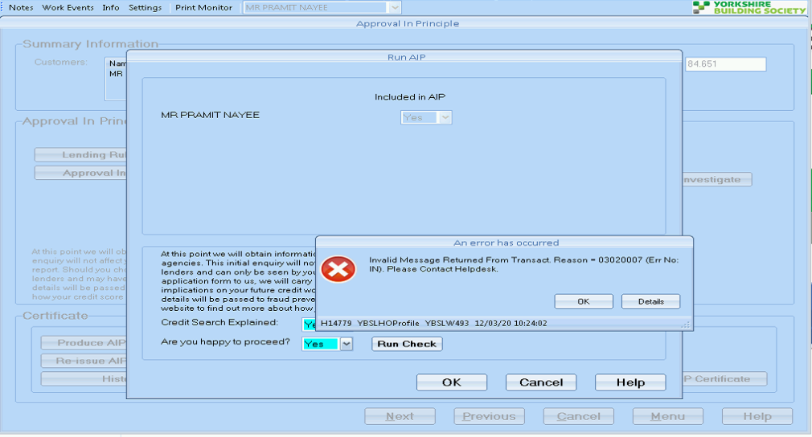

The credit check was run around the time there was a system outage.

RD

Richard Durn

Work notes•

13-03-2020 10:19:36

Hi Sally,  
  
I think there's a couple of cases which attempted a credit check during the outage and are still failing. Would you be able to amend some data to force a rebureau on this case?

**INC0560964**

**ISIS - "Root element is missing" when performing credit check**

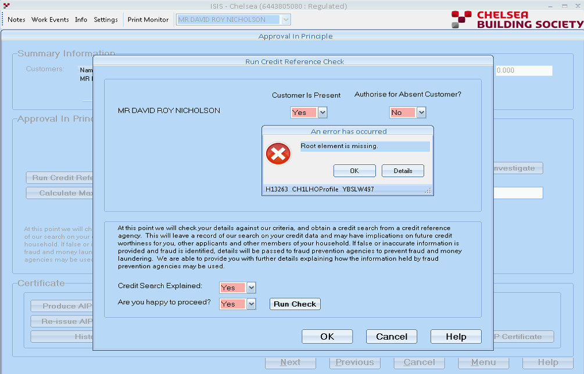

RD

Richard Durn

Work notes•

16-08-2019 16:29:36

Hi Jill,   
  
The zero balance is causing some weird problem in the credit check logic. Can we get a temporary balance on the account?

Jill Mortimer

Additional comments•

16-08-2019 16:34:41

Account 6443805080 - the error message is received as there is a nil balance on the account therefore ISIS cannot calculate an LTV. You will need to contact Mortgage Service and ask them to make a refund so that a balance of £105.00 remains on the mortgage account. Once this has been done you should be able to progress the additional loan application.

**-----------------------------------------------------------------------------------------------------------------------------------**

**INC0560931**

**Prod tfr on ISIS and gets to the end the system freezes and come up error timed**

**Also see INC0561020 same issue.**

**Details – Prod tfr on ISIS and gets to the end the system freezes and come up error timed out**

**She has logged out of isis and when she gets back to the end to print and submit the forms it does the same thing**

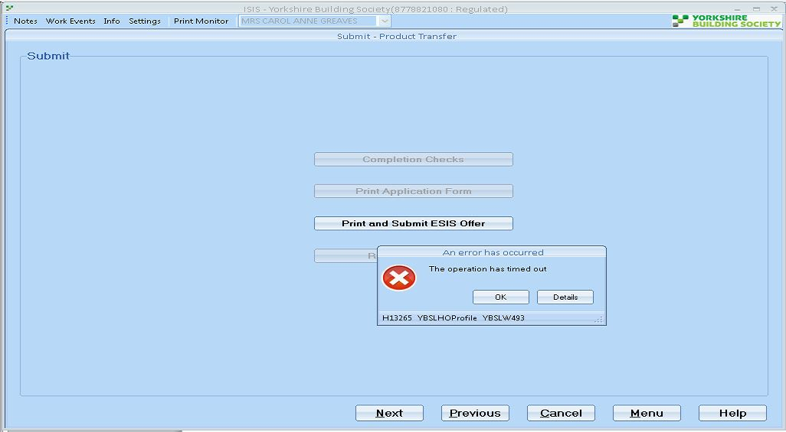

RD

Richard Durn

Work notes•

19-08-2019 11:41:57

We think this has been fixed now – we reversed the migration of the APPOFP document (until we can get a change into ISIS to support it). Am I ok to resolve the parent incident or do we have to do some ringing around etc?

**INC0559815**

**Can’t find broker on ISIS so can’t offer case**

**Details – Phil called as had a broker that did a product transfer online but then wanted a different product so Phil said they agreed that if the broker cancelled this they would give him a different product so now they are trying to offer the second one but the broker won’t show up on ISIS system even though he did before on the first offer and has still showing in YBS Live. Can this be investigated?**



**Solution:** //Mainline/setup_data/amendment_scripts/a9iss3313.sql

**INC0560218**

**ISIS - Payment reduced when rate increased query**

**Details – Prod tfr on ISIS putting them on a higher interest rate, but the mthly payment is coming up as lower which she does not feel is correct given the rate has increased, can this be checked**

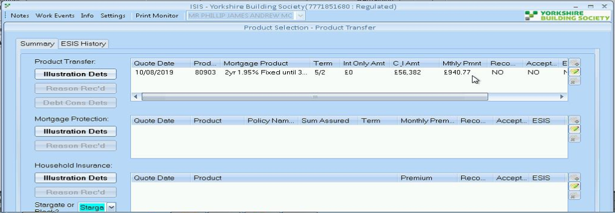

**Solution:** Try toreload the illustration; it might give the correct figure

**INC0562024**

**ISIS - error returned from Transact API**

Error returned from Transact API interface. Error code = 528 (050#)

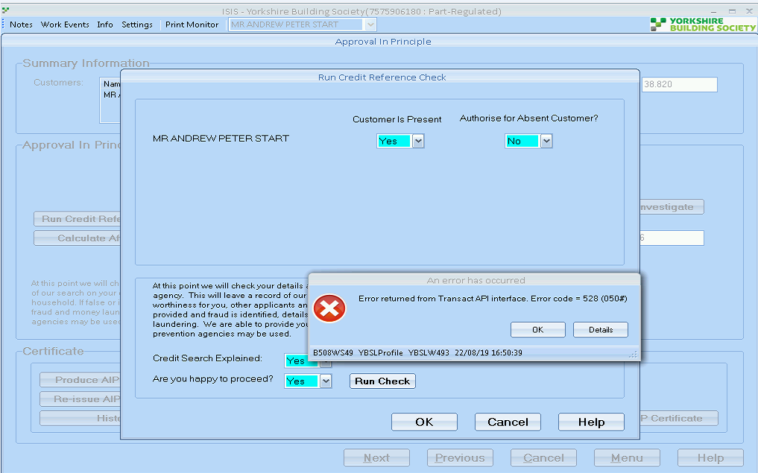

**INC0562177**

**ISIS - Not producing maximum borrowing figures 9625260980 ( INC0562818)**

**Details – Working through an additional loan on ISIS and once getting to the end it is not producing maximum borrowing figures**

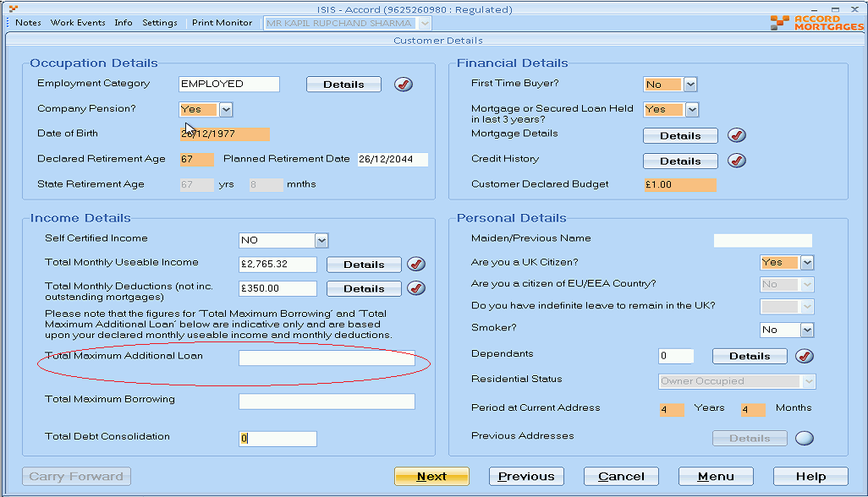

RD

Richard Durn

Additional comments•

02-09-2019 11:51:17

Hi,   
  
The reason this doesn't work is that the additional loan has been added to the product transfer after the product transfer has been submitted to Core. Unfortunately the system will not calculate Affordability on the screen in this scenario.

**INC0562637**

**Isis - Ybs - Incorrect saving details on application – 1511377480**

**Details – The customer has been in touch after receiving the application form in post and they have noticed that under Saving amounts for Mr the figures are incorrect , as they application form stated :-**

**Mr £40500.00**

**When looking at the attached screen shots of the system details , it is clearly show the :-**

**Mr - £6200.00**

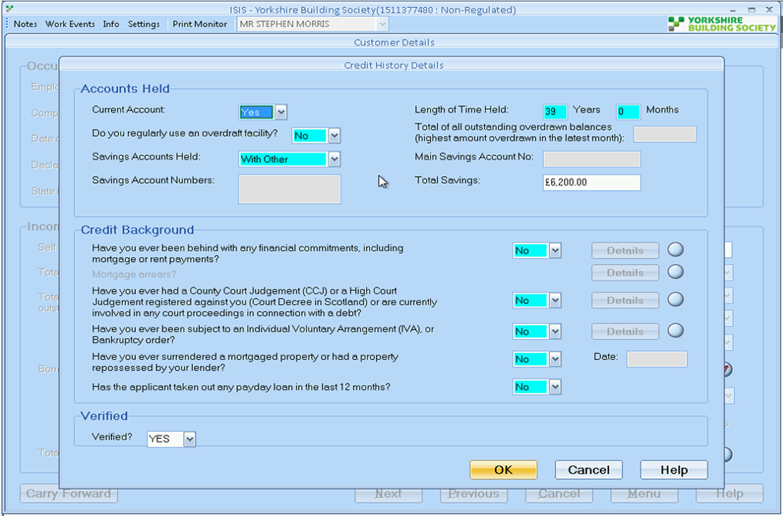

**Solution:** search sales_app_parties using the party_sysid instead of the account number

**//Mainline/setup_data/amendment_scripts/a9iss3317.sql**

**INC0563608**

**ISIS - Illustration not Printable with error message**

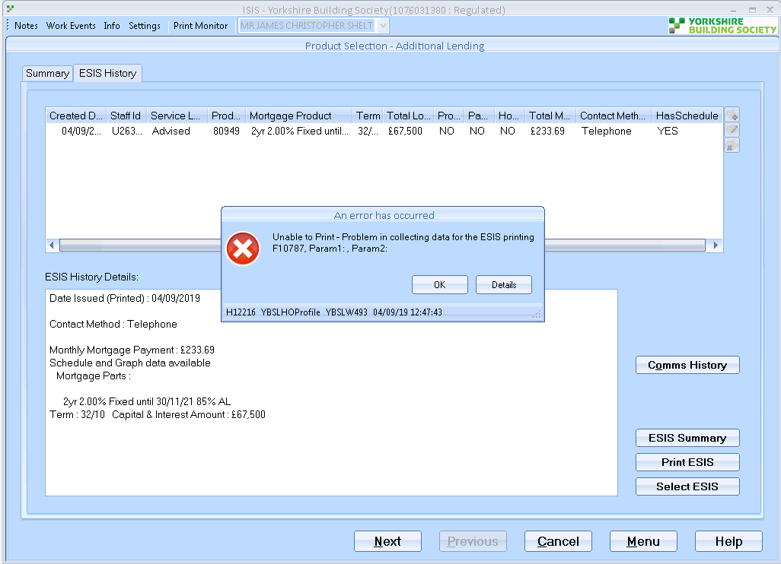

**Similar Incident but Different Case:** INC0609523

**INC0565072**

**ISIS - unable to select product**

**Details – Unable to select product - error stating the amount is less than the minimum for the product. Product Development have advised that this should not be occurring as another part on the same mortgage has the same product selected**

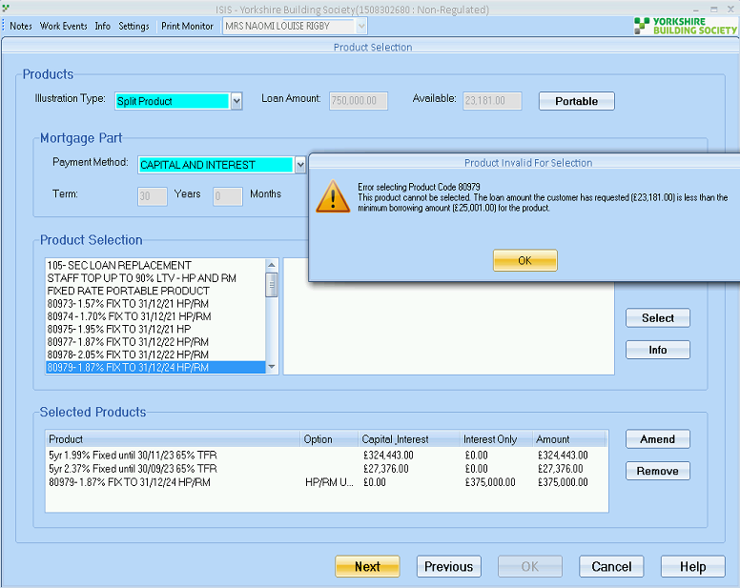

**Hi,**

**It's a free valuation product. The min loan amount needs to be changed on this product to get the product on. Further on this change, if you stayed on the screen, it wouldn't have been reloaded. So case needs to be reloaded in ISIS.**

**Thanks,**

**Kamal**

**INC0565908**

**Isis - Accord - Submitting to Leap issues - " Rechecking for AIP to be resubmitted"**

**Details – Trying to submit to leap , but not allowing them to do so " Rechecking for AIP to be resubmitted", this case has now been rekeyed 2 times as was getting the same message.**

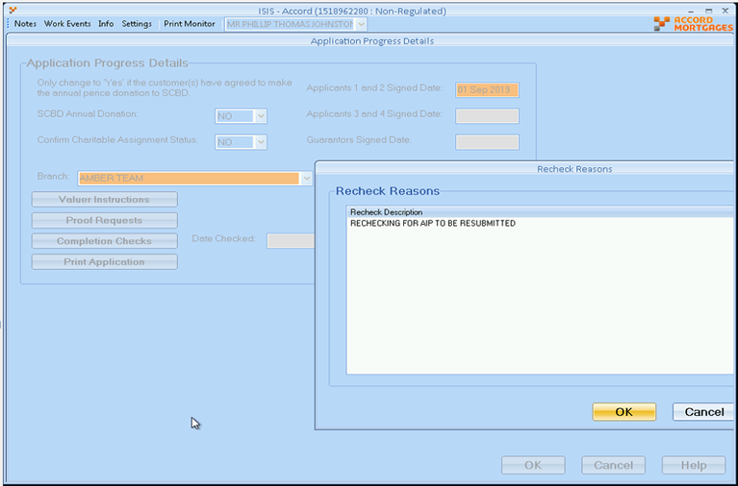

**Solution:** //Mainline/setup_data/amendment_scripts/a9iss3329.sql

**INC0566053**

**CHE ISIS: Unable to select product transfer**

**Details – Customer completed Product transfer and additional loan. After talking with the customer they decided to go on with a different product. the variation gets successfully cancelled and re-added but on the product selection the product transfer button is greyed out.**

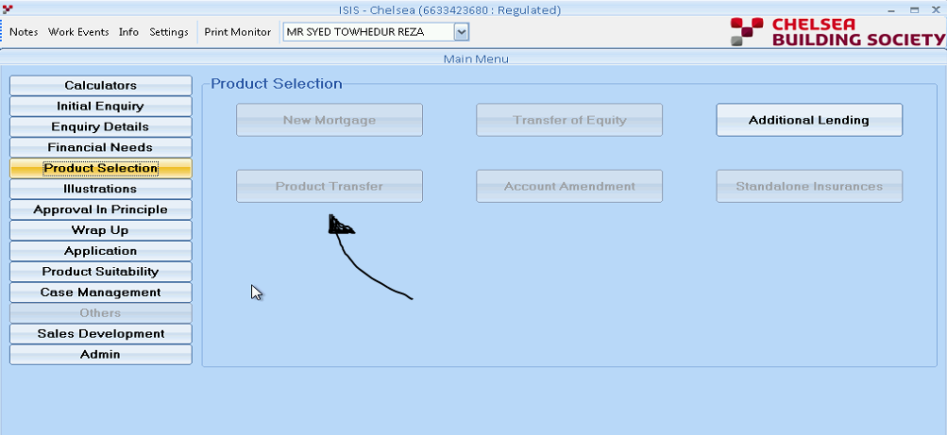

**Solution: Hi,**

**It seems something unsupportive. Cancelling the EBT and then trying to add it back. Case needs to cancel and start again.**

**Another Incident: INC0568755**

//Mainline/setup_data/amendment_scripts/a9iss3342.sql

**INC0567199**

**Case saying its taking into retirement but it is not.**

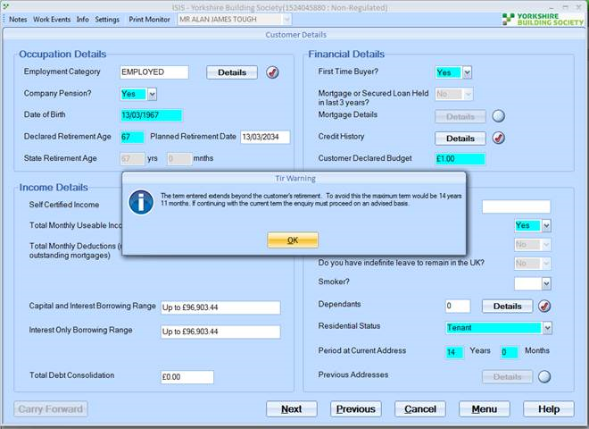

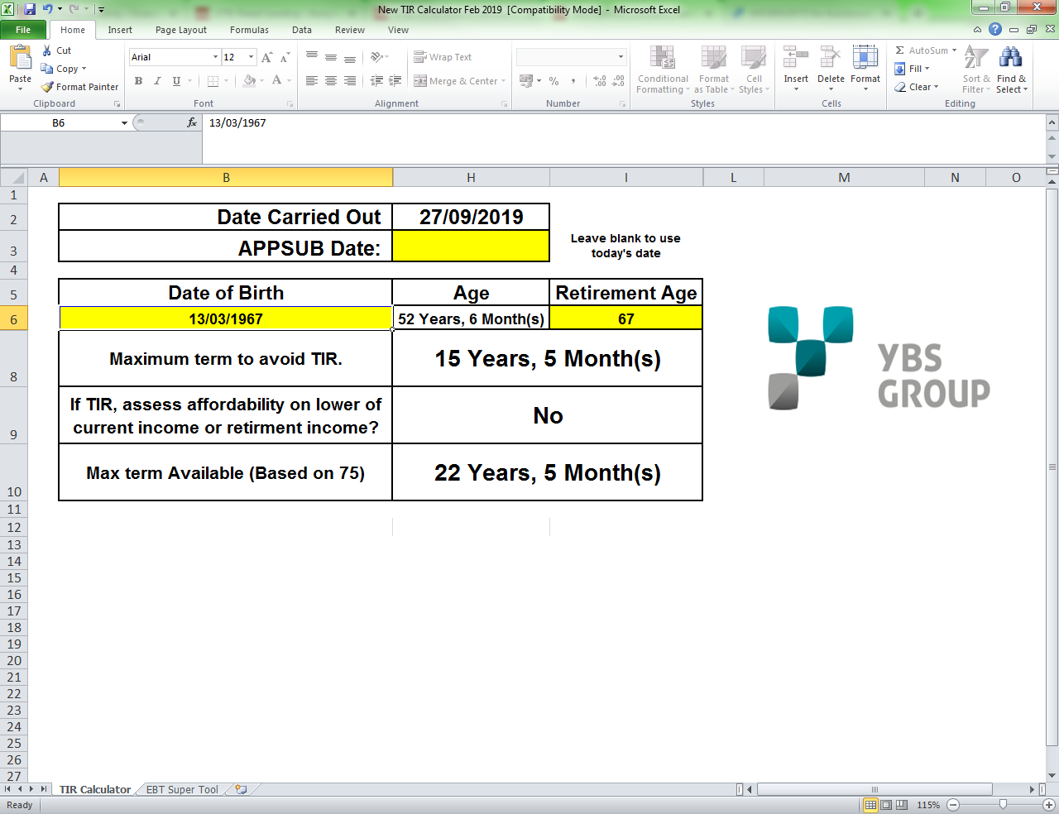

**Solution: //Mainline/setup_data/amendment_scripts/a9iss3337.sql**

**INC0567585**

**ISIS - unable to add debt onto an account**

**Details – ISIS - unable to add debt onto an account**

**option greyed out to add deductions**

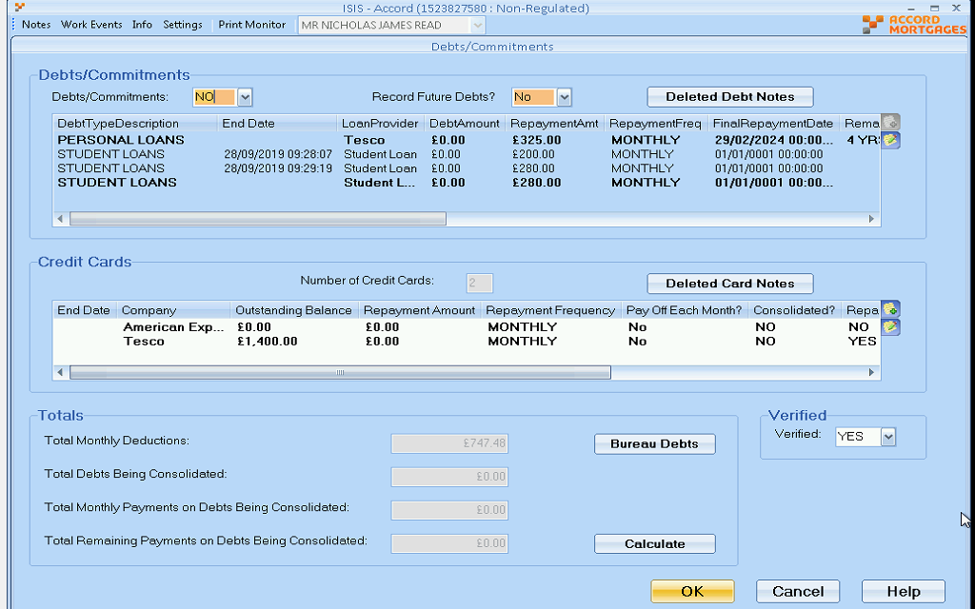

RD

Richard Durn

Work notes •

04-10-2019 10:57:35

The Debts/Commitments flag is set to NO.

**INC0568344**

**ISIS - cost calculator showing big difference to illustration**

**Details – Eleanor called to advise that the ISIS the cost calculator is showing around £80 difference to the illustration with it is is pulled though which is causing an issue when speaking to the customers. Should normally have a £1/£2 difference but this account is showing a £75 difference**

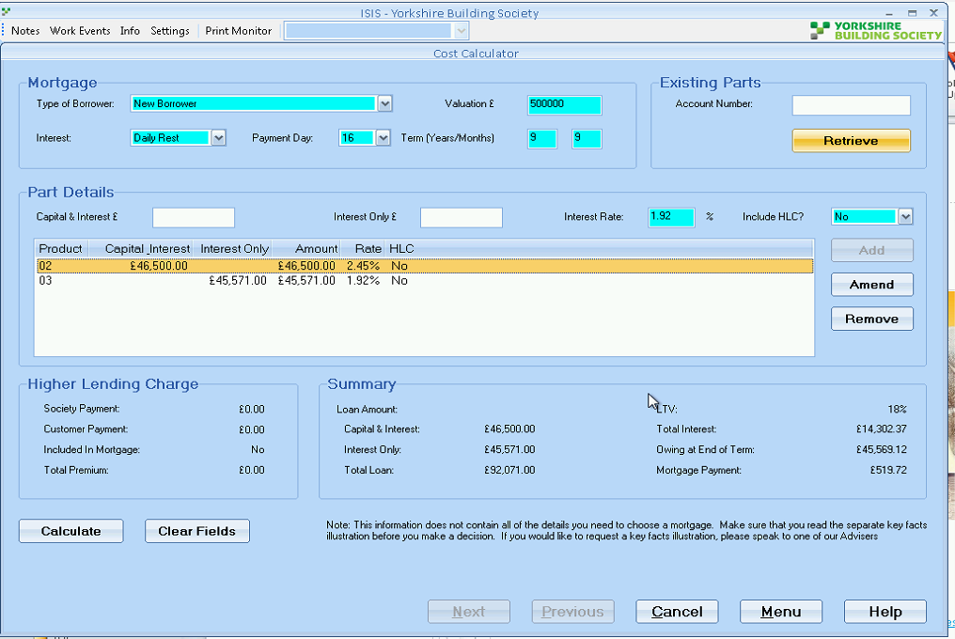

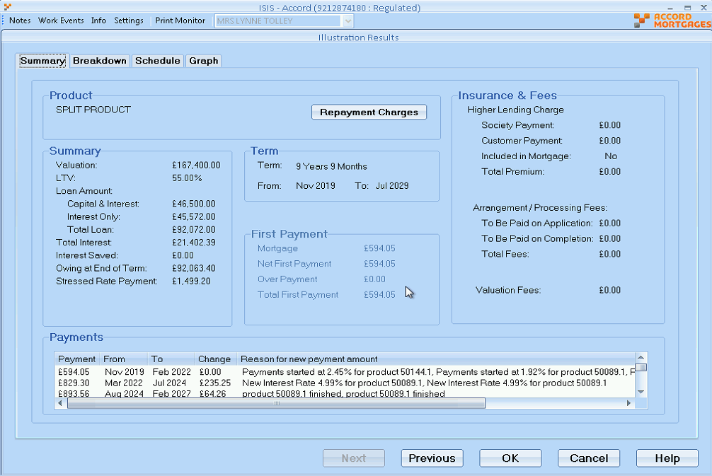

**Solution:** It was illustrated incorrectly in the first place. Re-illustration required.

**INC0568958**

ISIS - Message regarding term length and customer retirement age is incorrect

Details – Additional loan application with a product transfer on ISIS. When accessing the financial needs screen it comes up with a pop up advising the term extends beyond the customer's retirement. Term is 19 years 6 months at this time the customer will be 67 years and 11 months which is within the 365 day window the the applications can be

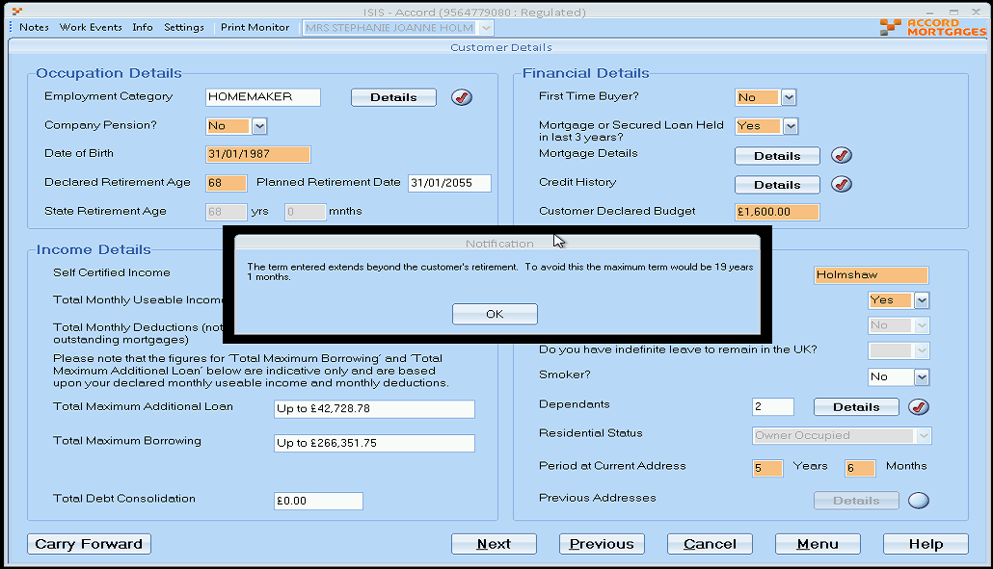

**Solution:** //Mainline/setup_data/amendment_scripts/a9iss3340.sql

**INC0569911**

ISIS - error when loading an account

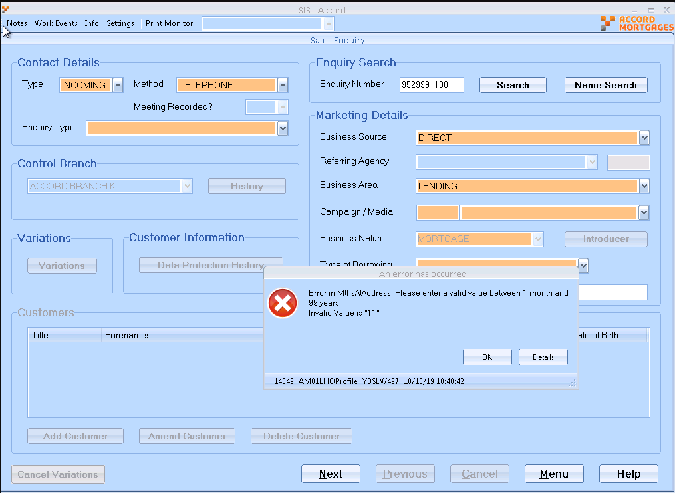

**Solution :** //Mainline/setup_data/amendment_scripts/a9iss3345.sql

**INC0570359**

**ISIS - Case saying its taking into retirement**

**Details – ISIS states case is going to into customers retirement when it isn't so looks like it isn't calculating properly.**

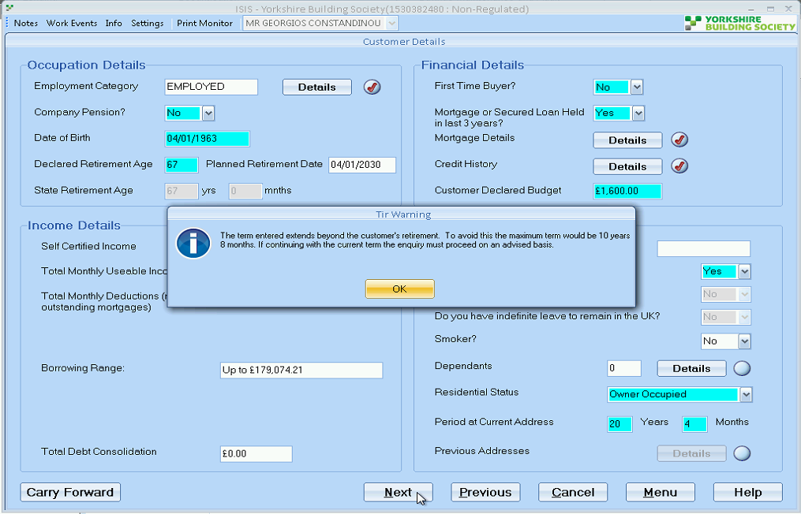

**Solution : //Mainline/setup_data/amendment_scripts/a9iss3347.sql**

**INC0570796**

**Cant select ISIS illustration as it thinks it is in customers retirement**

**Details – Customer can have a term upto 15 year and 7 months, Laura has recommended 15 Years 4 months however ISIS still wont accept teh case and believes it is running into the customers retirement and asking to run affordability.**

**Solution:** for tir cases?

Subtract 6 months in start date and update into lending_applications

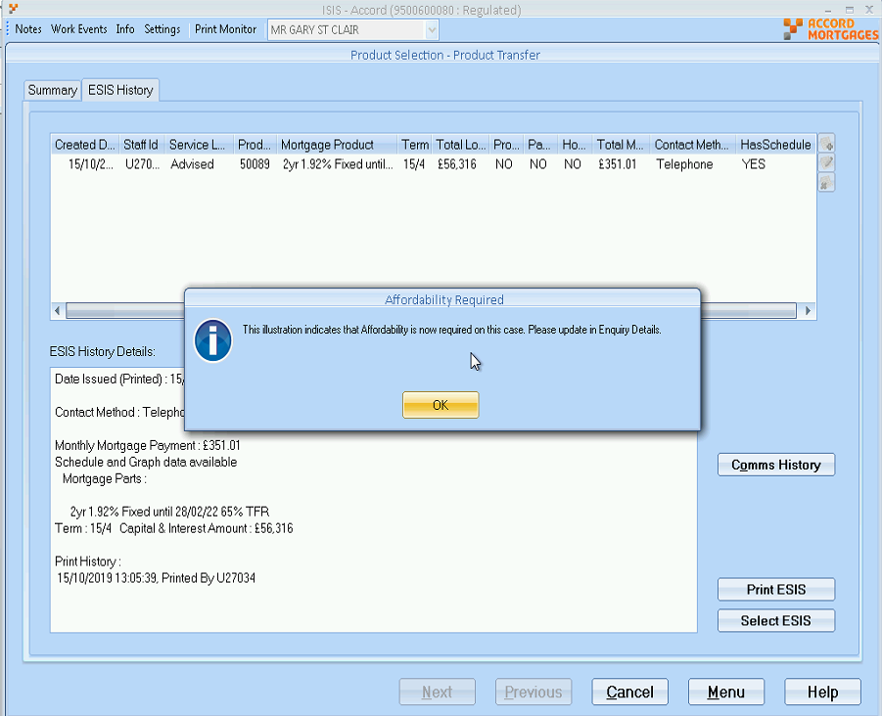

**INC0571485**

**ISIS - Unable to re-add additional loan variation**

**Details – Robert called with a ToE and AL application. The offer for the AL had expired so Robert went to remove the variation and readd it. When readding it he was advised that all the amendments on the ToE need completing. When continuing it will advise that the variation was added successfullu but when accessing the enquiry screen the Additional Loan tab is greyed out**

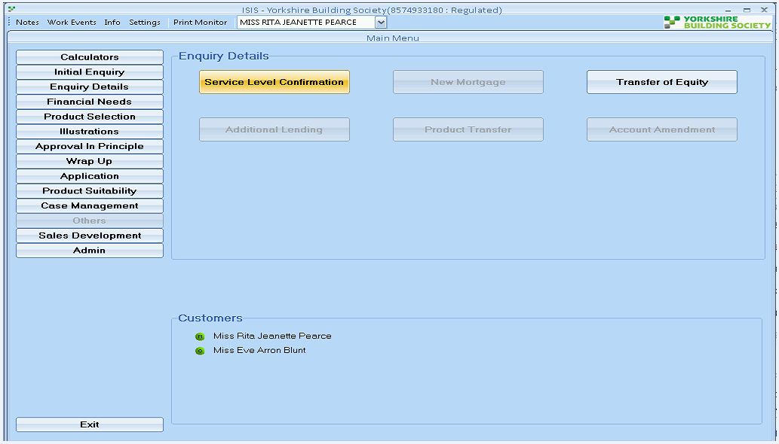

**Solution :** //Mainline/setup_data/amendment_scripts/a9iss3350.sql

**INC0573961**

**ISIS error when submitting into ALPS**

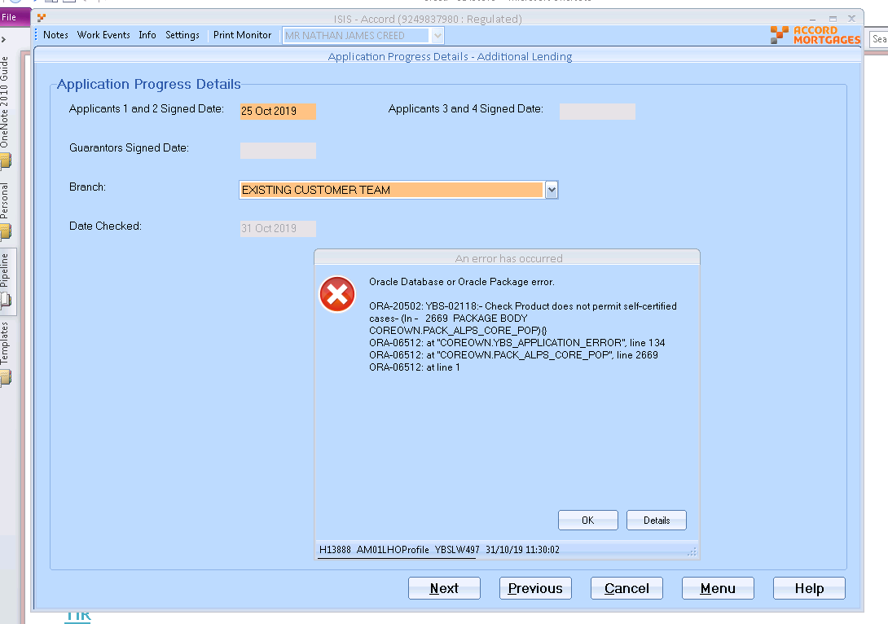

The case is for self-certified, so I believe additional loan of the same type would be required for this

Products 50160 not permit for self cert I believe.

SC

Sally Carney

Work notes•

04-11-2019 12:04:36

Checked the case and the income details are set to Self Cert for both applicants however product 50160 (ESILL) is not for this type of borrower so unsure how they have managed to select it.  
Tried to replicate and when the list of products is populated it still has only the non self certs listed, see attached 573961.doc, can you see why.

Vicki Mackwell

Work notes•

06-11-2019 09:29:39

Sam calling , i advised her of the update from sally and they are saying that this should be a NON self cert mortgage, so if this is so , than will need to amend the customer in ISIS to non s/c and the case should be ok.  
  
Sam is going to speak to the person and than update us to the progress.

**In Case: If unable to make the change then have to write patch - INC0586609**

**//Mainline/setup_data/amendment_scripts/a9iss3402.sql**

**INC0575790**

**ISIS cannot remove a solicitor –**

**Details – ISIS cannot remove a solicitor**

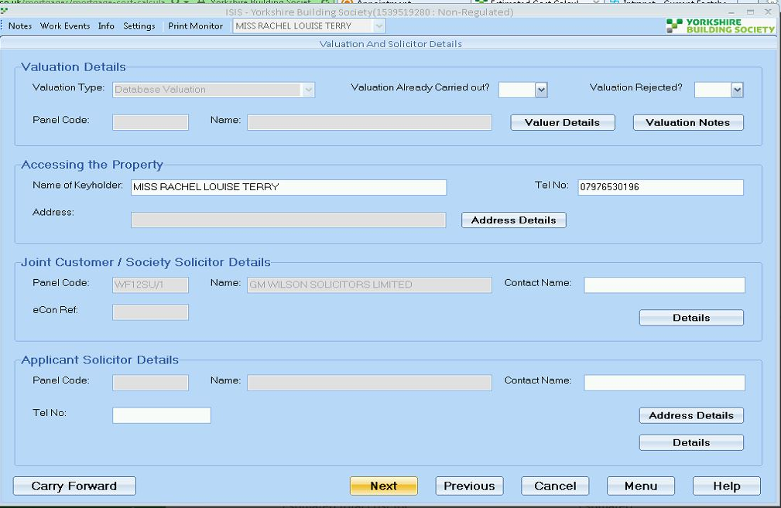

**Solution: //Mainline/setup_data/amendment_scripts/a9iss3376.sql**

**INC0574945**

**Unable to get into ISIS - no such host known**

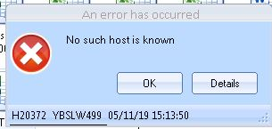

RD

Richard Durn

Work notes •

15-11-2019 14:33:16

Server needs amending as per known issue.

they shouldn't come to us (they usually don't), Service Desk are aware of the fix

**Similar INC0604502**

Ask the service desk to check the server name - should be YBSLW493   
service desk can amend

**INC0575185**

**ISIS - Need term barrier removing for product & TIR retirement error**

**Details – Laura as a case where the product they want needs the minimum term barrier removing for product 35462 as it is only 4 years 9 months, also the case has the TIR warning error where it believes the case is going to extent beyond the customers retirement so needs patch running**

Jill Mortimer

Work notes•

15-11-2019 16:47:41

Sent this over for investigation. The TIR issue will now be resolved however the issue with the product transfer is ongoing. They are trying to select 35462 (currently re-activated) however it is not appearing in the list for selection. They are extending the term to 4 years 9 months which I think is sufficient as the account will need to remain open until Aug-2024 to avoid ERC's. Can you please advise?

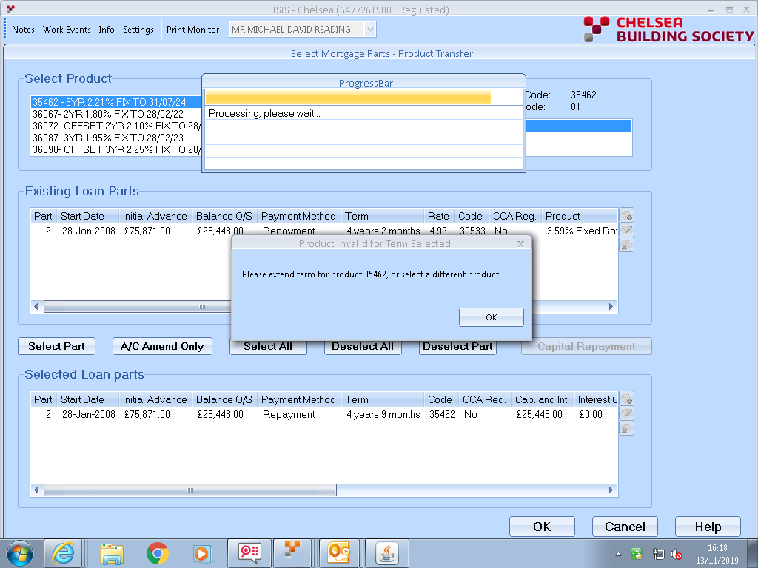

**Richard:** the term on the product needs changing and leaving overnight   
overnight is the key   
because the error message uses downloaded data

**INC0577060**

**Details – unable to offer case - see attached error**

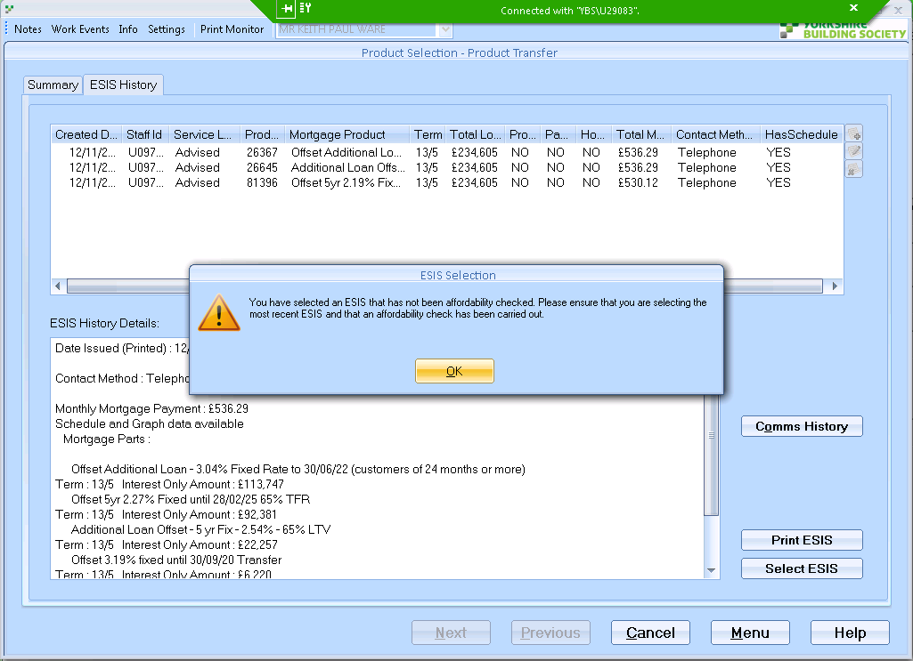

Jill Mortimer

Work notes•

19-11-2019 13:02:42

This is just a product transfer and Laura is advising the 4 quads have not been completed and the AIP is not required. Can you please confirm?

**Richard:**

**Hi,**

**It's not a check that we should be doing in this area (it's not a very good check in the area where we should be doing it).**

**If the user re-illustrates, creates ESIS, selects it will be ok.**

**-------------------------------------------------------------------------------------------------------------**

**INC0579431**

**ISIS A/L Error when printing IDD statement**

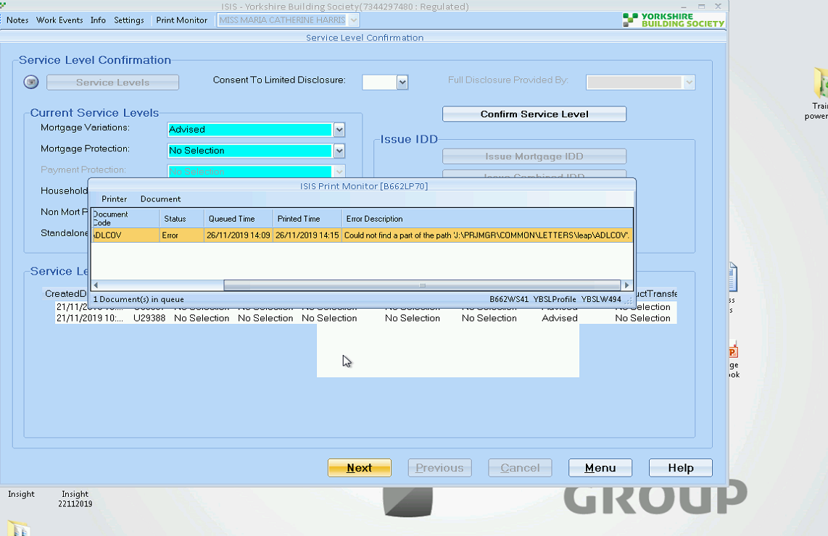

Richard Durn

Work notes •

28-11-2019 16:29:32

Can we have a screenshot of the J drive mapping please?

[‏28/‏11/‏2019 16:41]  Kamal Batham:    
Is this really because of J drive mapping?   
    
[‏28/‏11/‏2019 16:45]  Kamal Batham:    
Where we do J drive mapping in ISIS?   
    
[‏28/‏11/‏2019 16:45]  Richard Durn:    
it's in windows   
\\ybslw057\letters   
otherwise it won't find the document path

**INC0580712**

**ISIS and LEAP showing different LTV values for account**

**Details – Gagan has a case where the customer is wanting to switch to interest only but when checking for what products are available he has noticed ISIS and LEAP show two different LTV values - see screenshots**

**Solution:**

**Richard:** send it back to ainslie   
say it looks like the customer wants a product transfer rather than an account amendment

**INC0580475**

ISIS ACC Error when trying to select ESIS

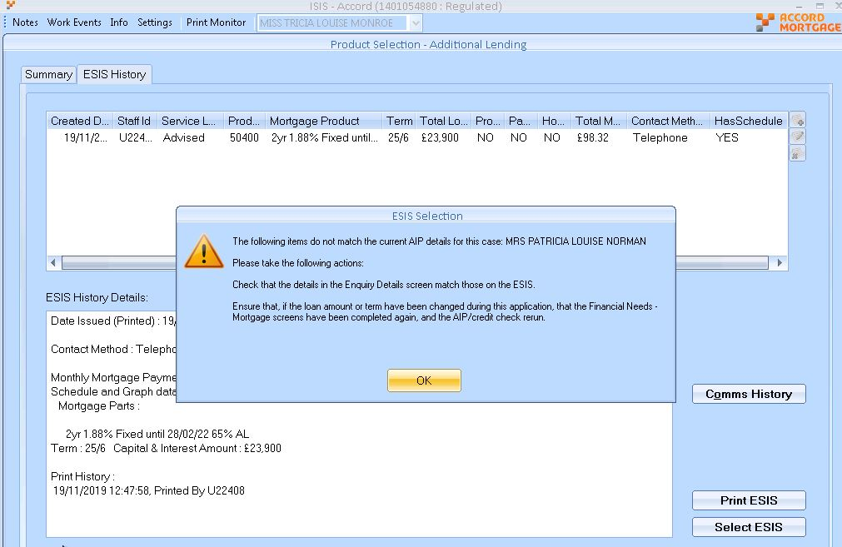

**Hi,**

**It's required new illustration.**

**Thanks,**

**Kamal**

**INC0584665**

**ISIS Prod Tfr - it is only pulling over 1 applicant not 2**

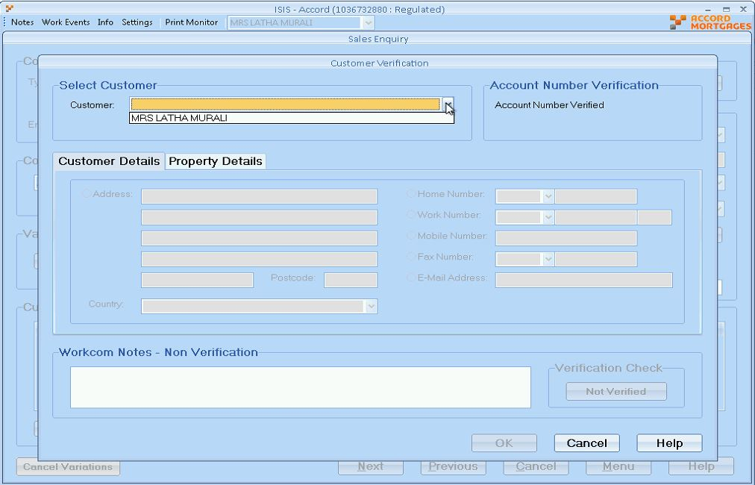

**Solution:**  //Mainline/setup_data/amendment_scripts/a9iss3398.sql

**INC0585294**

I've had a look at this one and can see the ESILL has been printed however it is not allowing the user to select it. He is trying to select the 02/01/2020 but it is not allowing him to do so

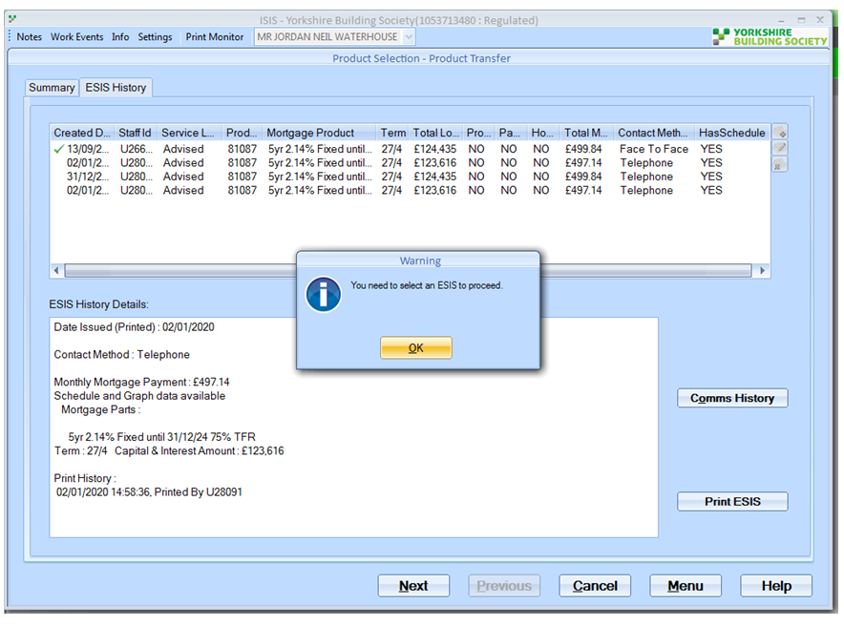

**Hi,**

**Product transfer seems to be done already. You need to reject the previous offer and start again.**

**Thanks,**

**Kamal**

**INC0587659**

**ISIS - case does not meet criteria**

**Unable to create a illustration the maximum loan to value has been exceed**

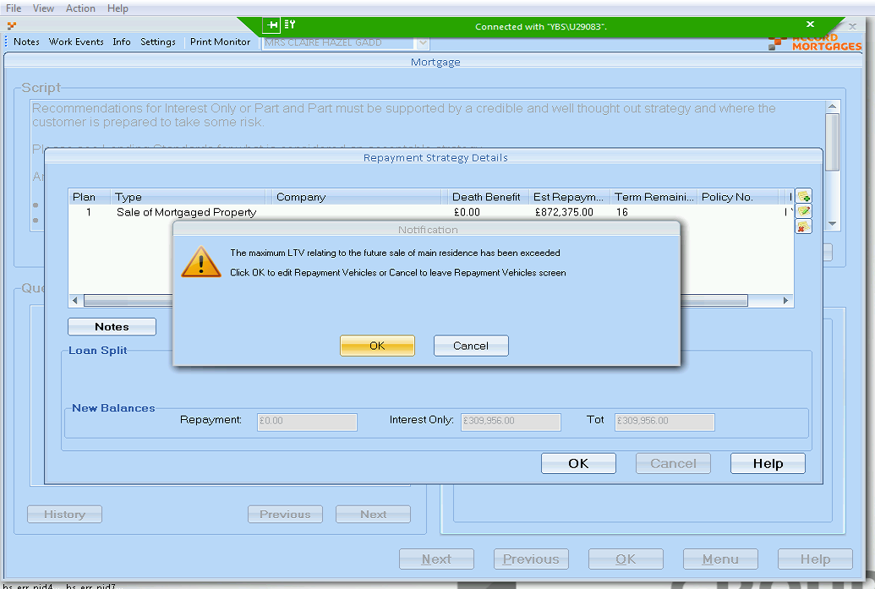

**INC0606933**

**Cant get past screen in ISIS**

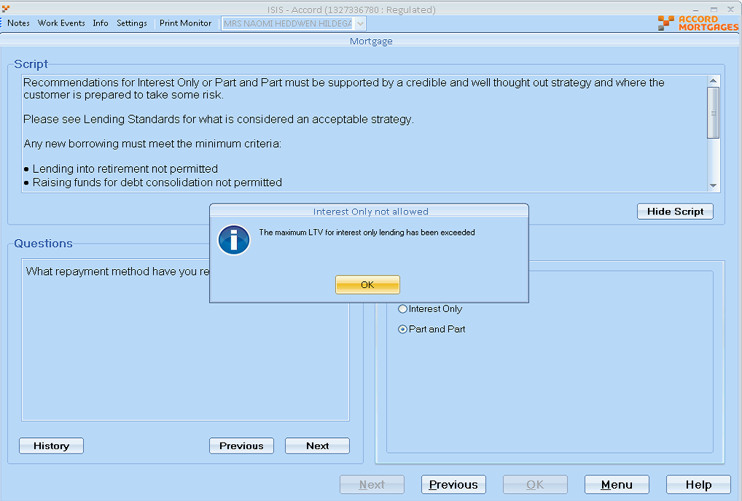

The system will not allow the change to part Interest Only as the current ltv of 80.10 exceeds the max permitted of 75%.

Richard Durn

Additional comments •

29-04-2020 14:23:16

Hi,  
  
ISIS is coded such that any case over 75% must be wholly Capital and Interest. This was certainly the policy when Interest Only was reintroduced into ISIS a couple of years ago. However it is sometimes the case that policy is changed and we're not informed, in which case I would recommend that a change is raised in the Demand Portal. There isn't currently any way to process this case in ISIS.

**INC0587369**

**Homebuyer fee but it is not showing**

**Details – ESIS produced on Saturday on ISIS showed a free valuation on the product 81462, customer is applying for the loan and he has put the home buyer it should show the cost of the homebuyer fee but it is not showing**

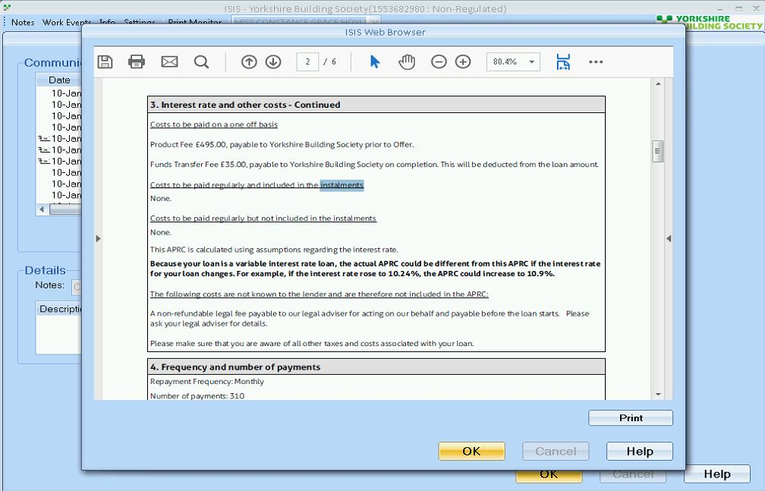

RD

Richard Durn

Additional comments•

16-01-2020 11:19:46

Hi,  
  
At the time the illustrations were done on this case, the property was processed as being in Scotland (presumably in error). Different valuation rules apply to Scottish properties, which is why the valuation did not show on the ESIS for this case.

**INC0589581**

**Details – isis got an error message - imported from online, she cannot access the self employment info, she gets the error - show both employed and self employed, but customer is self employed**

**When click on Detail button of Employee Category**

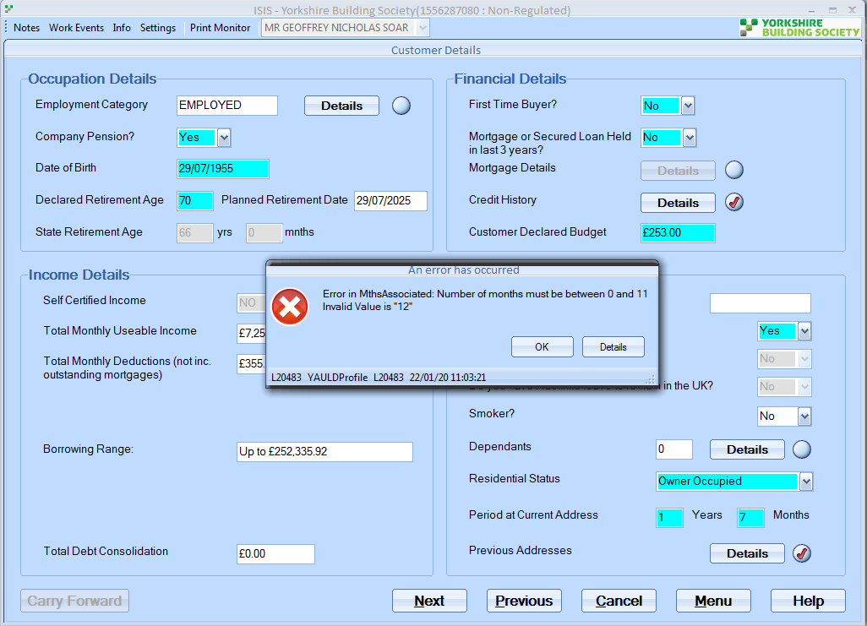

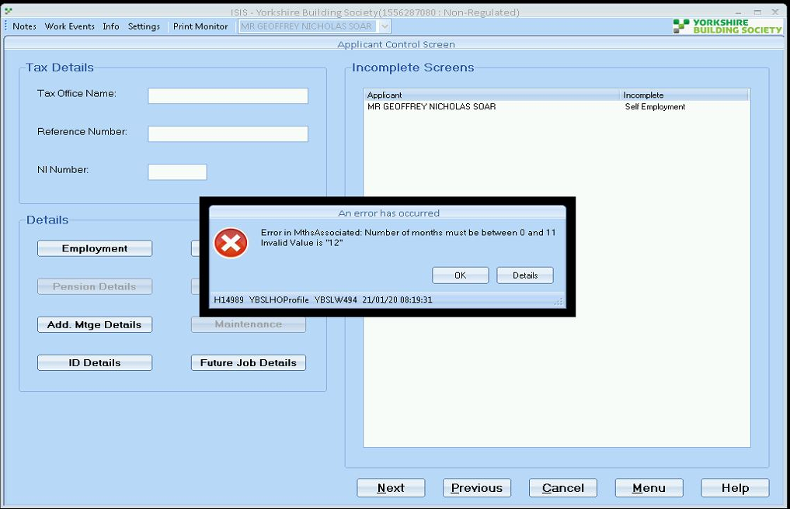

**Solution:**

**//Mainline/setup_data/amendment_scripts/a9iss3408.sql**

**INC0592570**

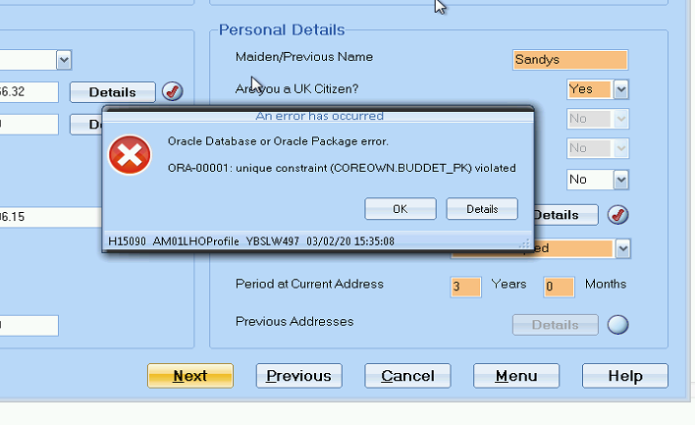

**INC0593200**

**Product Transfer and Additional Loan Issue**

**Details – Customer is wanting to go from Interest only to repayment and to also do a term extension - application has come back from customers but the products have changed - Branch are therefore trying to do a new illustration, however it's saying the term extension wont meet the age of the customers.**

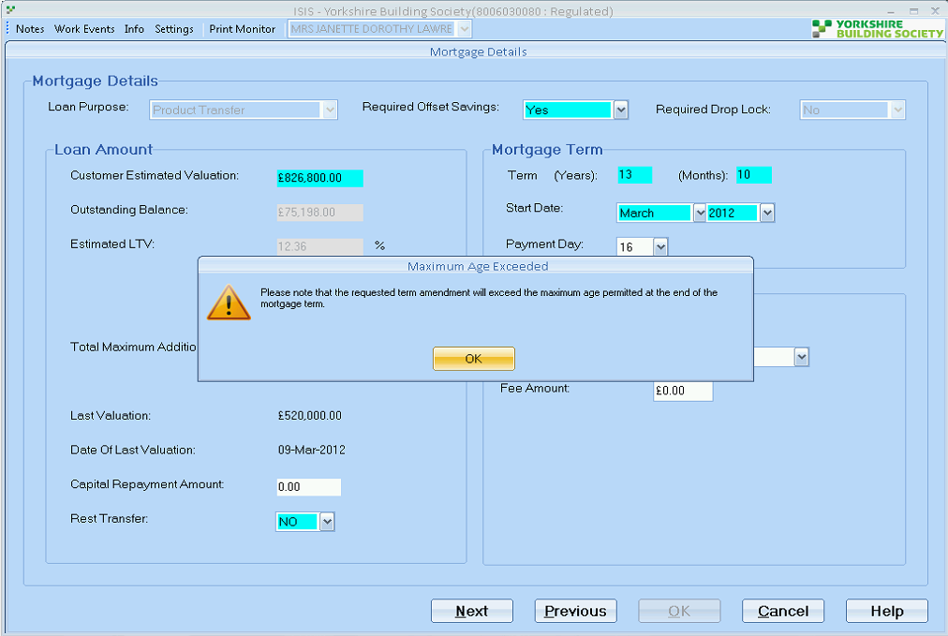

RD

Richard Durn

Additional comments•

07-02-2020 14:06:09

Hi,  
  
Unfortunately this message was missed off when we did the change to max age 80. However, this is only an advisory message, so it shouldn't stop you illustrating or proceeding in any way.

**INC0593761**

**Subscript out of range for index '1' in collection 'ISIS.Common.LeapTableData.DataCollectionBase`1[T]'**

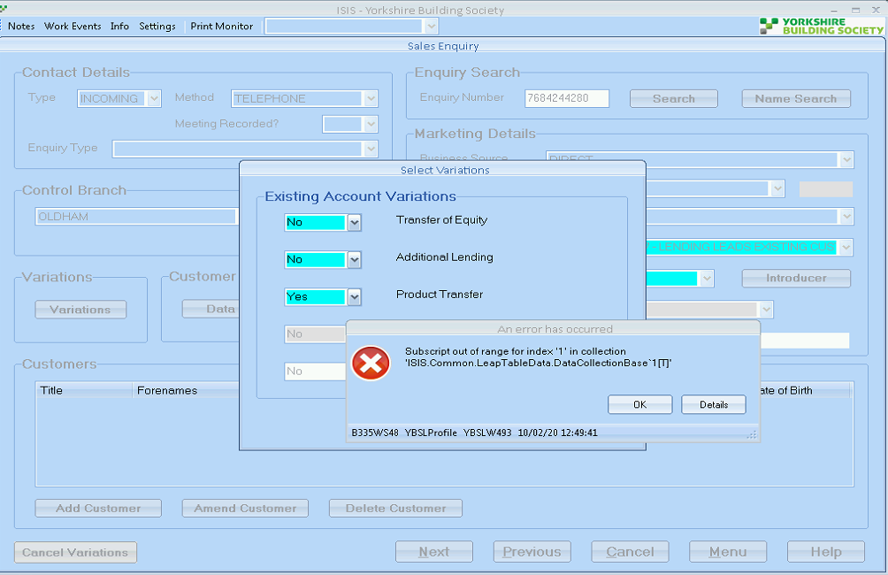

**Solution:**

Hi,  
  
There isn't enough existing data on the previous variation, ISIS doesn't handle that well and falls over.  
  
If you select No to using the existing application details, the variation should create without any issues.  
  
Thanks,  
Kamal

**INC0595012**

**ISIS A/L Error when submitting application**

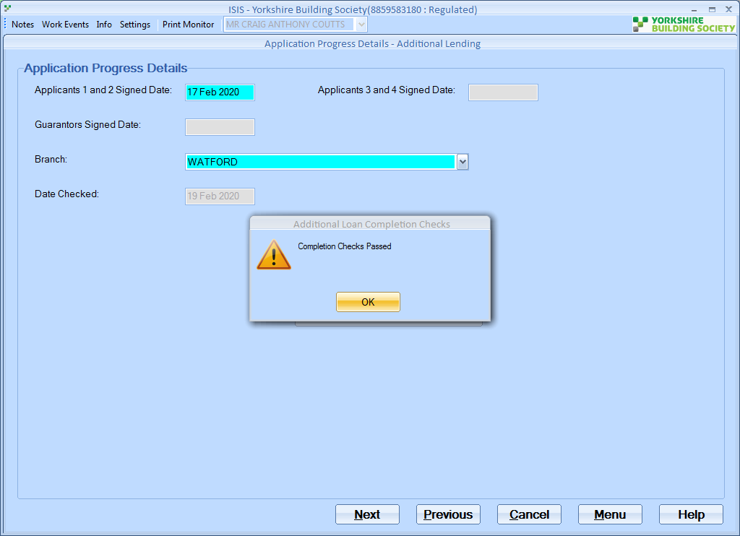

**After Completion Check -🡪 When Submit to ALPS, throw below error**

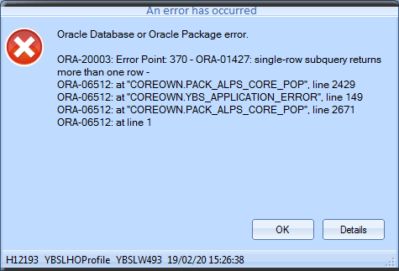

SELECT e.ref_no

FROM Loan_Applications la,

Sales_Variants_Details svd,

Enquiries e

WHERE la.loanac_accgrp_num = ln_orig_acc_no

AND svd.loanap_sysid = la.sysid

AND svd.lenvar_new_acc_no = e.account_no

AND la.loaptp_code = ps_loanap_fthadv

AND svd.lenvar_new_acc_no = (SELECT lv.new_lenapp_acc_no

FROM lenapp_variants lv

WHERE (lv.orig_lenapp_acc_no = la.loanac_accgrp_num

OR lv.orig_loanap_acc_no = la.loanac_accgrp_num)

AND RANK = (SELECT MAX(RANK)

FROM lenapp_variants lv

WHERE (lv.orig_lenapp_acc_no = la.loanac_accgrp_num

OR lv.orig_loanap_acc_no = la.loanac_accgrp_num)));

RED Query returns two rows

SELECT *

FROM lenapp_variants lv

WHERE (lv.orig_lenapp_acc_no = 88595831

OR lv.orig_loanap_acc_no = 88595831)

AND RANK = (SELECT MAX(RANK)

FROM lenapp_variants lv

WHERE (lv.orig_lenapp_acc_no = 88595831

OR lv.orig_loanap_acc_no = 88595831))

Solution:

**//Mainline/setup_data/amendment_scripts/a9iss3417.sql**

**INC0599360 – Similar as above worked by Richard**

**INC0595228**

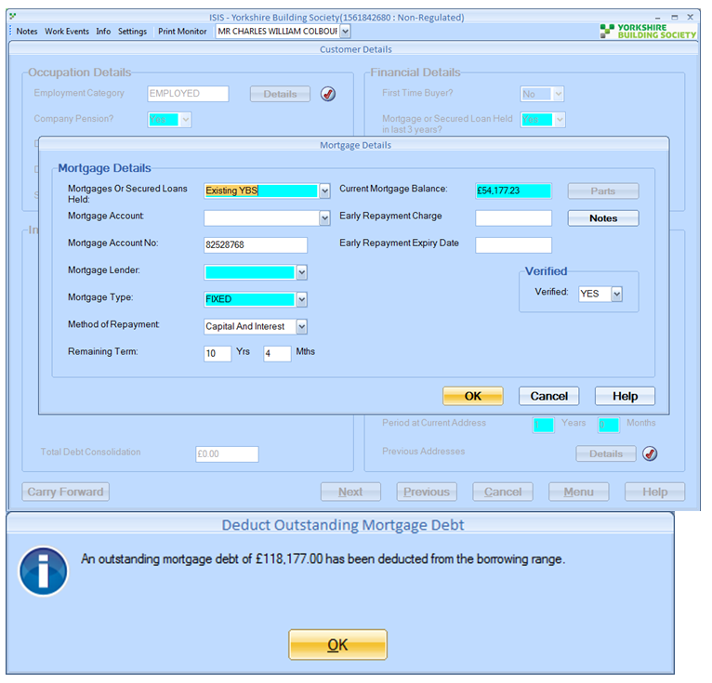

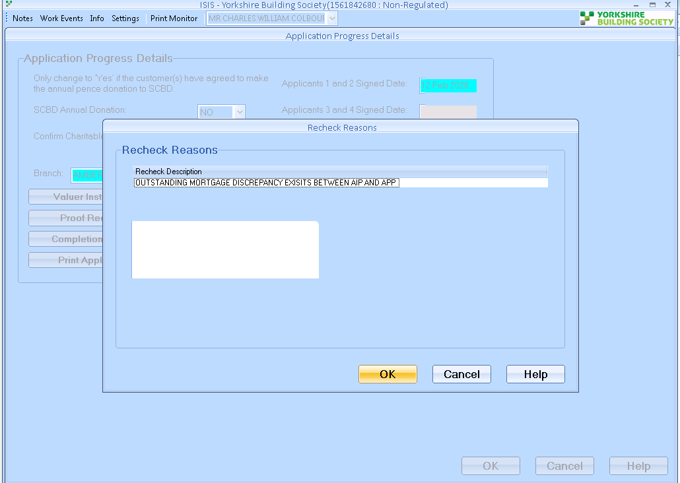

**Solution:**

**//Mainline/setup_data/amendment_scripts/a9iss3418.sql**

**INC0606000**

**CBS PT need parameters opening**

**Details – Gagan called as he has an account whee the parameters need opening as its BTL case and we need to increase the valuation amount so that it can go through.**

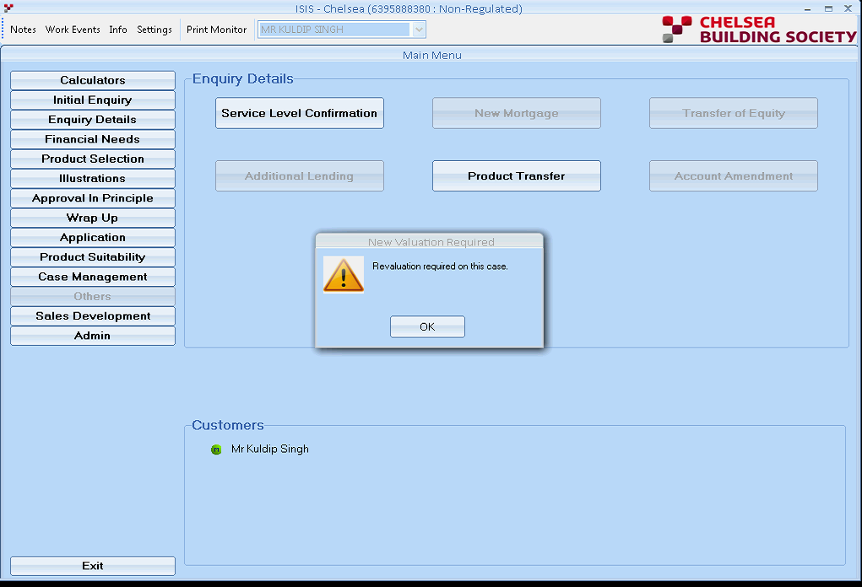

**Solution: Need to fudge the valuation date. That's the only way to get around the revaluation requirement is to temporarily amend the valuation date, although this will impact the HPI valuation.**

**INC0595518**

**ISIS - Re Val Issues - addition lending**

**Details – When dealing with an addtional loan in ISIS , and clicking through to page LEP006DT , enquiry details, the system is asking for a "Revaluation " , on the original mortgage the system is saying it had, external valuation completed , but if fact they had a FULL valuation, the valuation form is on DIP.**

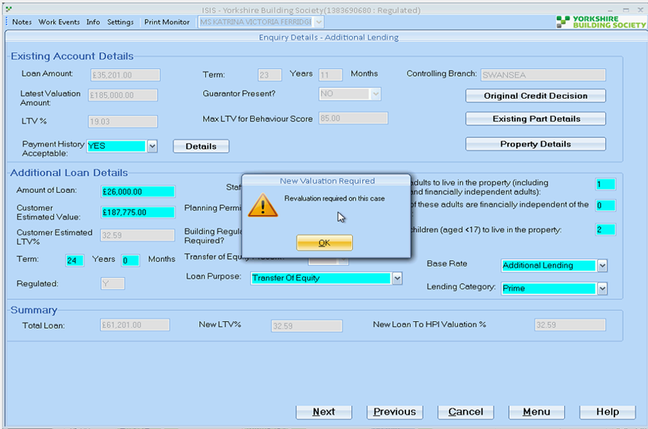

**Richard Knowledge on this –**

[‏25/‏02/‏2020 15:10]  Richard Durn:    
so if the last val on a case was a DV (database valuation) then a new valuation is required for this app   
if it was a 'proper' valuation then a new valuation won't be required   
it may be that what was typed onto the system a while ago doesn't match what actually happened   
    
[‏25/‏02/‏2020 15:12]  Richard Durn:    
I can see on LEAP that a DV was instructed   
I expect that's what ISIS is picking up   
it also seems that a 'proper' valuation was received back   
which is odd

RD

Richard Durn

Additional comments•

28-02-2020 10:14:55

Hi,  
  
Revaluation is selected as the valuation type in the Valuation and Solicitor Details screen (through the Application menu). If you remove this in the screen, then if you create a new illustration, this shouldn't have the revaluation attached.

**INC0595925**

ISIS Error when trying to produce a conveyancing quote

I can get a quote from the website, however I need to attach this to the actual application in ISIS and instruct the solicitor via ISIS?  Is this still possible – I thought it would need to all go through ISIS?

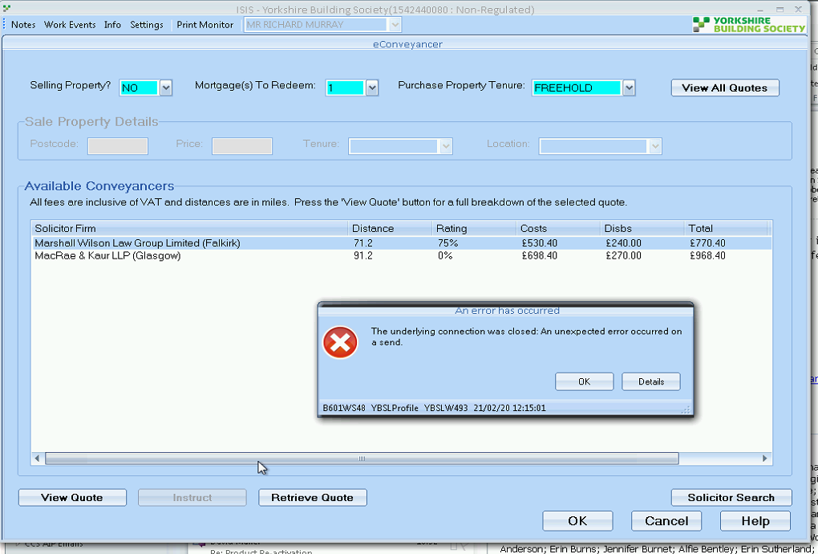

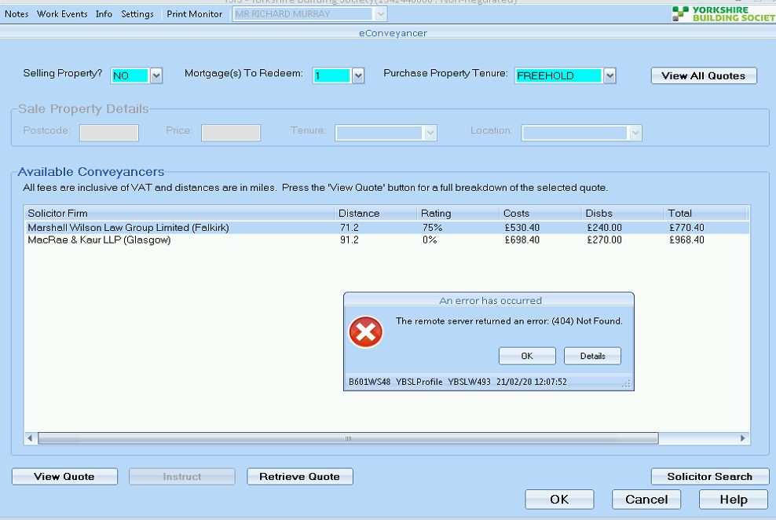

Solution:

RD

Richard Durn

Additional comments•

27-02-2020 10:40:55

Hi,  
  
The quote doesn't need to be attached in ISIS. It's fine to instruct the conveyancer via Ecomm and then just add the solicitor details in ISIS.

INC0598105

ISIS Orcale Database or Oracle Package Error message

There is an outstanding high priority incident that is currently being worked on. User has had a new AD and profile created and whilst adding access to the new U number ISIS is not letting her in, Zee from CC has been up this week and managed to do something to resolve it however a new error message is now appearing.

RD

Richard Durn

Work notes•

04-03-2020 14:35:23

The dcomenquser account is locked on YBMLD - needs assigning to Database Support to unlock.

INC0598728

ISIS Porting - No products coming up

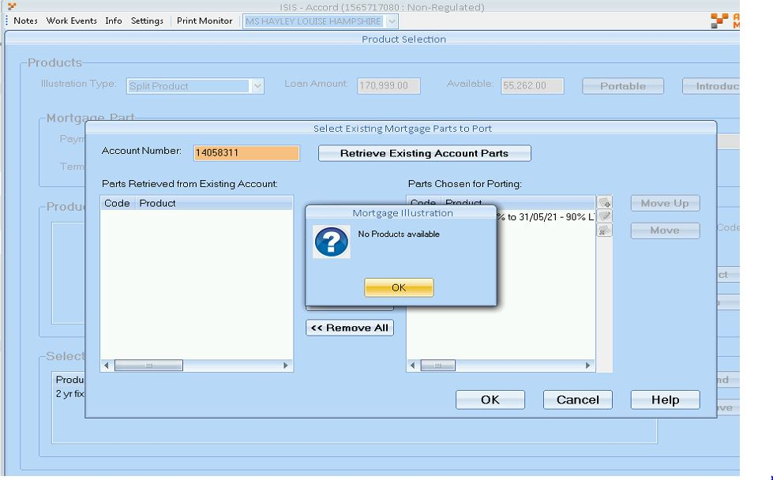

Hi,

There is a problem with Broker record, which ended. Please contact to BDA team.

Thanks,

Kamal

SC

Sally Carney

Additional comments•

10-03-2020 12:52:13

1565717080  
The Broker linked to this application has been ended. Although a new record has been created it is still linked to the old one.  
You will need to remove and re-attach the Broker.  
Regards  
Sally

**INC0599810**

ISIS - trying to Print Offer gives error message

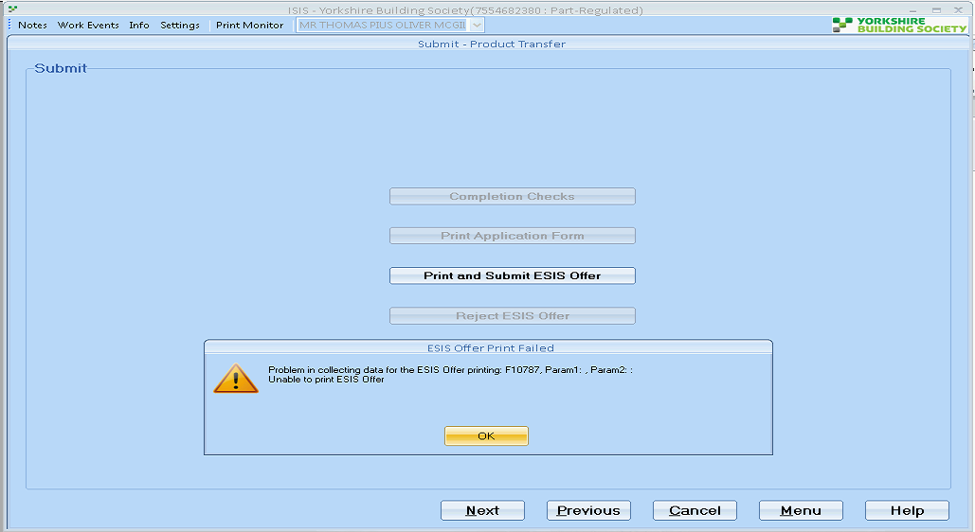

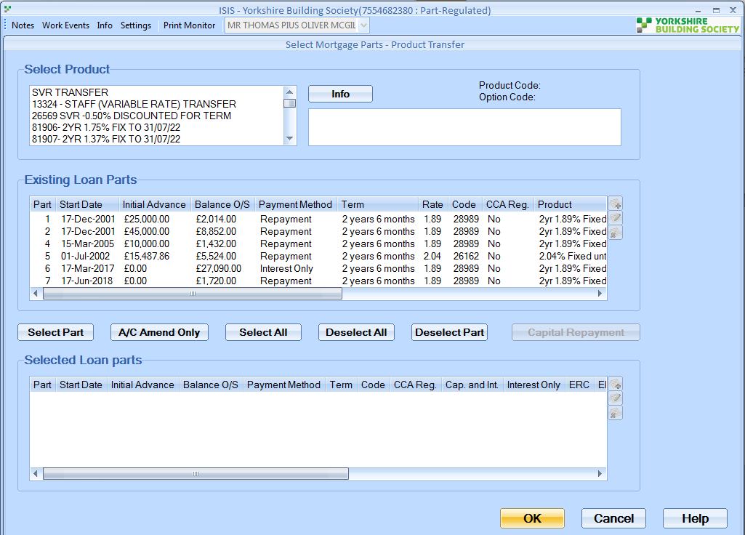

RD

Richard Durn

Work notes•

13-03-2020 16:21:25

To cut a long story short, the issue with this is the number of parts being transferred - it's overwhelming a variable in a package somewhere. So we'll need to merge parts if we can. It looks like parts 1 and 2 can be merged. If this is done, creating a new illustration based on that should go through ok.

SC

Sally Carney

Additional comments•

16-03-2020 09:44:26

7554682380  
The error is due to the number of parts being transferred.  
I have checked the account and parts 1, 2 and 7 are on the same product, repayment basis, same remaining term and end date so could be merged. You will need to contact Mortgage Services to get the parts merged, if this is done, creating a new illustration should go through ok.  
Regards  
Sally

INC0604178

SIS Install - Failed to connect to remote host & reinstall

Details of issue: ISIS was getting Failed to connect to remote host error, but also when trying to reinstall wouldnt accept my admin to install ISISInstaller as he required it changing to version 5.565 and branch code 103

RD

Richard Durn

Work notes•

07-04-2020 11:33:26

The PC is set to use server YBS058AP which doesn't exist any more. Not sure what server it should be as presumably it's one of the many test servers we have, but YBSXW502 is a good place to start. Possibly amend via the registry if you're having problems with ISIS Installer.

INC0606065

ISIS all brands : Campaign Media field Blank

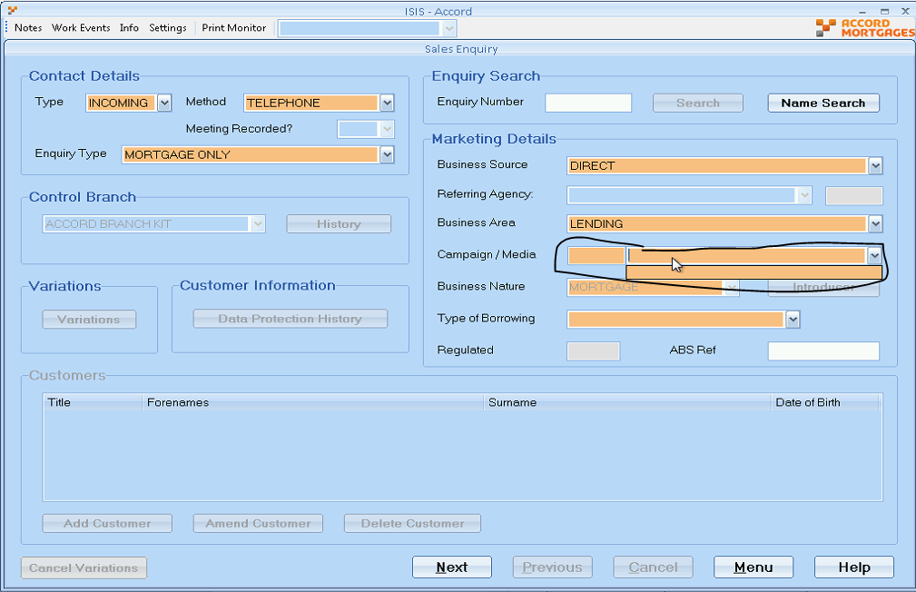

Solution: //Mainline/setup_data/amendment_scripts/a9iss3440.sql

Richard Durn

Work notes•

22-04-2020 11:13:42

Someone has invalidated all of the marketing campaign reasons on the database (I don't know who, presumably someone in Marketing).I've reinstated the Lending Leads reason, so advisers should be able to progress. HOWEVER! They will need to close and reopen ISIS in order for this to take effect.  
  
At some point I will have to find out who has made this change and why, but that's probably not a job for today

INC0607888

ISIS - Unable to Print a Product Transfer

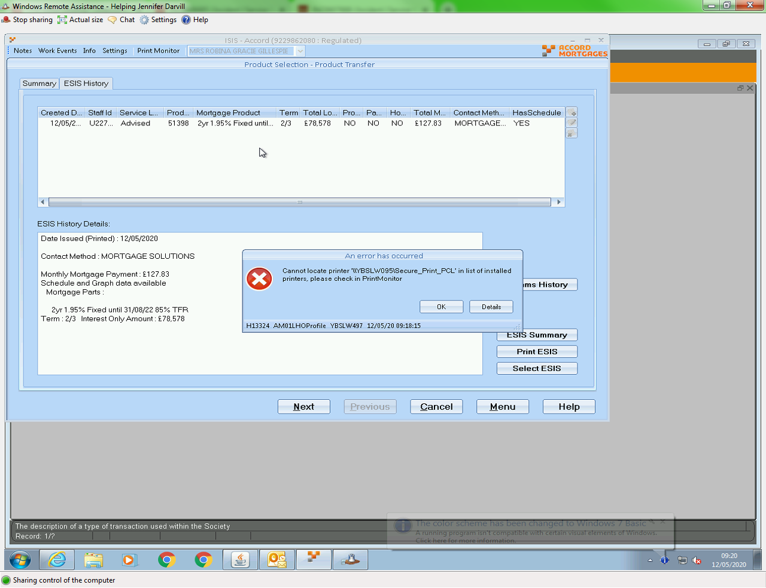

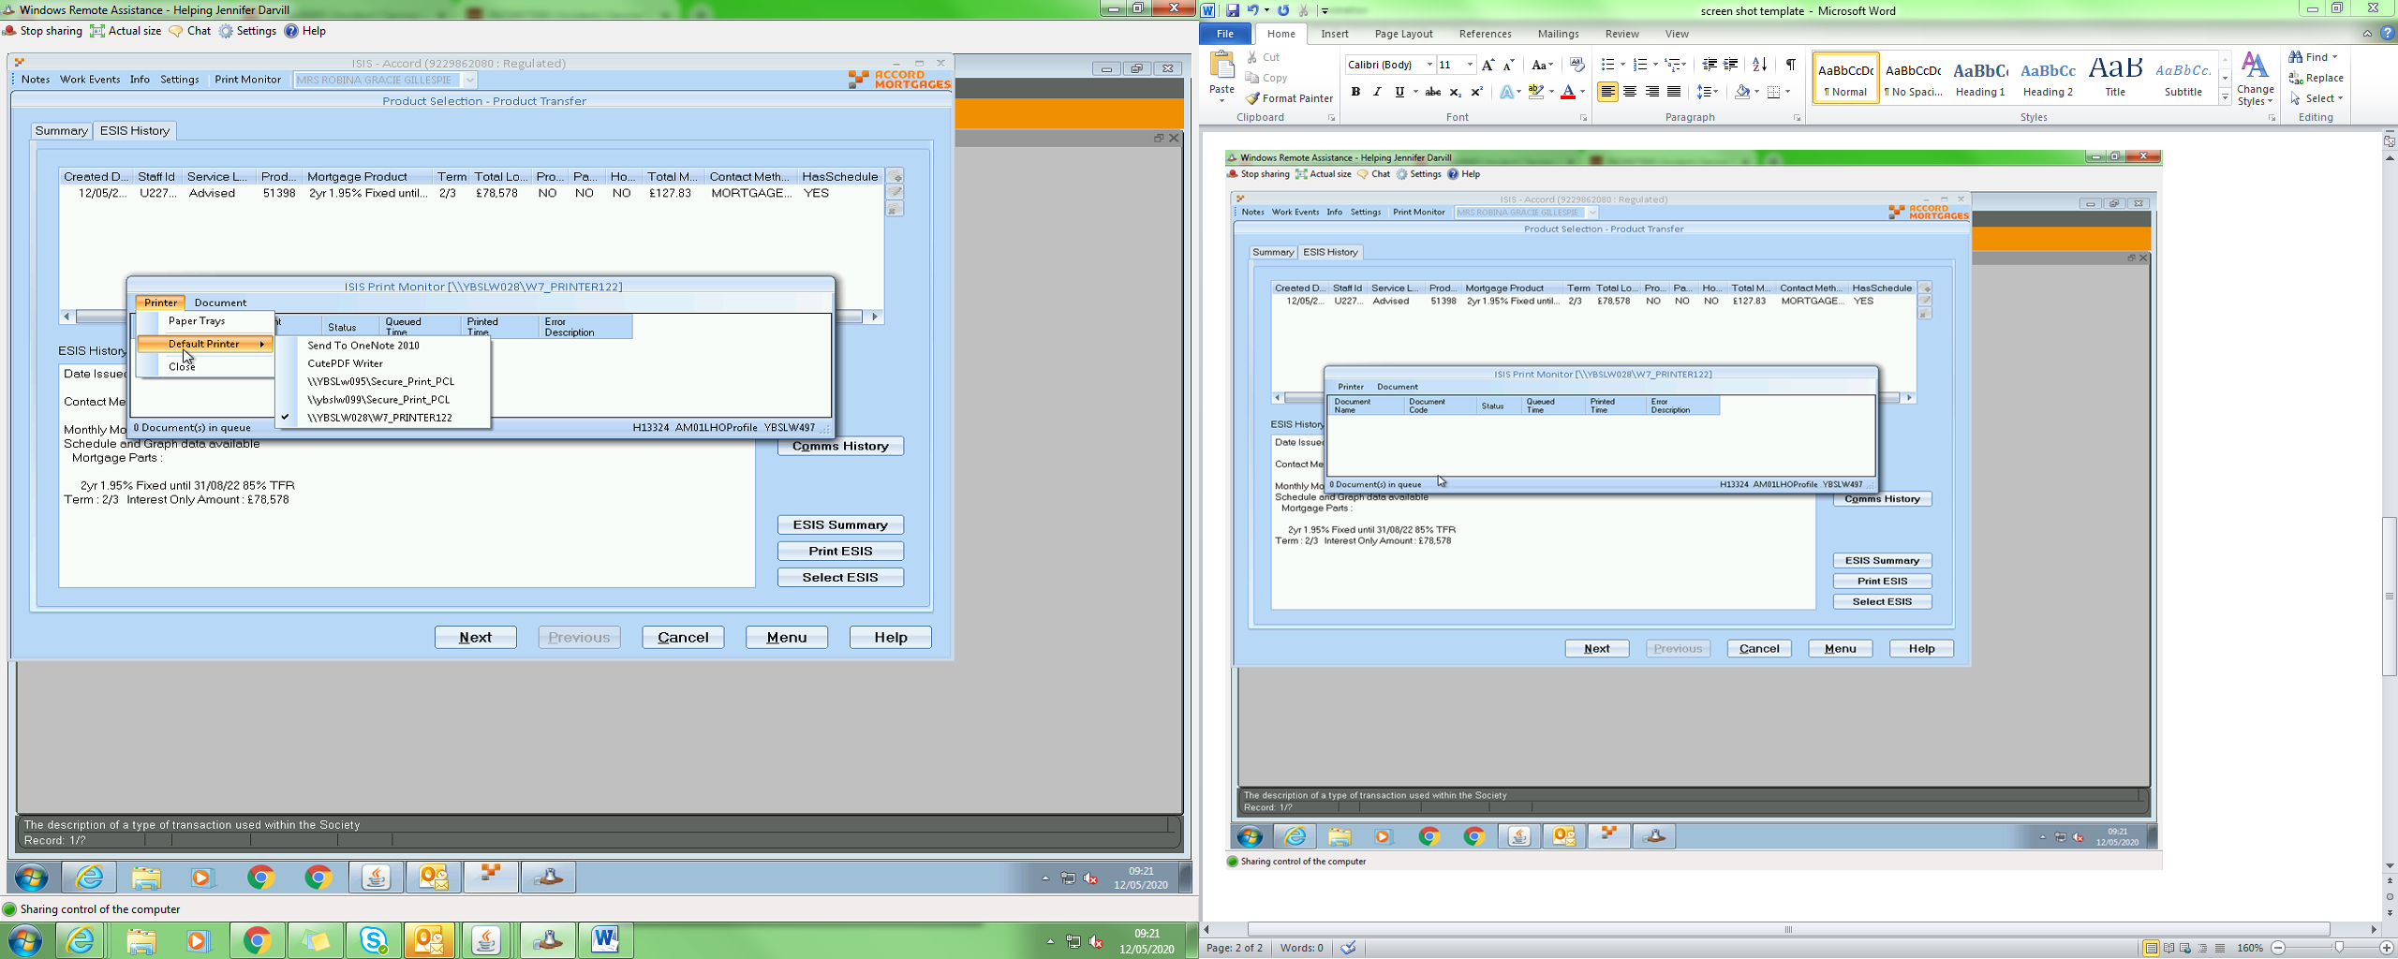

Richard Durn

Work notes •

13-05-2020 13:14:23

It looks like the secure printer has been added in a dodgy fashion - even though it's not the target printer, it could still be causing problems. Can you remove and reinstall? The workstation seems to be H13324.

[‏13/‏05/‏2020 13:11]  Richard Durn:    
check the error message   
oh, i just noticed something   
    
[‏13/‏05/‏2020 13:12]  Richard Durn:    
on the last screenshot, in the list of printers, YBSLw095 is mixed case   
I reckon that needs removing and readding in Windows   
    
[‏13/‏05/‏2020 13:13]  Kamal Batham:    
YBSLw095 is mixed case ? what this mean?   
    
[‏13/‏05/‏2020 13:14]  Richard Durn:    
Lw as opposed to LW or lw   
    
[‏13/‏05/‏2020 13:14]  Kamal Batham:    
Ahhh, Yeah

**INC0607705**

**ISIS YBS Unable to perform EBT illustration as parts in wrong part order**

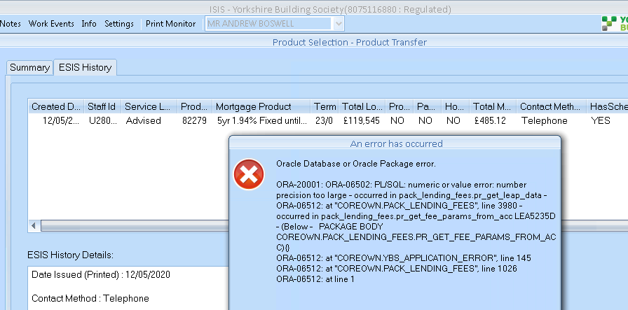

**Solution: //Mainline/setup_data/amendment_scripts/a9iss3445.0.sql**

**INC0609018**

**ISIS - no products showing to be selected, prod tsfr**

**Details – Lending - no products showing to be selected**

**What system are you in ie LEAP, ISIS, ALPS, Core and if in Core did this a/c start in MSO**

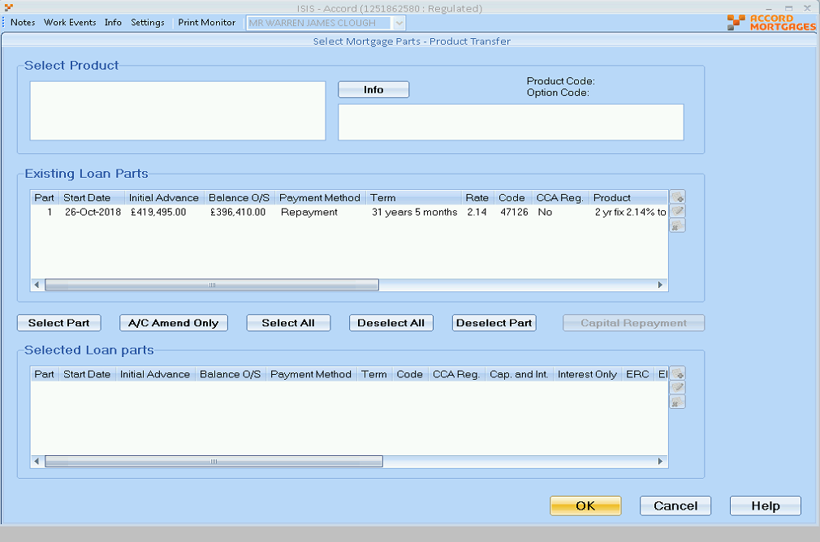

**Solution: //Mainline/setup_data/amendment_scripts/a9iss3446.sql**

**INC0609525**

**ISIS - illustration not showing lending partner**

**Details – Nicola advised "have a broker who has put an illustration request through on the website, this has gone through to the variations team to process on ISIS. ISIS is not showing the lending partner. This is pulled across from Leap as far as I understand, Leap is showing the correct lending partner for the broker. I have tried to reslove this with the variations team but they dont know how to fix it. The broker is called Tony Lenderyou"**

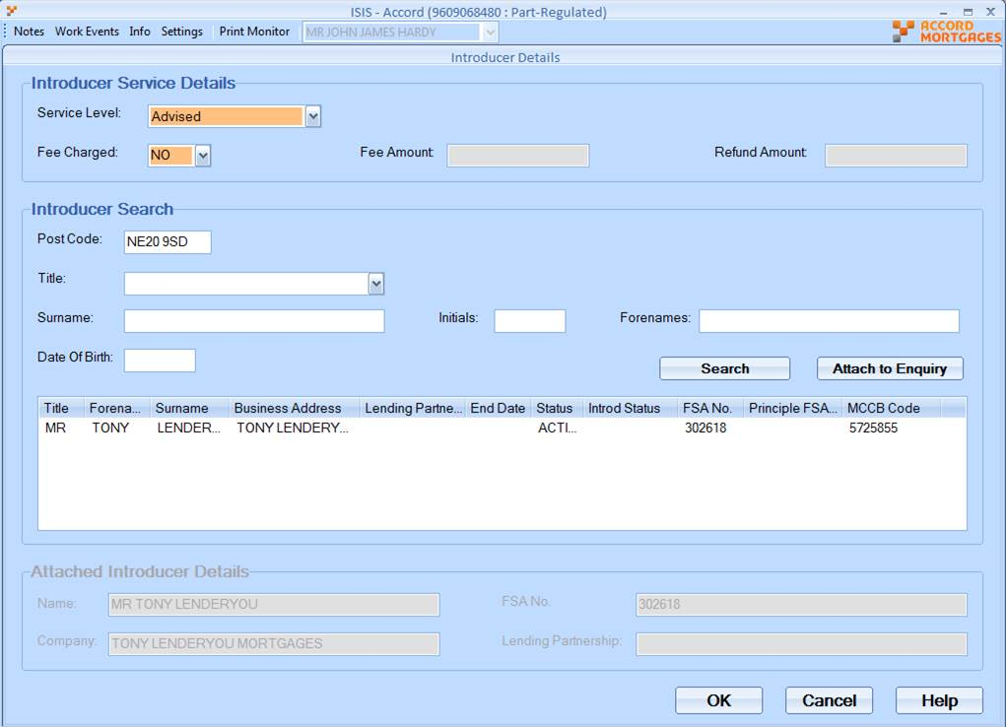

JM

Jill Mortimer

Work notes•

18-05-2020 16:11:24

The sysid for the broker in Core is currently 6963595742 , 4864818192 was ended in Jul-2018 in ACCGRP therefore I guess this is where the problem lies…..

RD

Richard Durn

Work notes•

19-05-2020 10:46:57

Hi Kamal,  
  
Please can you check the patch in Perforce at //Mainline/setup_data/amendment_scripts/a9iss3448.sql?  
  
Thanks,  
Richard.

**INC0610075**

**Accord No products showing in ISIS**

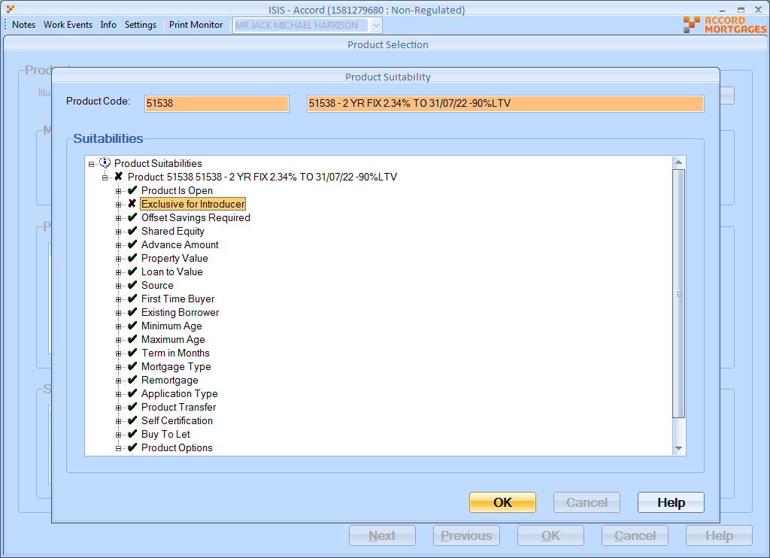

**Solution:**

**//Mainline/setup_data/amendment_scripts/a9iss3450.sql**

**INC0616512**

Unable to create a new variation. Error on screen advising Main Holder must be present, Mrs Patterson is the Other holder and there is no option in LEP003 to add customer.  
Account is in joint names, Mr is the main holder but can't see why his details are missing as he is on the account in CORE

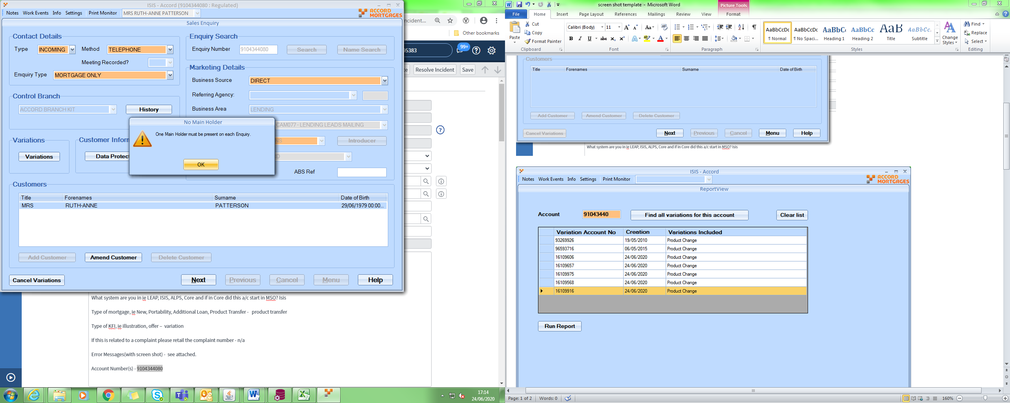

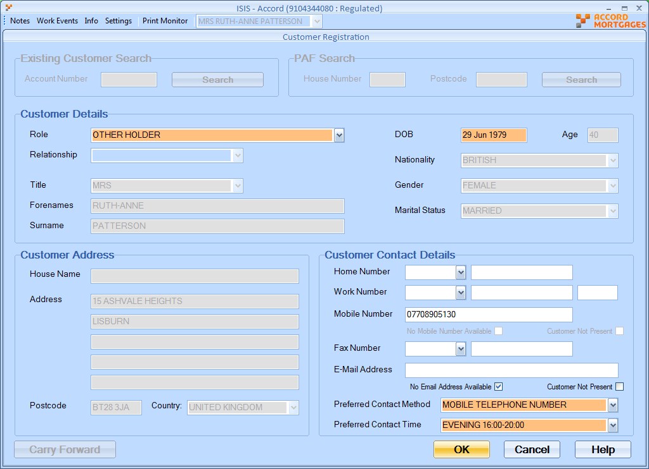

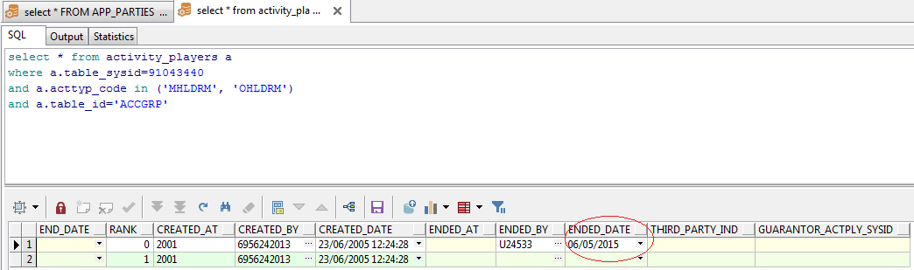

**INC0617566**

Replicated details and illustration returns a payment of £2,33.74.  
Input the details to LEN7040Q and the payment is £1599.22, if i amend the rate to svr 4.49% it is almost same as ISIS £2397.16, see attached 617566.doc.  
Can you see why the svr rate is being applied for this illustation.

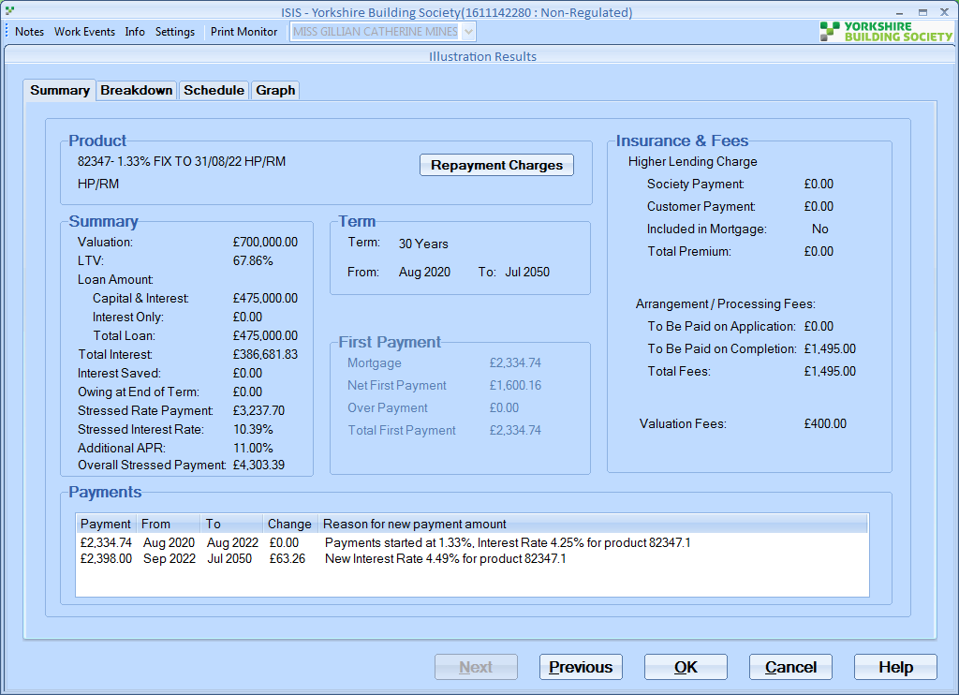

[‏02/‏07/‏2020 11:21]  Richard Durn:    
mmm, something is very odd here:  
select * from COREOWN.MORTGAGE_ILLSTR_PROD_STEPS t   
where t.morpro_sysid = 7579180   
i thought there was a payment event or something on there, but there isn't

[‏02/‏07/‏2020 11:34]  Richard Durn:    
select * from COREOWN.LENPRD_INTEREST_RATES t   
where t.lenprd_product_code in (82347, 82597)   
the product ranks are in the wrong order for 82347   
ranks 2 and 3   
**Richard Clarification:**

[‏02/‏07/‏2020 11:46]  Richard Durn:    
well, I found the illustration request and there was nothing unusual in it   
but the product code is part of the request   
so I decided to look at the product   
and I know how product setup works   
but if you look at the product in mort_illust_prod_steps it doesn't make sense   
    
[‏02/‏07/‏2020 11:48]  Richard Durn:    
e.g. rank 2 of the product doesn't have an end date, but rank 3 does   
it should always be the last rank which  doesn't end, because that's what happens if you stay on the product forever   
so the illustrator will have got confused by this

 **Solution:** [‏02/‏07/‏2020 11:37] Richard Durn:    
pass it back to sally and say that the interest rate setup for 82347 is incorrect - product development will need to fix it.

**INC0617735**

**ISIS ACC Porting - ESIS Sec2 suggesting broker due no fee**

**Producing illustrations in ISIS but doing this for broker they should get a procuration fee.**

**But when producing it is saying that the broker is not due a fee.**

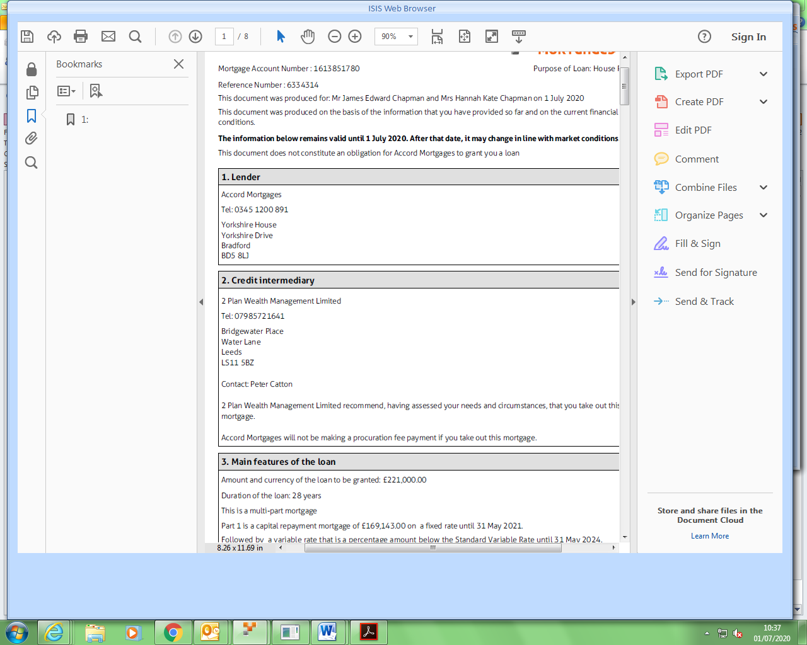

**INC0619043**

**ISIS but not showing on case to select it - product code is: 82644**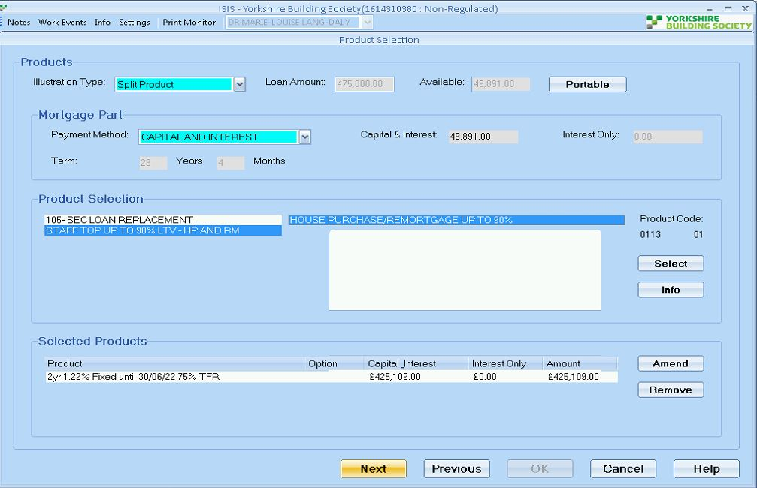

RD

Richard Durn

Additional comments•

08-07-2020 15:25:06

Hi,  
  
82644 is a FTB-only product. This case hasn't been processed as FTB (which seems reasonable as its porting) so the product won't appear.

**INC0620351**

**ISIS - ilustration showing incorrect amount**

**Details – bringing up the old valuation fees forward illustration is showing incorrect amount for the home buyers.**

Sally Carney

Work notes•

17-07-2020 11:10:49

Replicated details and get same issued. In LEP041MF the correct fee amount of £350 is displayed however in LEP041FF it shows £460.  
I have checked in Maintain Valuation Fee screen and it should be £350.  
Enquiry was started in January before the fees were amended, is it still using that date somewhere in the system, they have run the aip again on the the 8th June so I would have thought this would update it ?

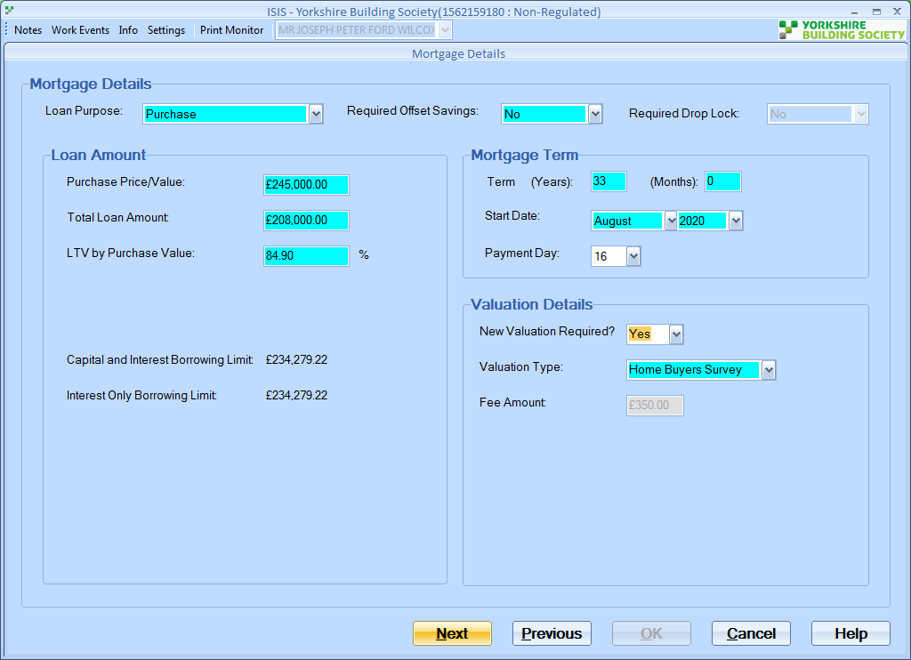

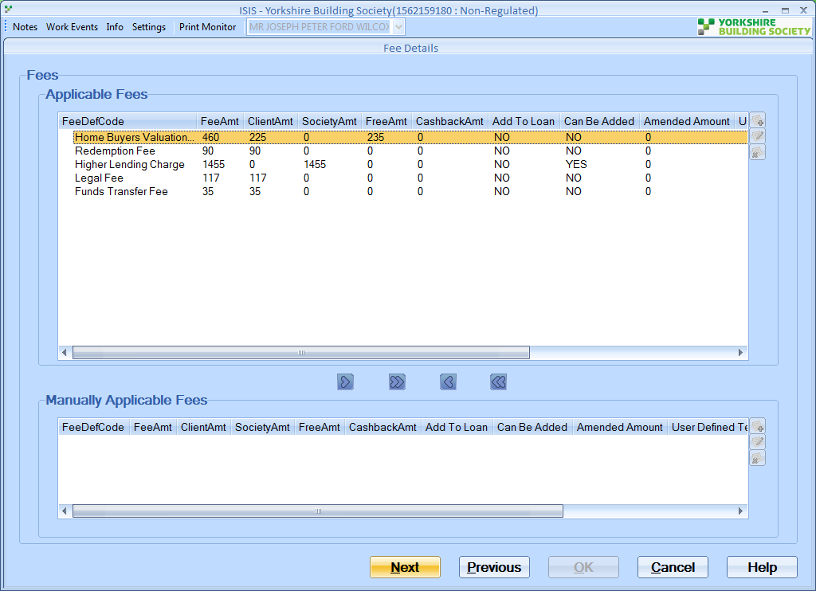

SELECT p.*

*--only want to know if it is an old/new product*

FROM mortgage_requirements m,

mtge_product_details p,

lending_products l

WHERE m.sysid = p.morreq_sysid

AND p.lenprd_product_code = l.product_code

AND m.lenapp_account_number = 15621591

AND l.end_date IS NULL

*-- AND p.end_date IS NULL*

ORDER BY nvl(p.ported,'N') DESC, l.start_date DESC

Switch the end_date to the other row

Solution: //Mainline/setup_data/amendment_scripts/a9iss3464.sql

**INC0621424**

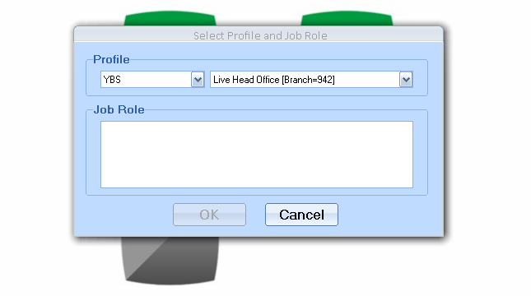

[4:07 PM] Richard Durn

select * from employment_details e where e.email_address= 'AMALIK@YBS.CO.UK' and e.known_as = 'AUSHNA'

Hi folks,

This person has a few employment_details records.  The one with the job roles attached doesn’t have the Oracle Id entered:

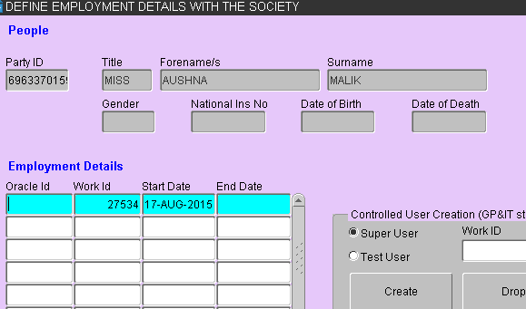

If this is added (make sure you have the correct Party ID as shown here), the job roles should work.

**INC0621634**

**1% Loading charge not pulling through on Authorised Let**

**Details – 1% Loading charge not pulling through on Authorised Let, showing 1.99% when it should be 2.99%**

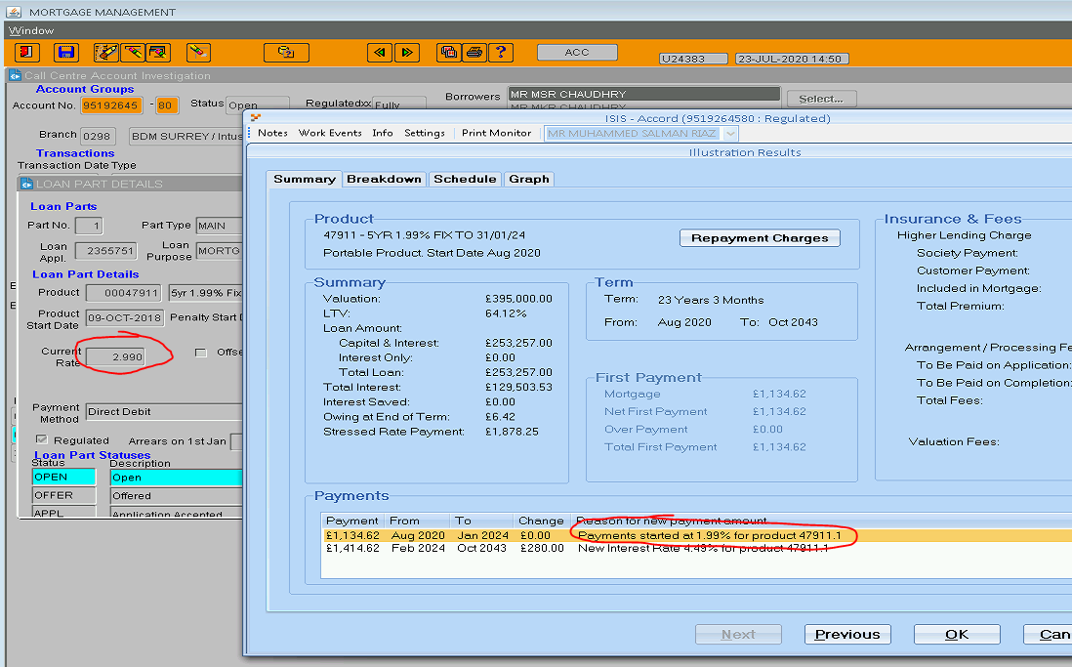

**Solution:**

**Hi,**

**The Variation is TOE, We only do authorized let loading on Product Transfer.**

**INC0622361**

**ISIS Income shortfall not being asked to be overriden or investigated**

**Details – ISIS Income shortfall not being asked to be overridden or investigated when running an AIP not being asked to investigate. Not showing in ISIS as an income shortfall and its not asking for an override but there is an income shortfall**

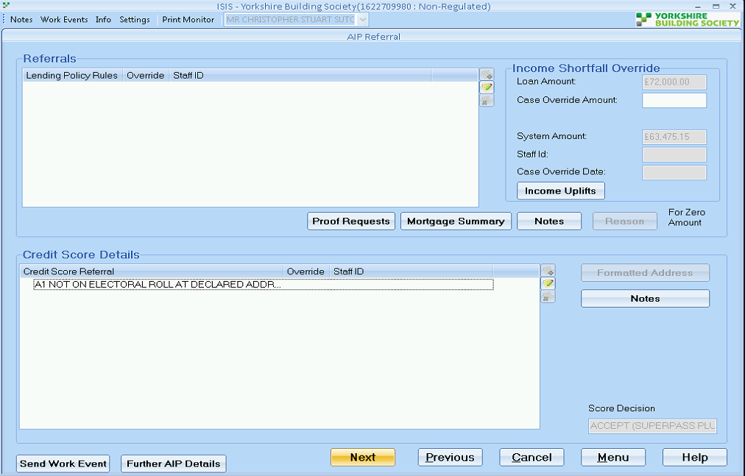

RD

Richard Durn

Work notes•

29-07-2020 12:18:37

The AIP was run on the 24th. At that point the case was affordable. The affordability figure decreased on the 28th, but that won't generate an income shortfall on its own; it needs the AIP rerunning.

Select *

from aff_max_borrowing amb

where amb.lenapp_accnum=16227099

**INC0624024**

**ISIS - Revaluation fee needs removing – duplicated**

**Details – Revaluation fee needs removing - duplicated - customer already paid the fee on 4th august 2020**

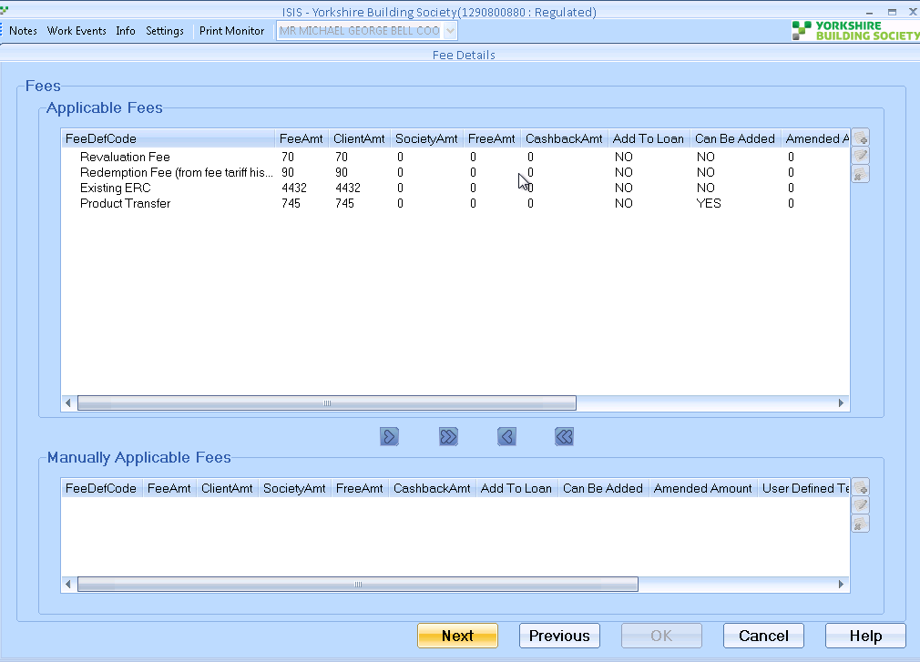

[12:19 PM] Richard Durn

I think it's this:

select m.valuation_type from mortgage_requirements m where m.lenapp_account_number = 16164844

​

[12:20 PM] Richard Durn

it gets set when processing a case which needs a revaluation, which this case did earlier

​

[12:21 PM] Richard Durn

normally this can be amended in the application screens, but it doesn't seem to be the case in this scenario

**//Mainline/setup_data/amendment_scripts/a9iss3473.sql**

**INC0619924**

**New lending application has 3 names - 1 in error needs removing**

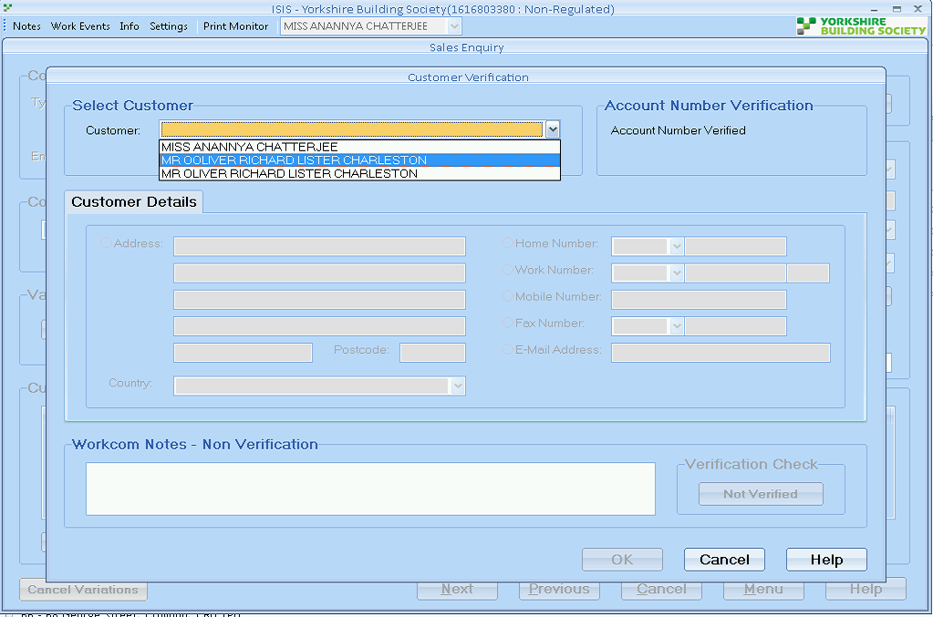

//Mainline/setup_data/amendment_scripts/a9iss3463.sql

**INC0625302**

ISIS - New lending application has 3 names - 1 in error needs removing - (INC0619924 NOT RESOLVED)

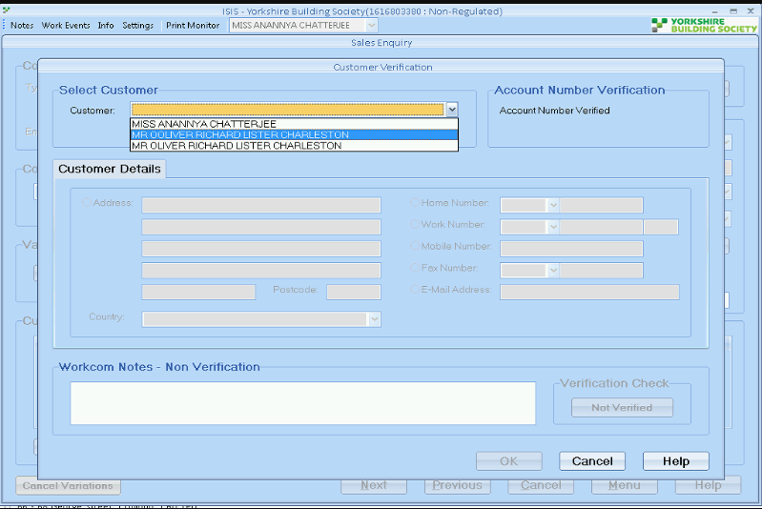

**INC0626081**

**Accord ISIS getting stuck at Mortgage details screen**

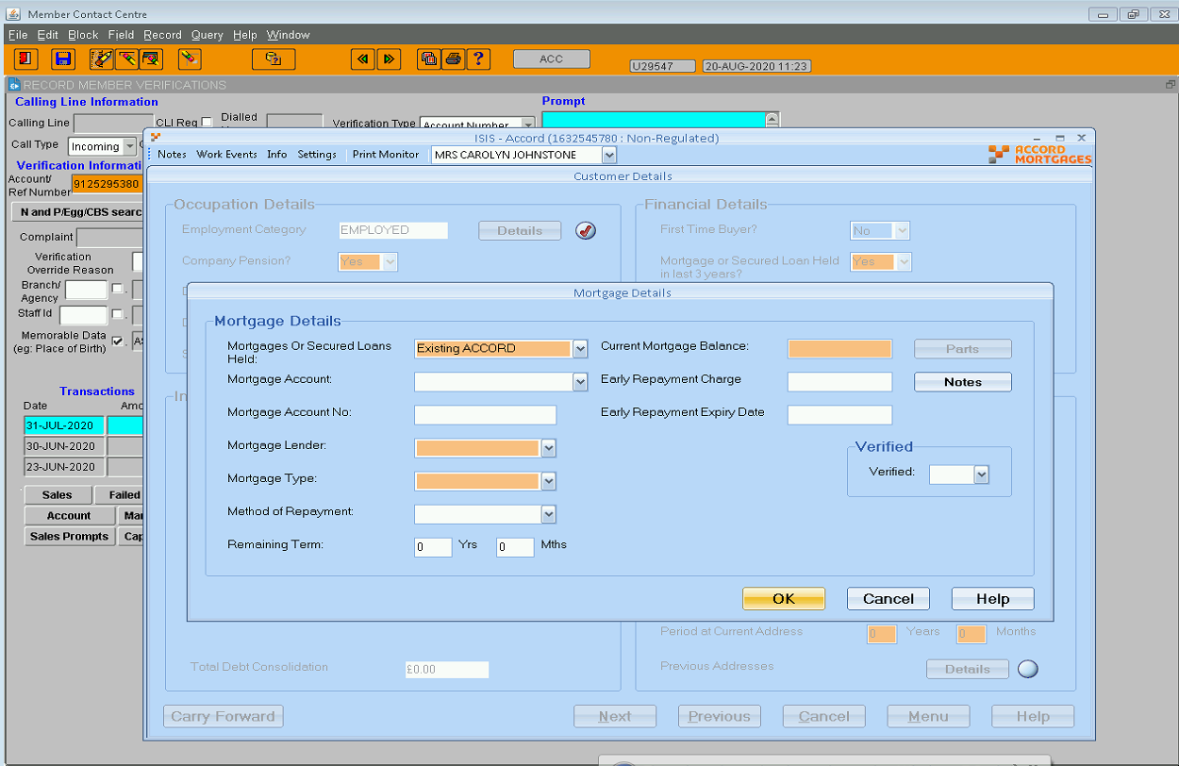

*--------- Line 5367--- Curson cur_exp_day fetch value of ln_expected_day - which comes Null*

SELECT exppay.expected_day

FROM expected_payments exppay

WHERE ('31-AUG-2020'

BETWEEN exppay.start_date

AND NVL(exppay.end_date, '31-AUG-2020')

OR

(SELECT trunc(MAX(lps.end_date) - 1)

FROM loan_part_statuses lps

WHERE lps.lpst_code IN ('OPEN', 'LOWBAL', 'LOWMEM')

AND lps.loanpt_part_num = exppay.loanpt_part_num

AND lps.loanpt_latype_code = exppay.loanac_latype_code

AND lps.loanpt_accgrp_num = exppay.loanac_accgrp_num

)

BETWEEN exppay.start_date

AND NVL(exppay.end_date, '31-AUG-2020')

)

AND exppay.ept_code = 'SYSMOR'

AND exppay.status_code = 'VALID'

AND exppay.loanpt_part_num = 1

AND exppay.loanac_latype_code = 80

AND exppay.loanac_accgrp_num = 91252953

ORDER BY exppay.start_date DESC;

*------ Fetch the split query from above and get latest sysId - End Date is 31/05/2020*

Select * FROM expected_payments exppay

Where exppay.loanac_accgrp_num = 91252953

AND exppay.ept_code = 'SYSMOR'

AND exppay.status_code = 'VALID'

AND exppay.loanpt_part_num = 1

AND exppay.loanac_latype_code = 80

ORDER BY exppay.start_date DESC;

*----- Update End Date as Month End Date - 31-AUG-2020*

Select * FROM expected_payments exppay Where exppay.sysid = 22884312 for update

**INC0624569**

**AL application keeps disapperaing from ISIS**

**Details – Andy has submitted AL 15496967 twice now and both times the variation has been wiped from ISIS.**

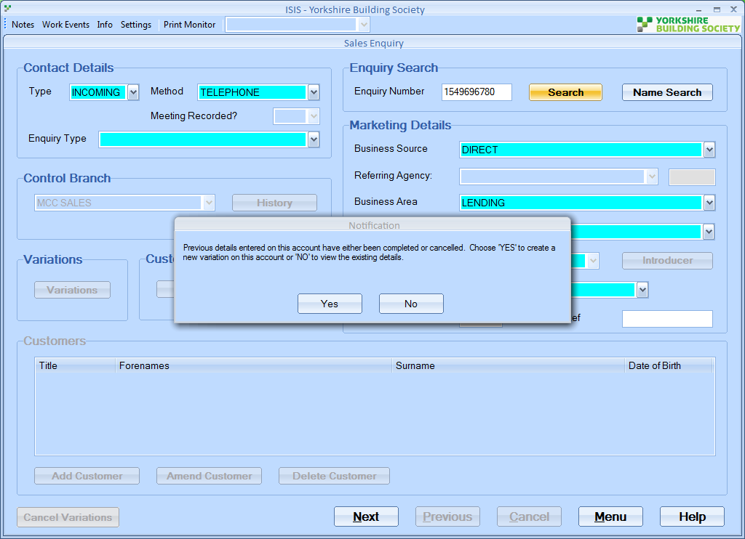

RD

Richard Durn

Work notes•

26-08-2020 11:25:22

It doesn't seem to have cancelled anything on the ALPS/Core side, thankfully. So if you set the status back to SUBMIT in isis_leap_variants and remove any end dates in isis_leap_variants and lenapp_variants, it should be fine.

**Solution: //Mainline/setup_data/amendment_scripts/a9iss3478.sql**

**INC0625855**

**ISIS - Total monthly reductions not saving**

**Details – ISIS - Total monthly reductions not saving, Colleague is amending them to yes but whenever saving the changes it reverts back to NO. (see attached)**

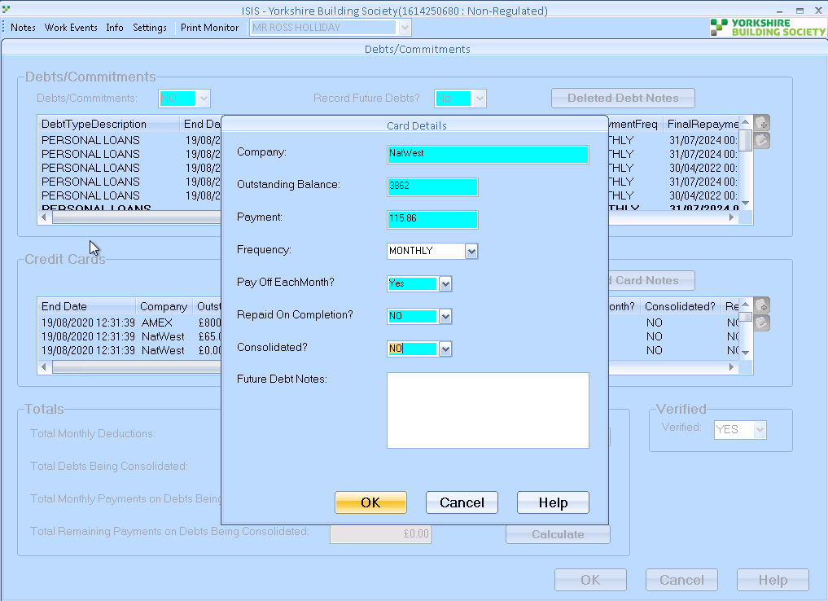

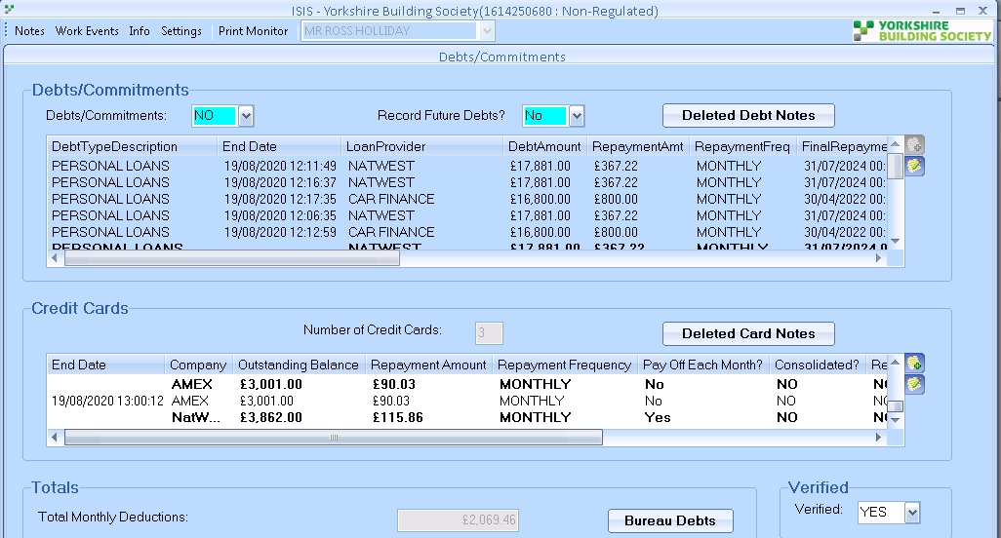

**Solution:**

KB

Kamal Batham

Work notes•

26-08-2020 13:04:16

Hi Jill,  
'Pay Off each month' doesn't exist for this case. No record found into outstanding_debts table.

Richard Durn

Work notes •

27-08-2020 10:04:26

Hi Jill,  
  
The field doesn't exist on the database so there is no way to save this. It's been like this since the very beginning of ISIS.

**INC0630336**

Details – Isis - printing "Produce AIP certificate" on printer LP70 issues , this is also affecting the "Lending Rule check" letter, both coming of on Plain paper, when system has B326Lp70 attached as a default printer,

**ISIS - printing "Produce AIP certificate" & "Lending Rule check" letters on printer LP70 issues since teller upgrade.**

RD

Richard Durn

Work notes•

18-09-2020 13:39:25

The driver used by this printer is one which we don't have ISIS settings for, although we should be able to fix that. Can you advise what trays are used for letterhead/plain paper here?

**Solution:** //Mainline/setup_data/amendment_scripts/a9iss3486.sql

**INC0633164**

**ISIS error - customer receiving 0% borrowing**

**Details – Customer is receiving 0% borrowing when trying to apply for a portability case over the phone. It seems to be an issue with affordability on ISIS**

**LEAP affordability is showing £300,000 borrowing**

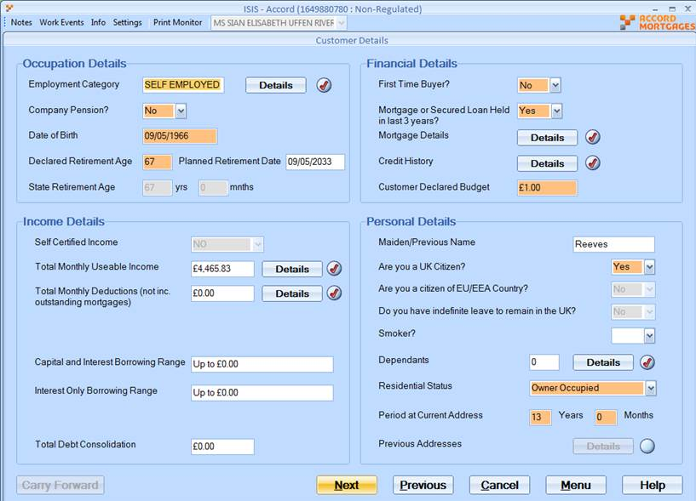

Richard Durn

Additional comments•

12-10-2020 10:59:19

Hi,  
  
The affordability figure for this case has been reduced due to the BTL portfolio. However, it appears that the mortgage balances entered on the system aren't correct (they're all the same figure). If these are corrected, it's possible that the affordability figure will increase.

Richard Durn

Additional comments •

12-10-2020 11:12:57

Hi Donna,  
  
The outstanding balance figure is £512,445 on each of those screenshots.